Bancassurance 4.0 – Campaign Emma Product Recommendation

# ROLE : MANAGER

## Upload Data

### Upload Detail

[TC 1.1.1 – TC 1.1.9]

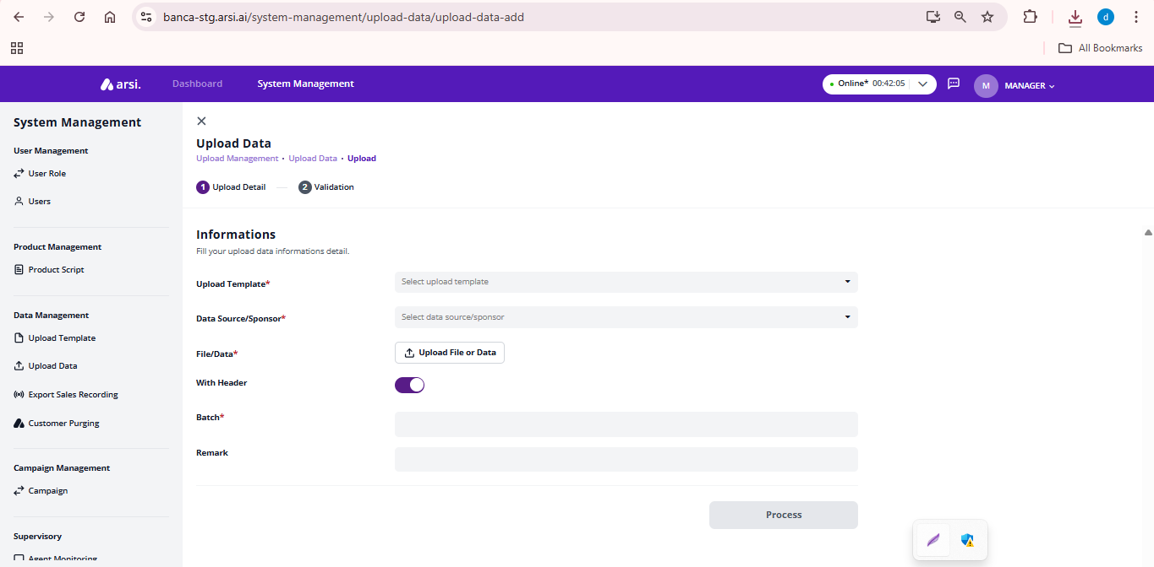

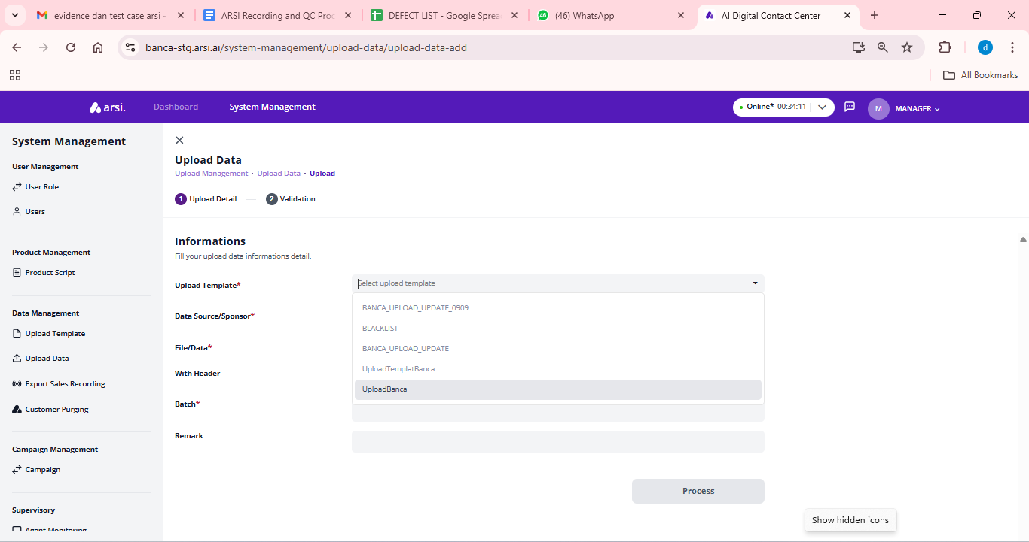

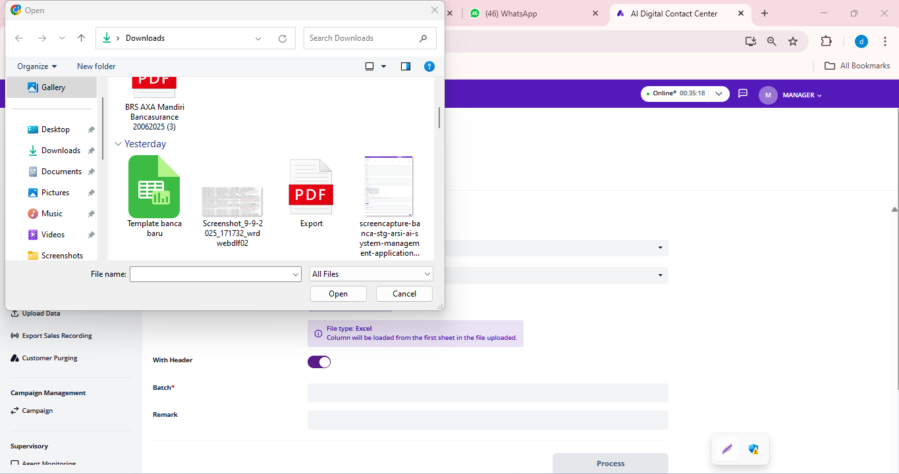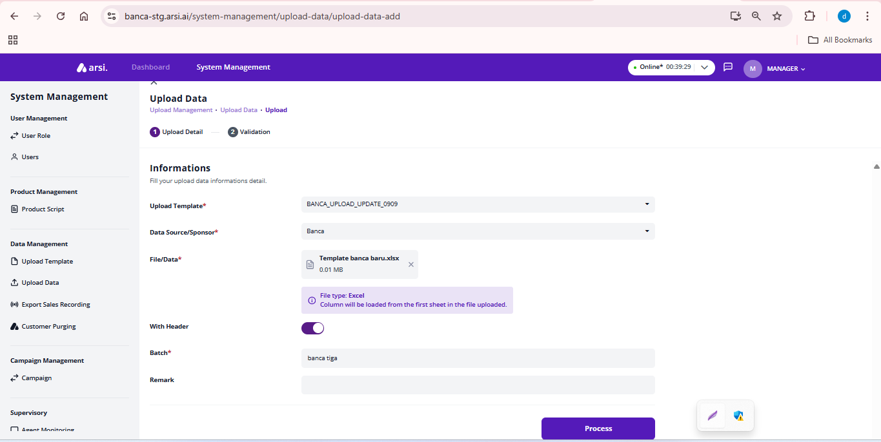

* Negative Cases

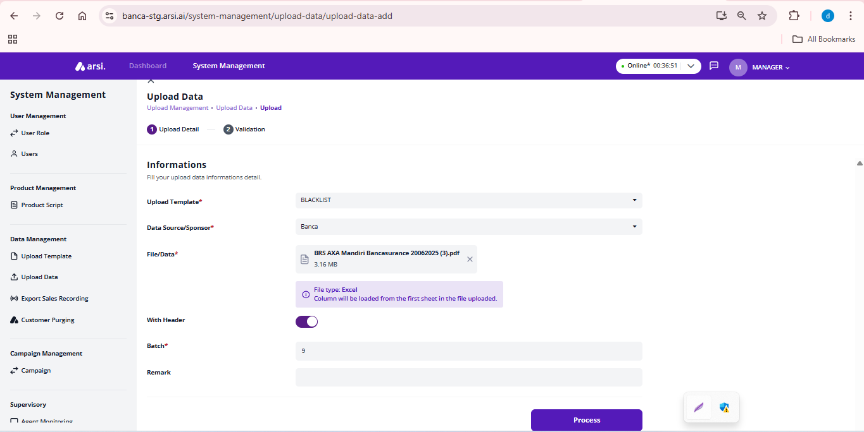

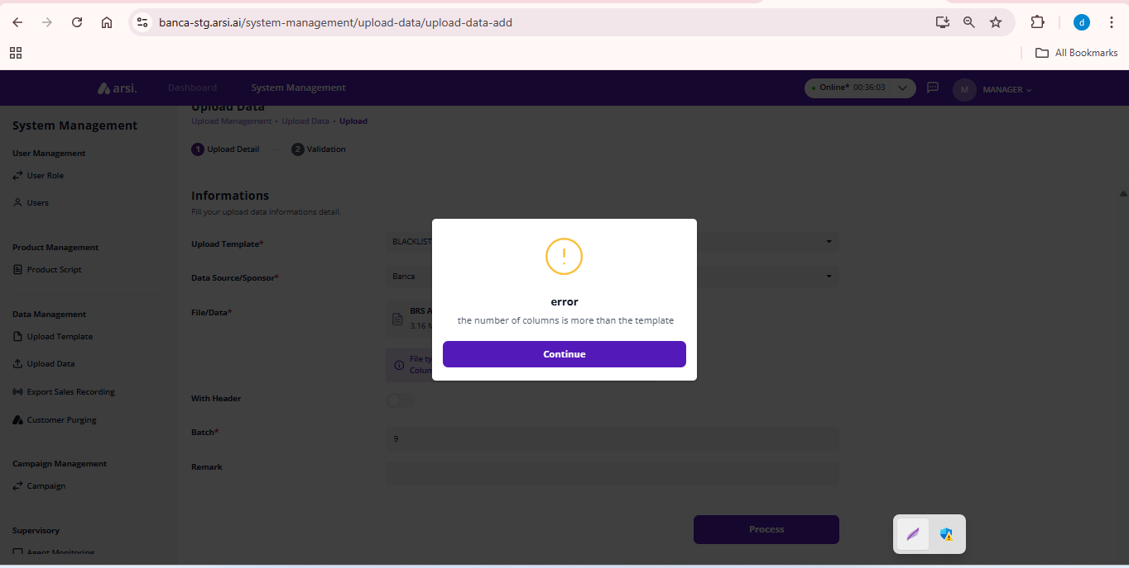

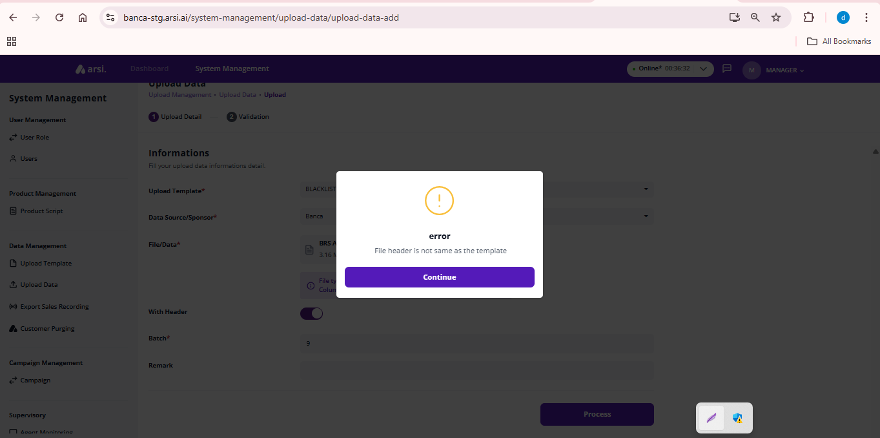

### Validation

[TC 1.1.10 - TC 1.1.18]

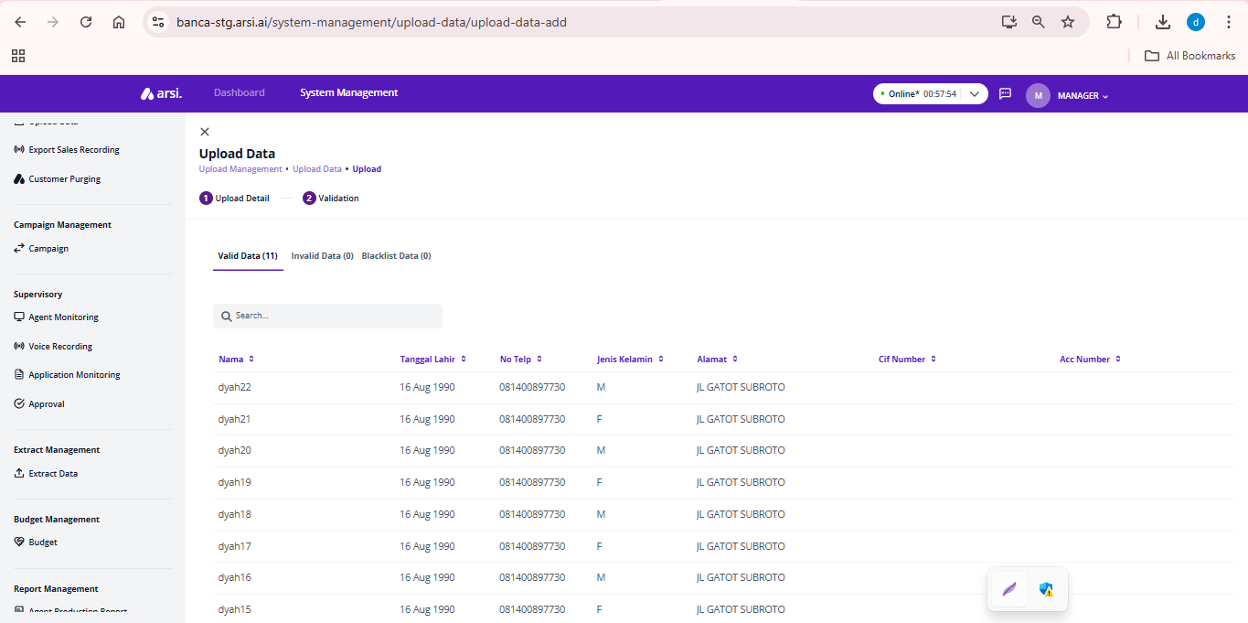

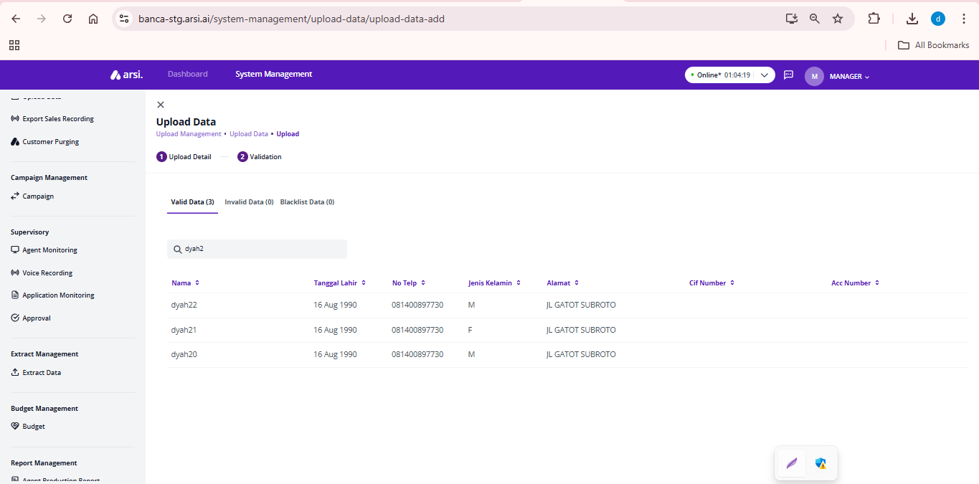

## 

## Campaign Management

[TC 1.1.1 – TC 1.1.8]

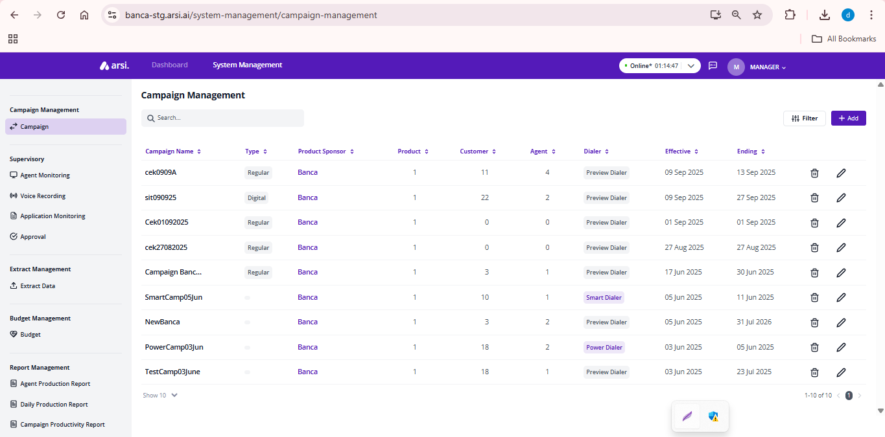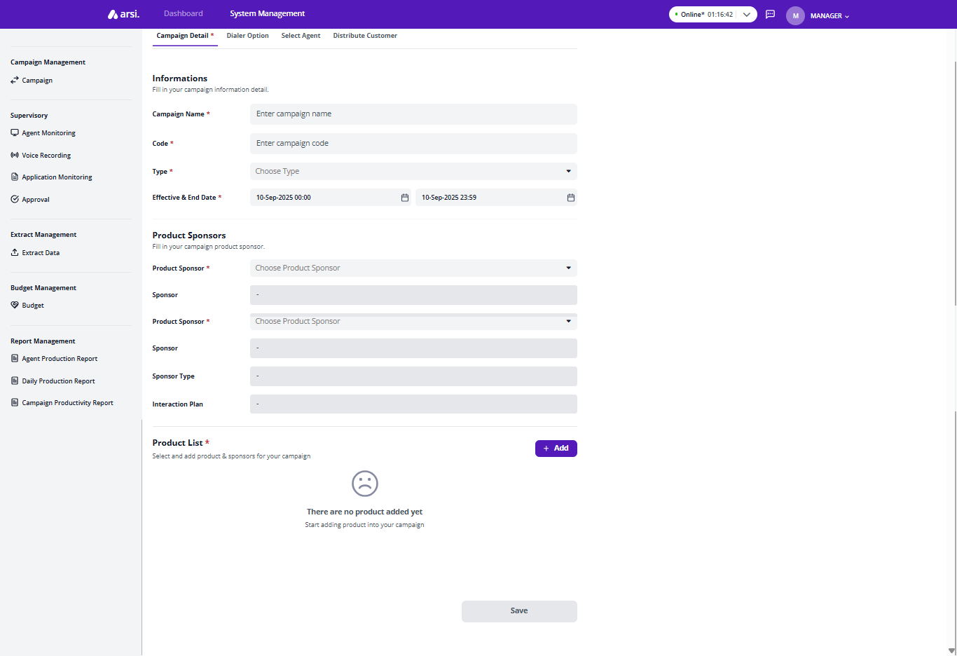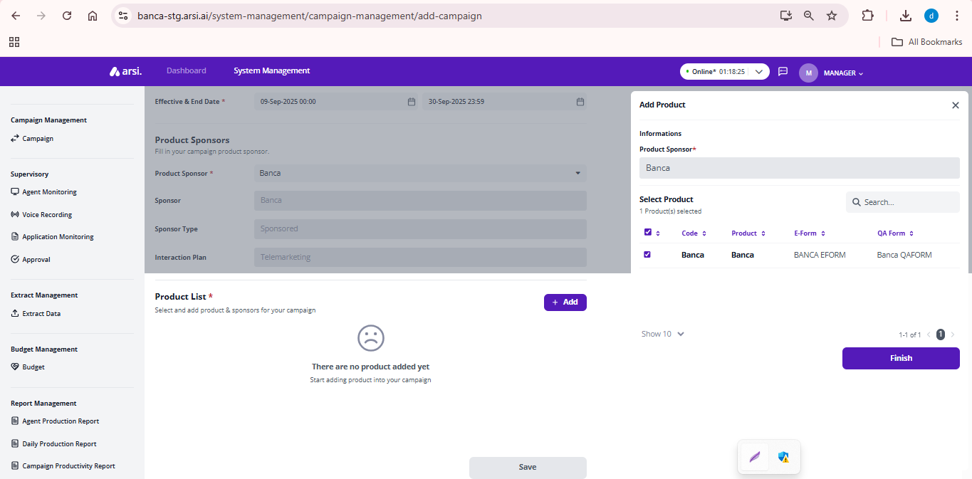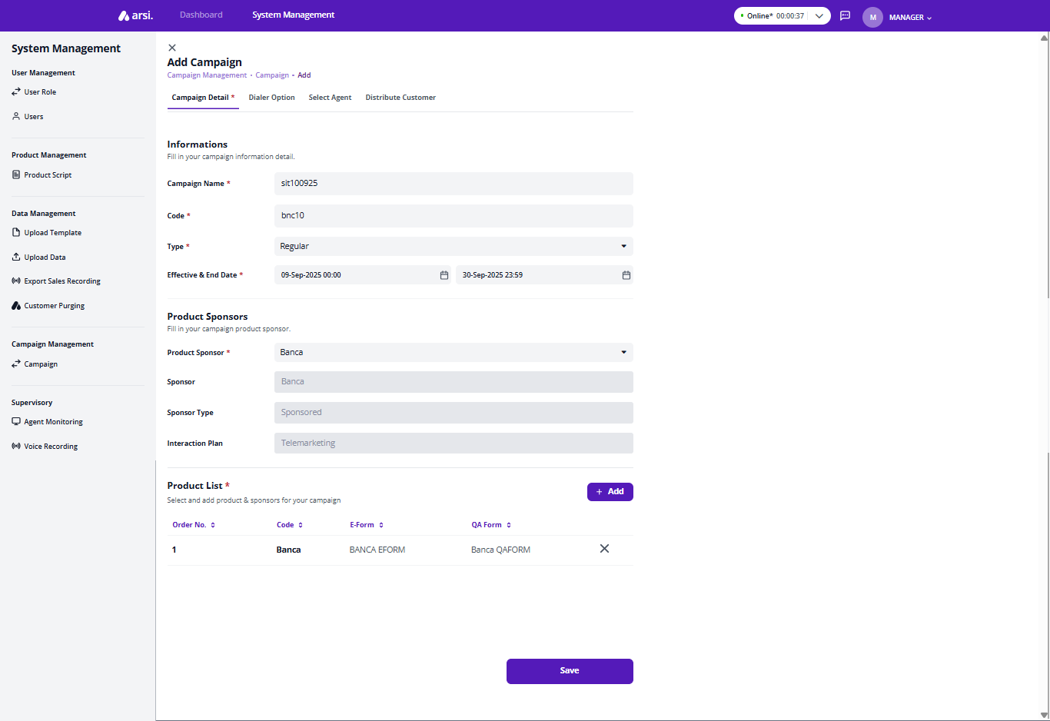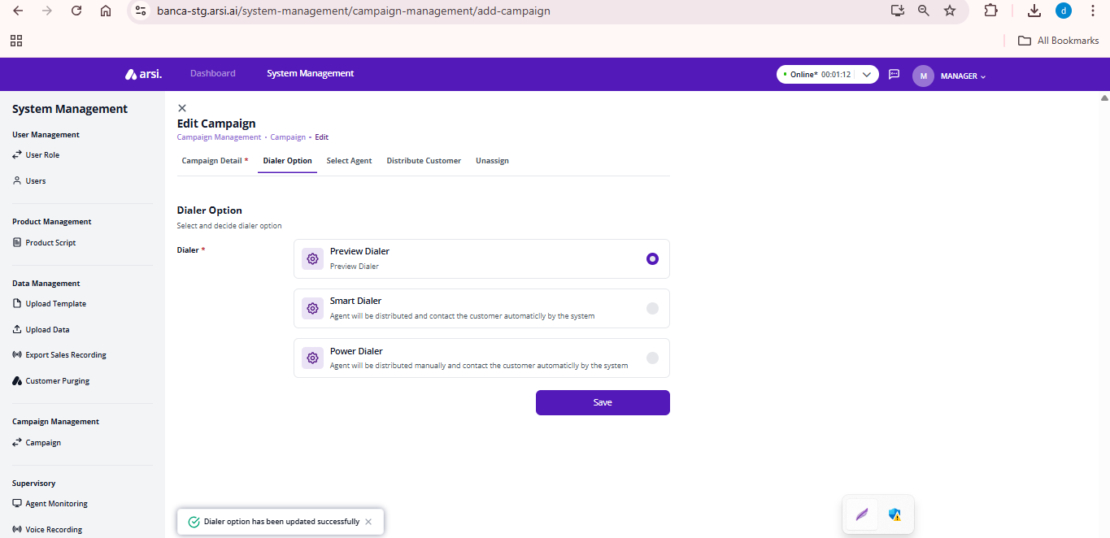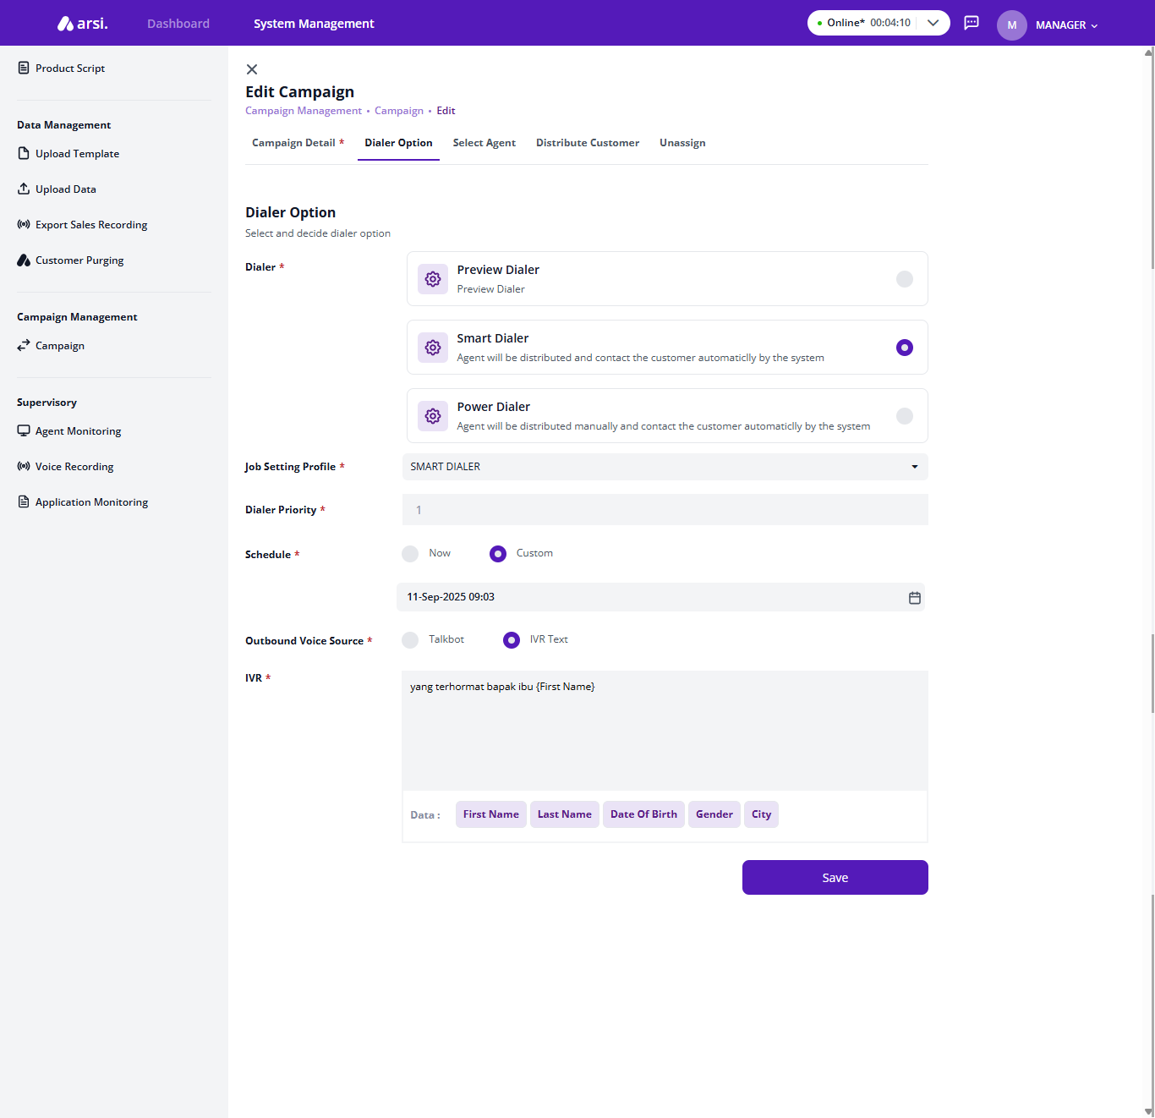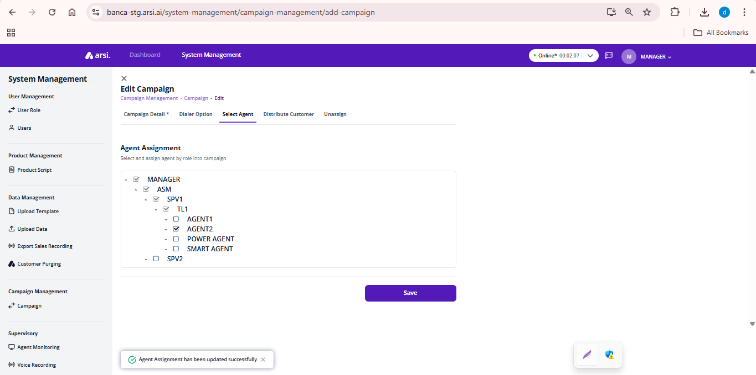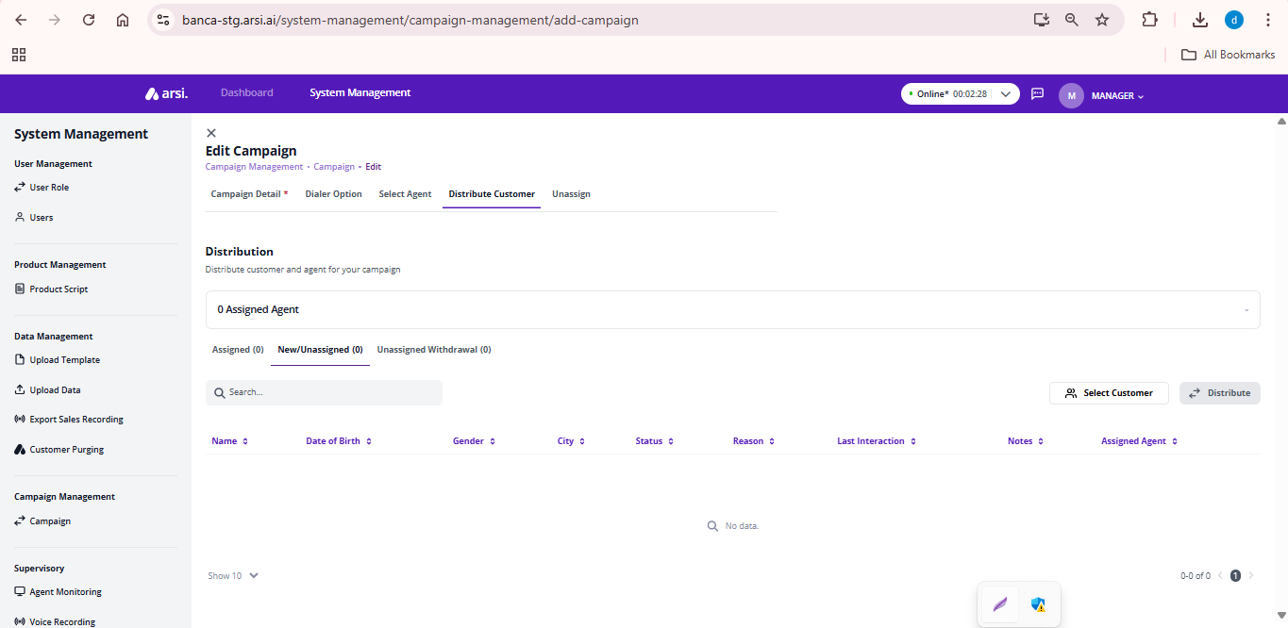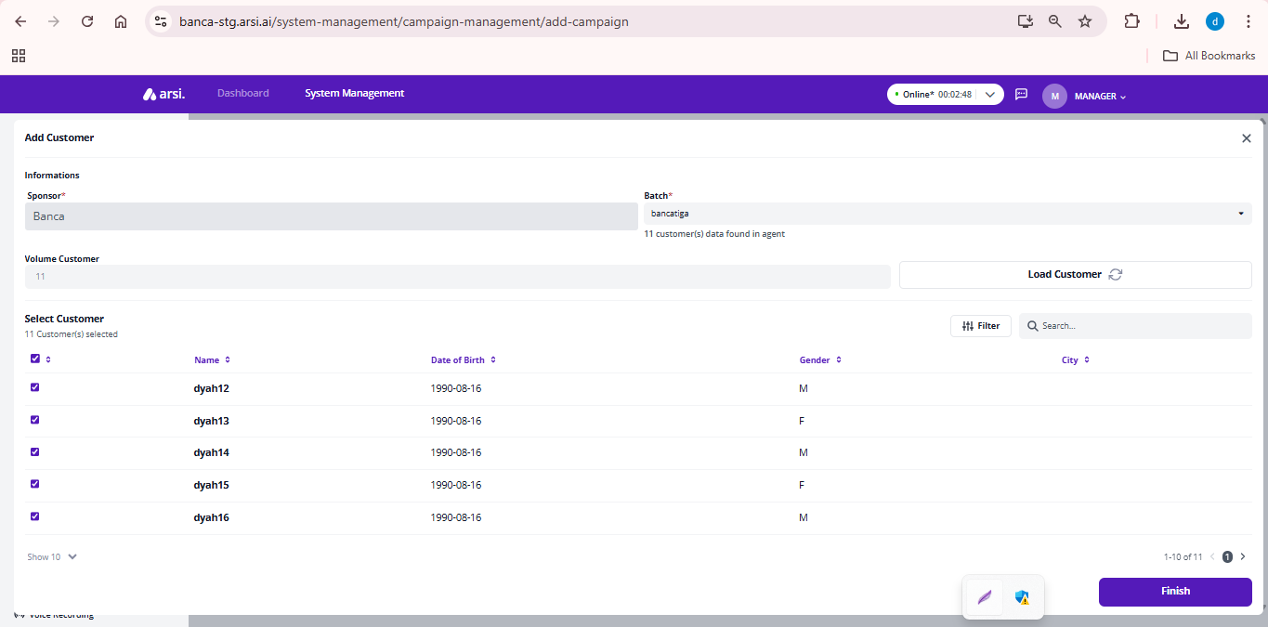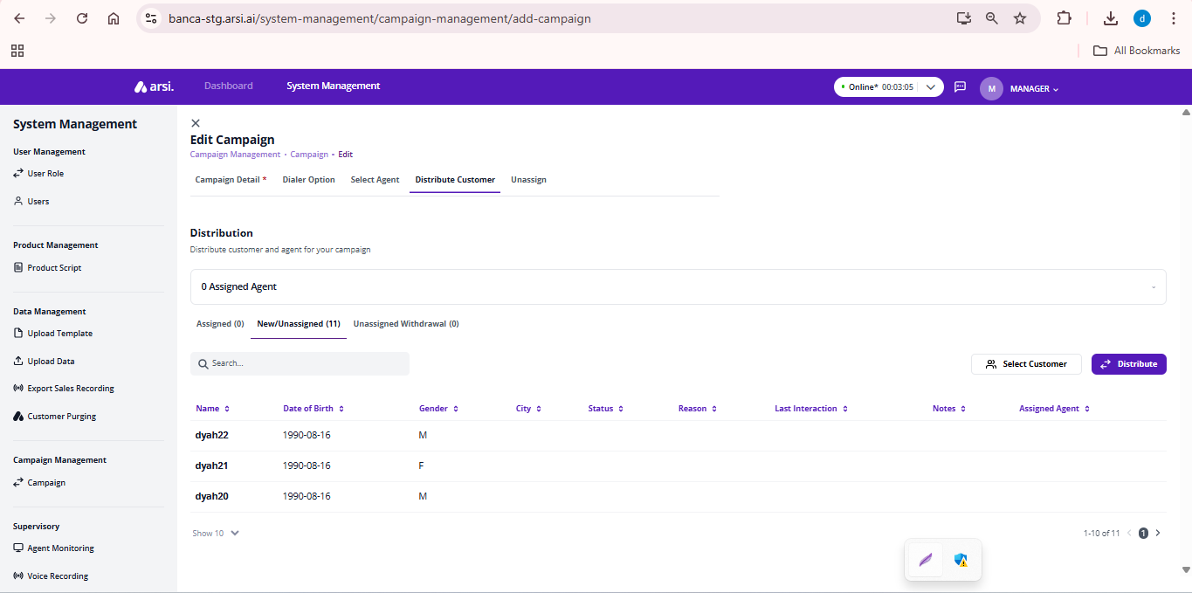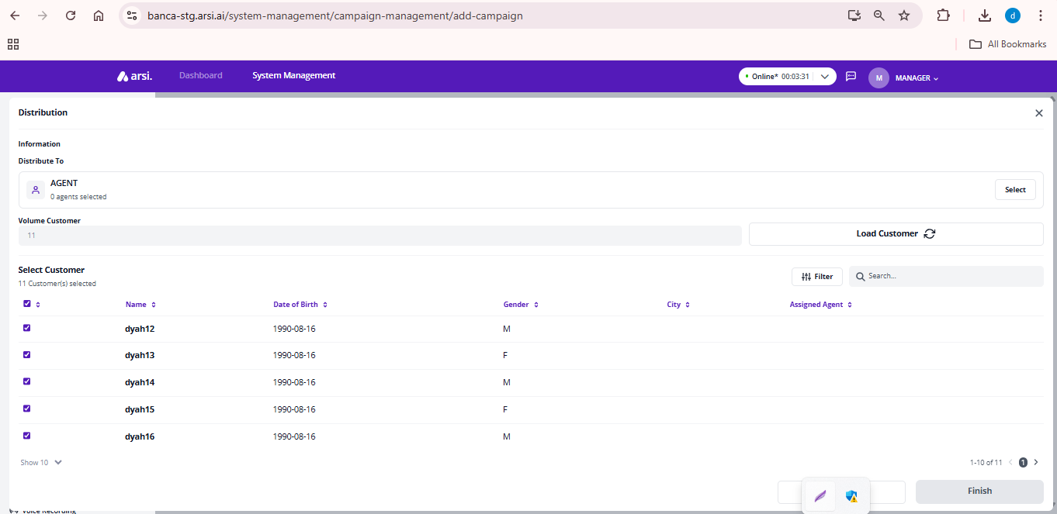

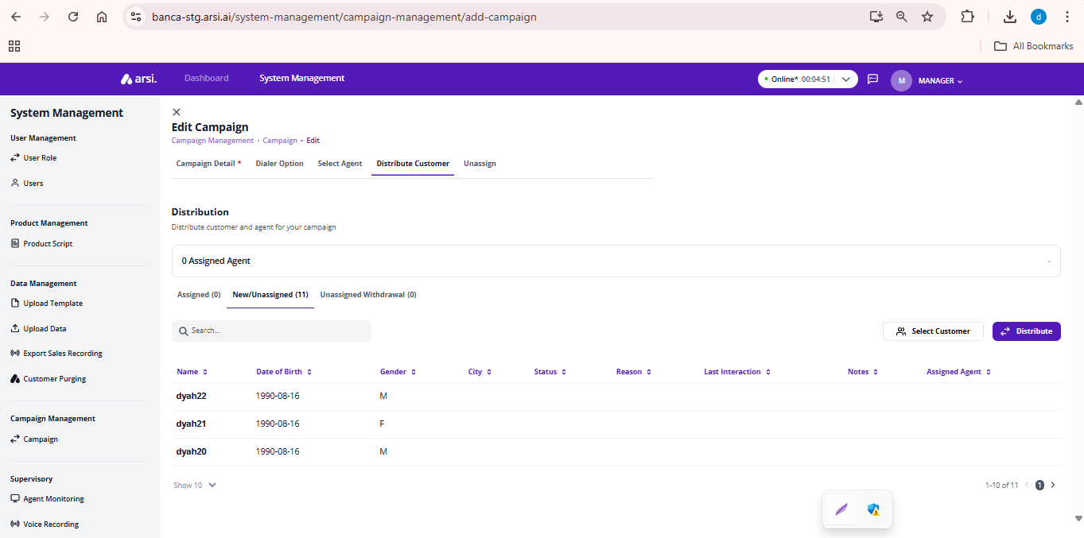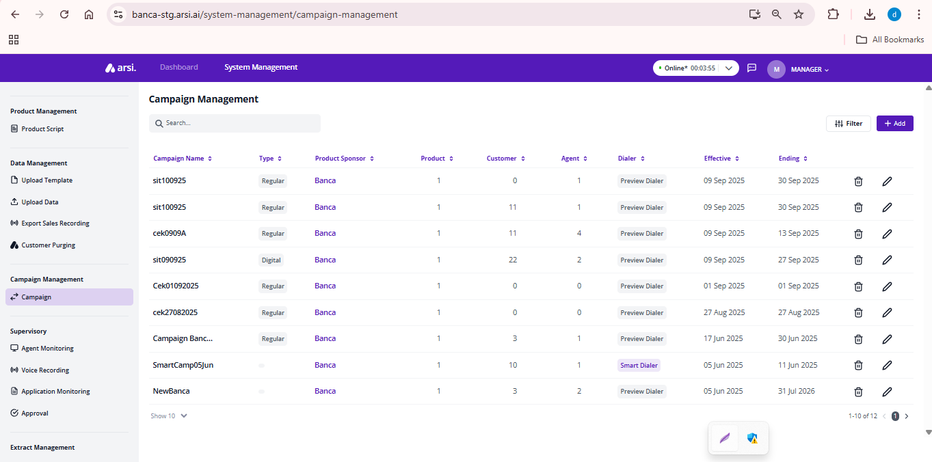

## Extract

[TC 3.1.1 – TC 3.1.2]

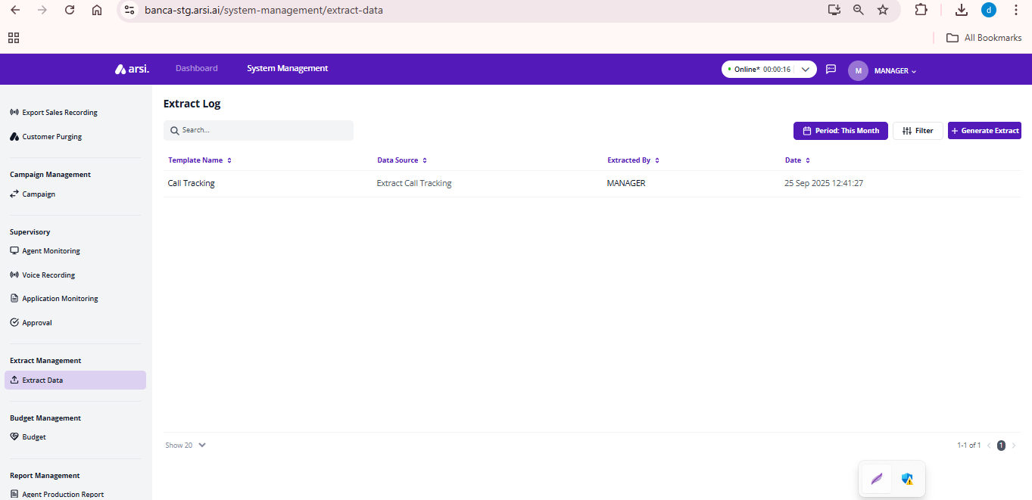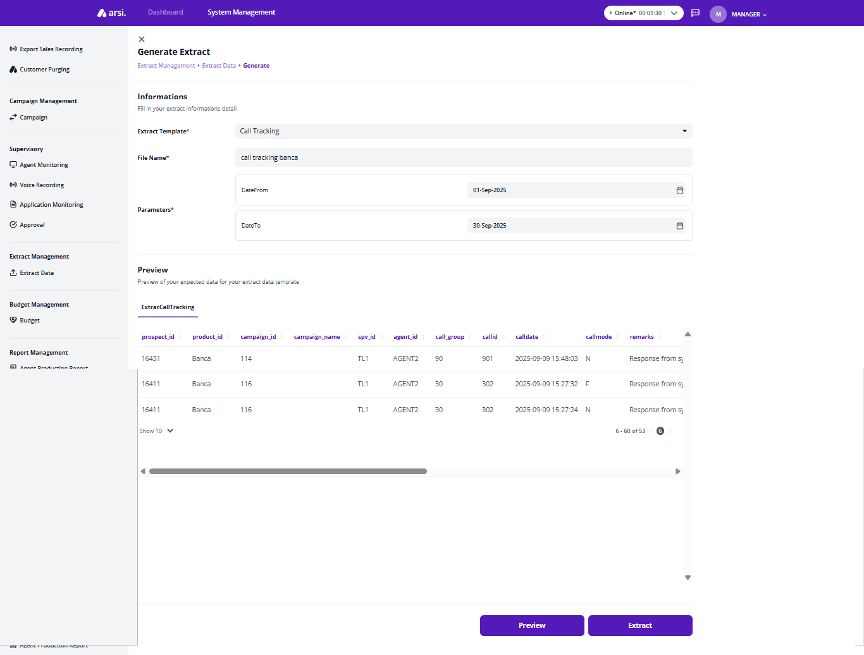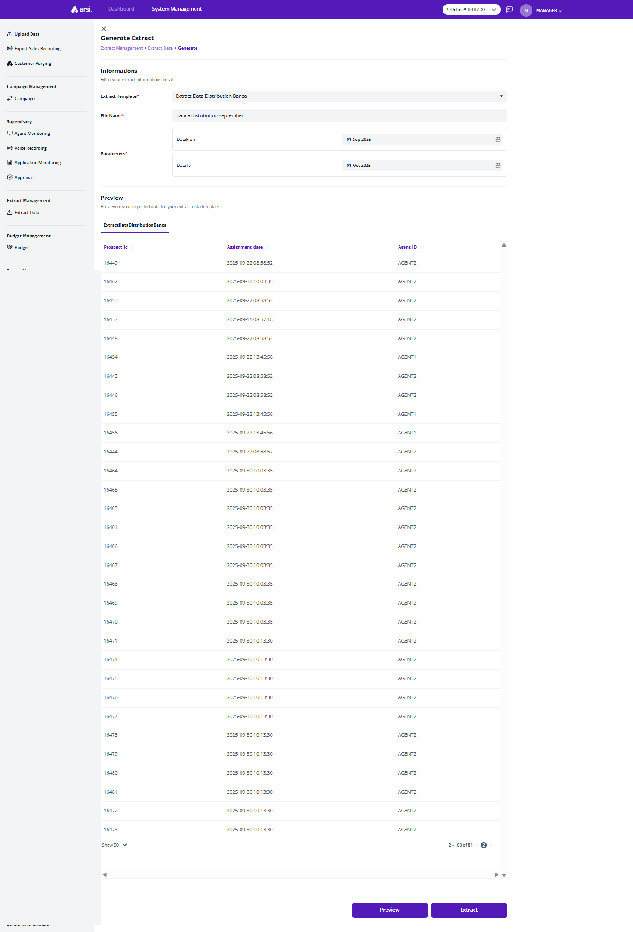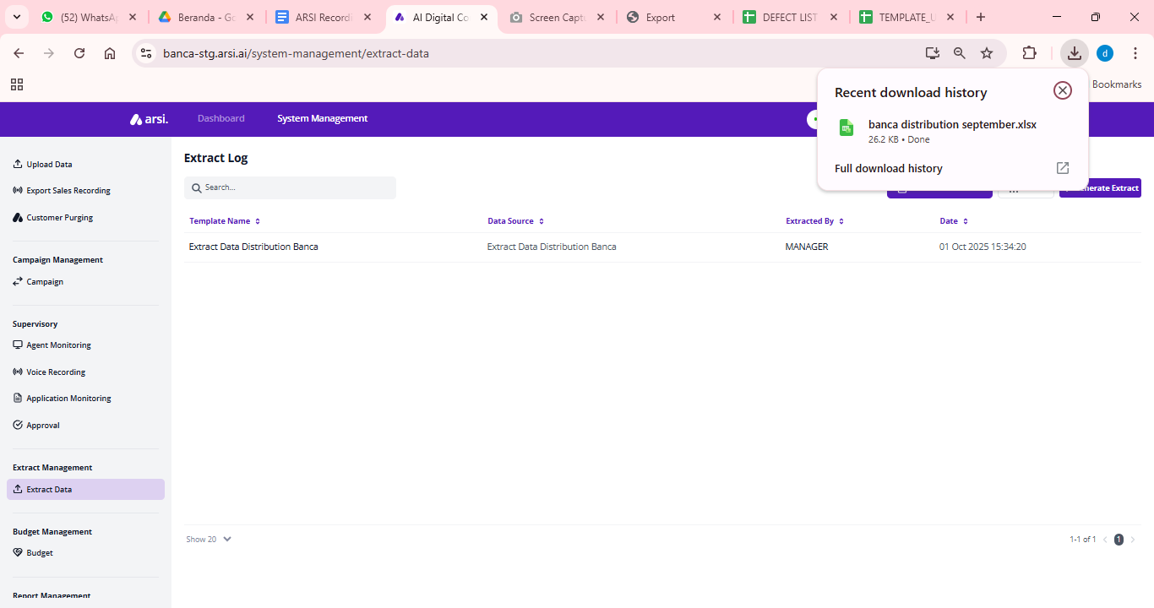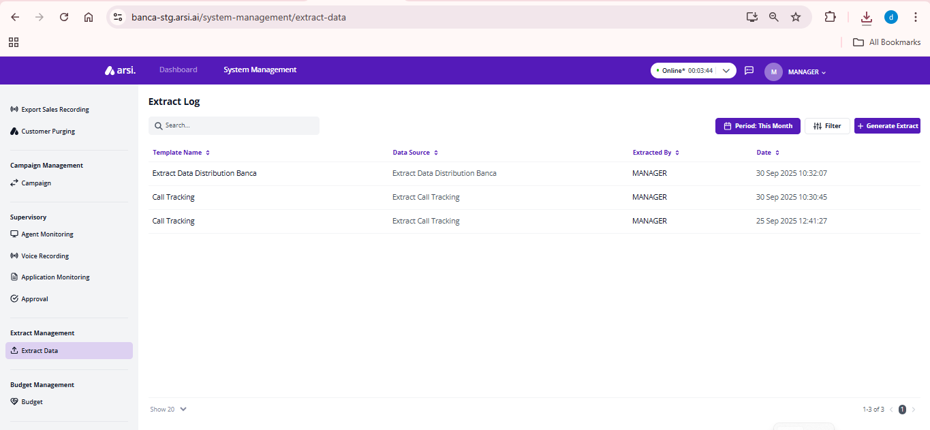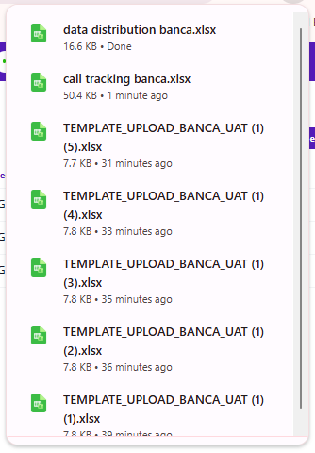

## ROLE : TAO

## Call Nasabah- Eform

[TC 4.1.1 - TC 4.1.14]

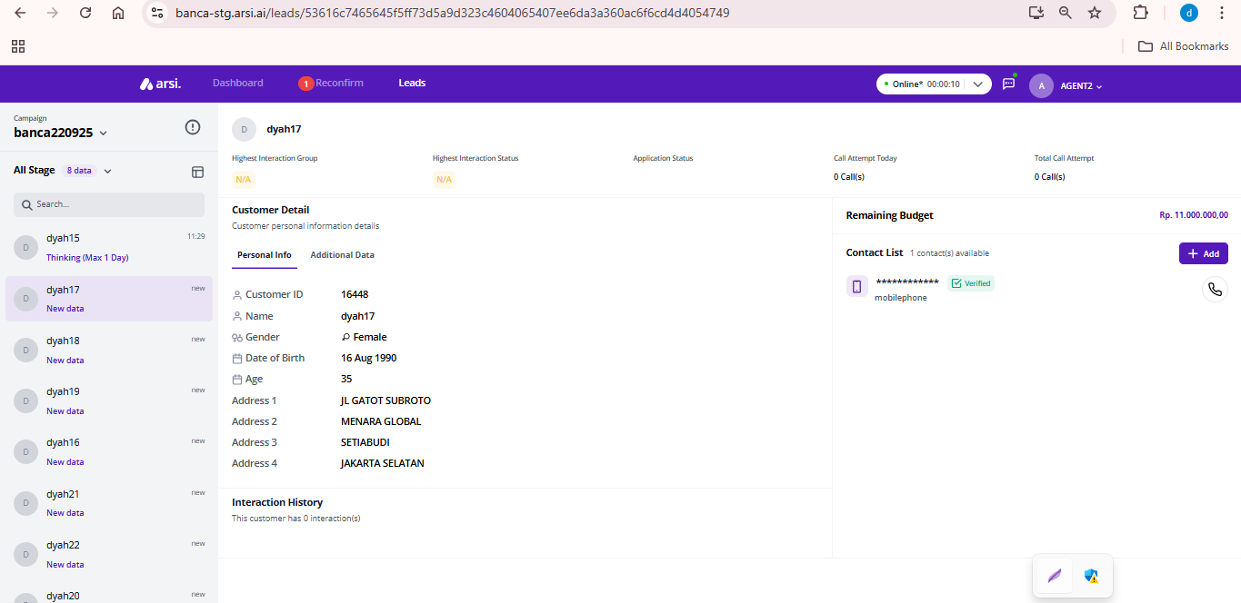

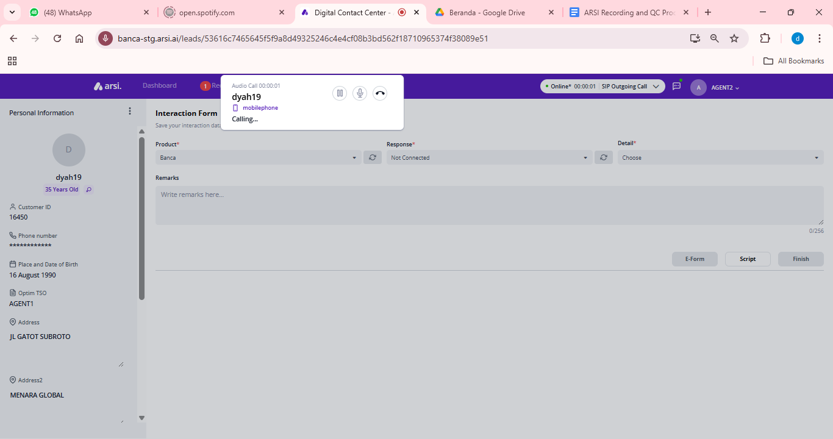

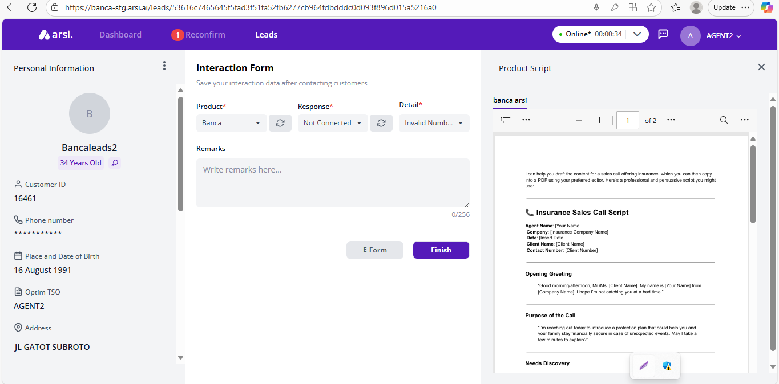

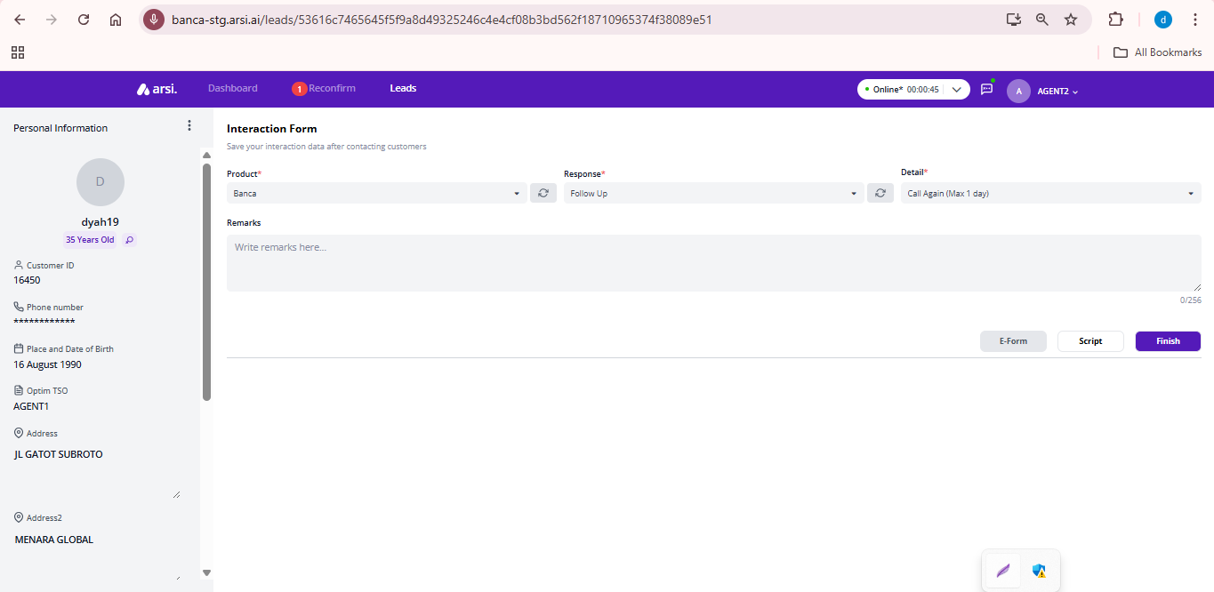

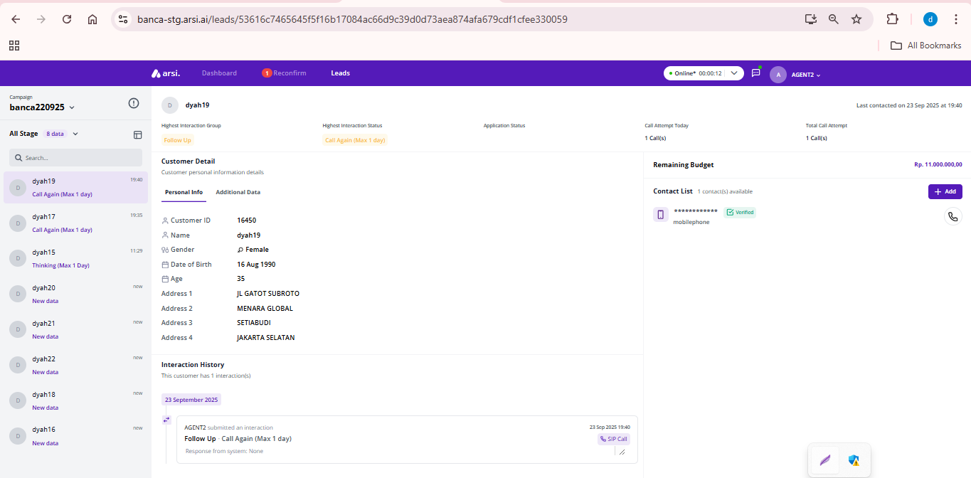

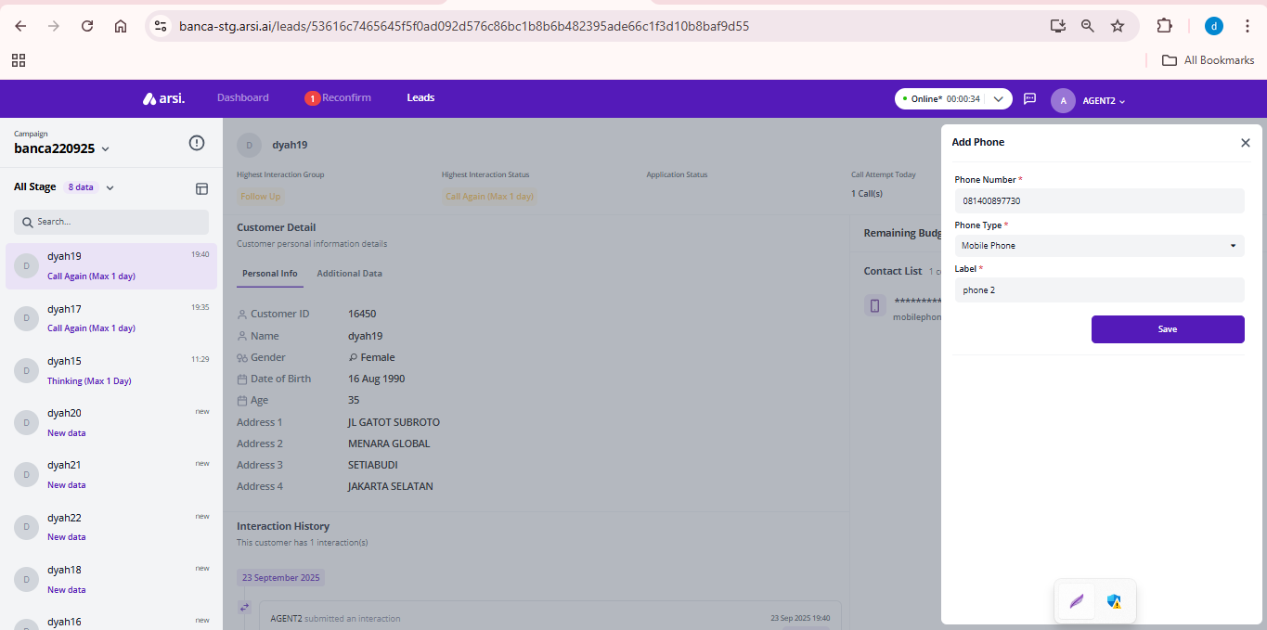

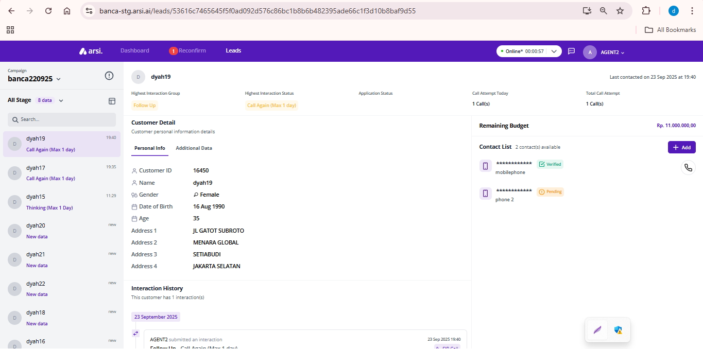

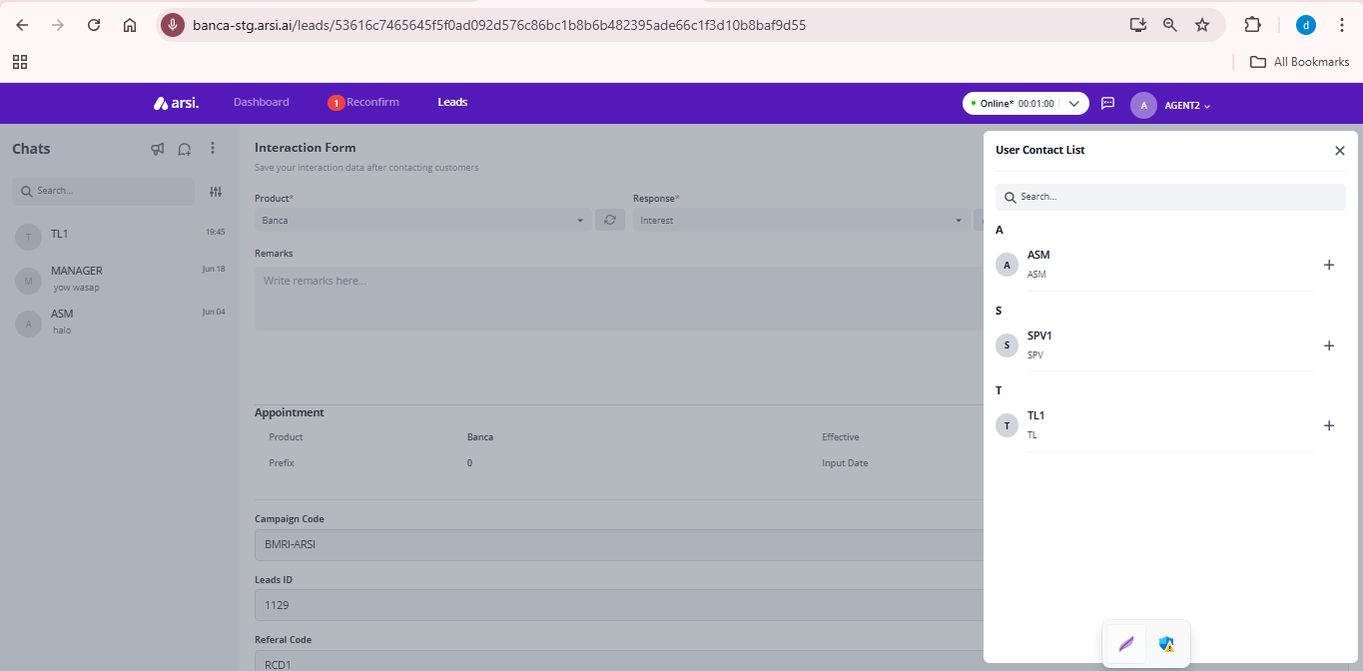

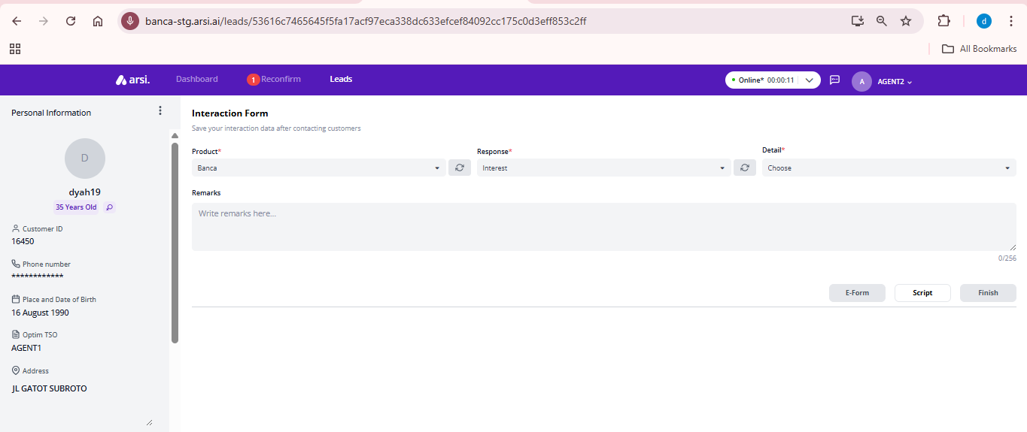

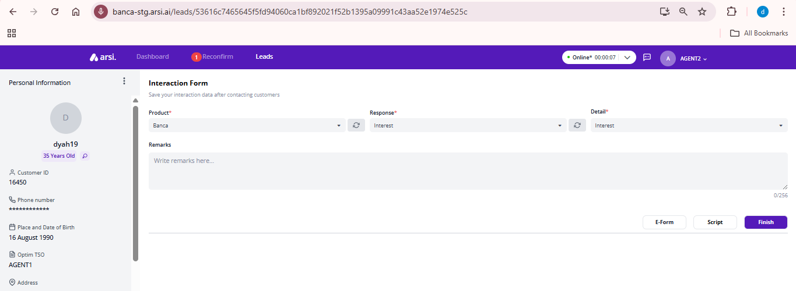

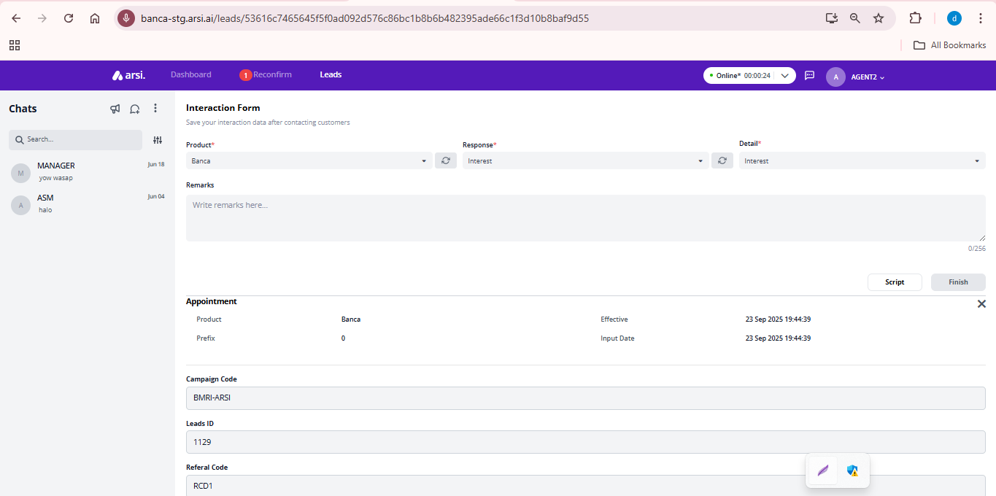

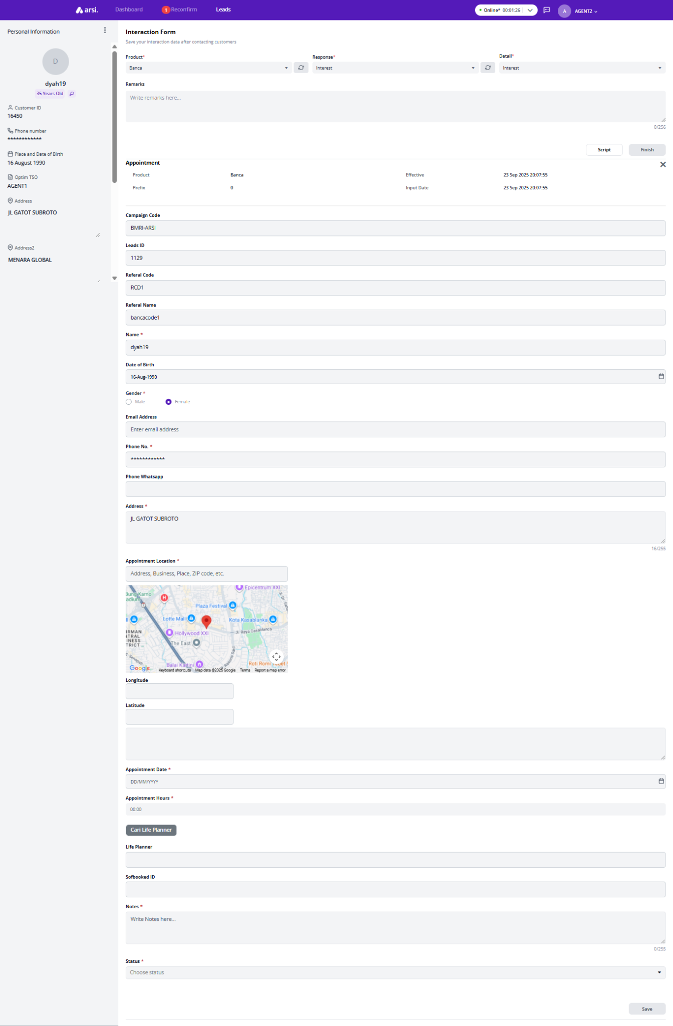

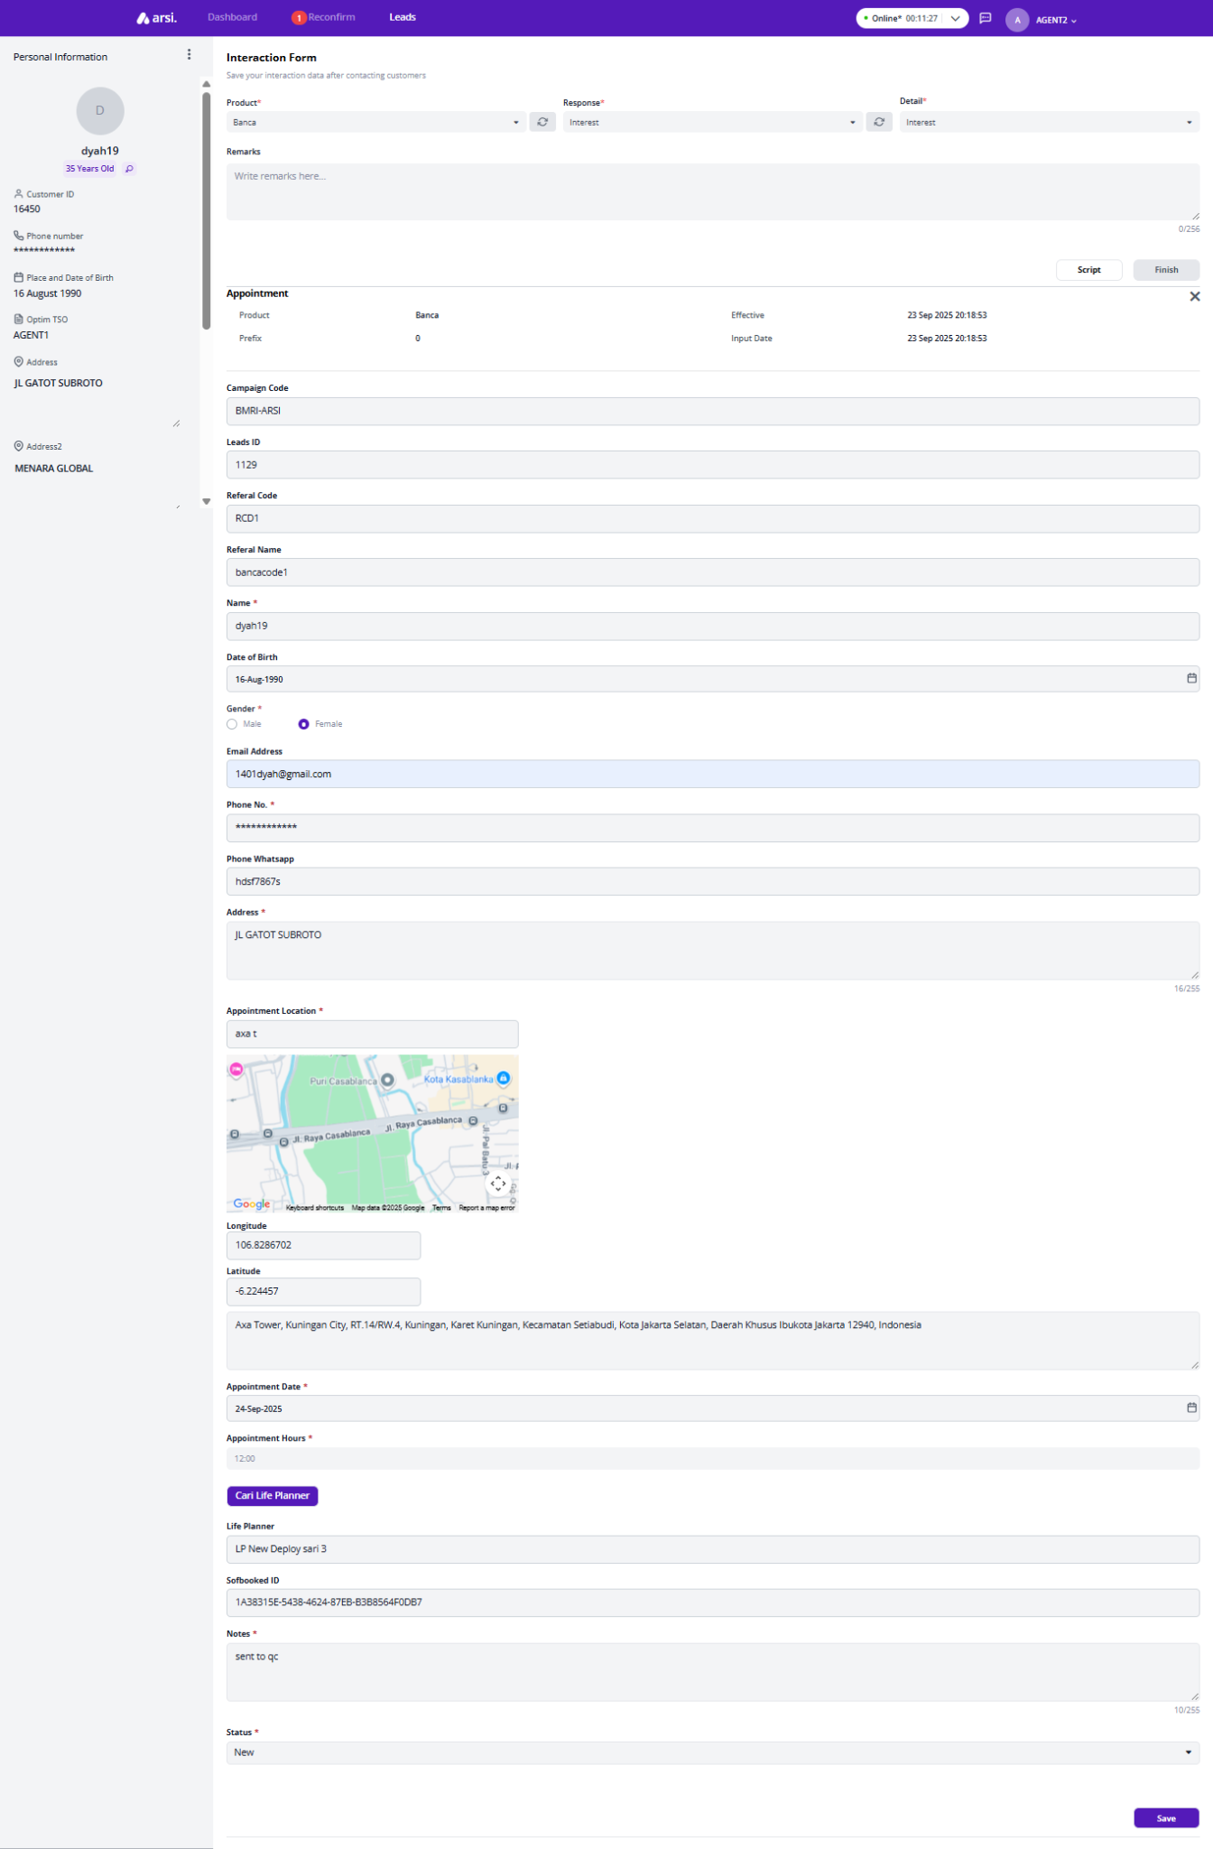

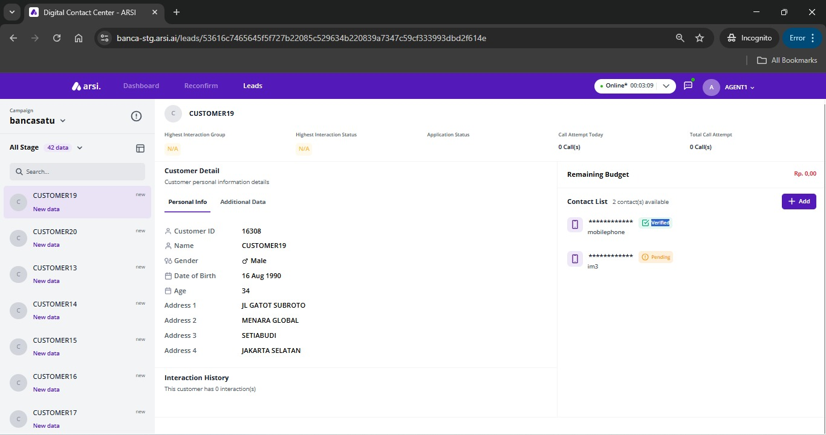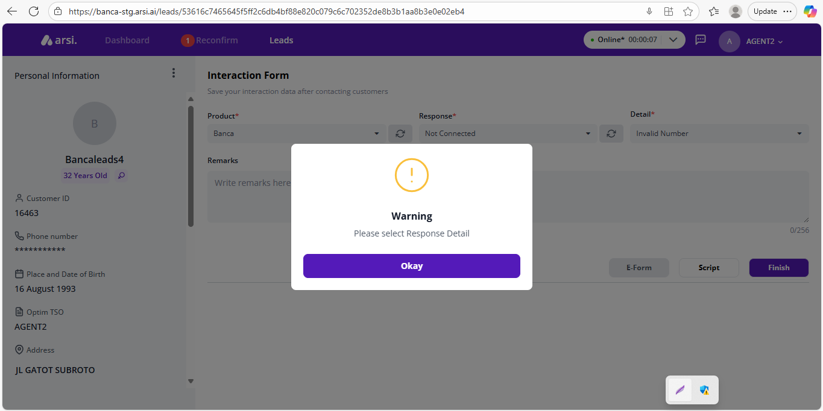

## Recall Leads

### Tab Leads

[TC 4.2.1, TC 4.2.2]

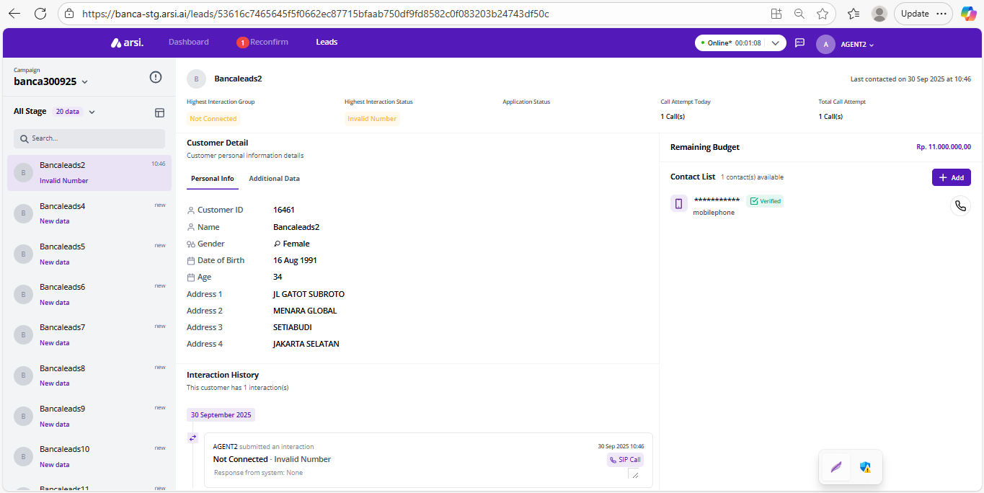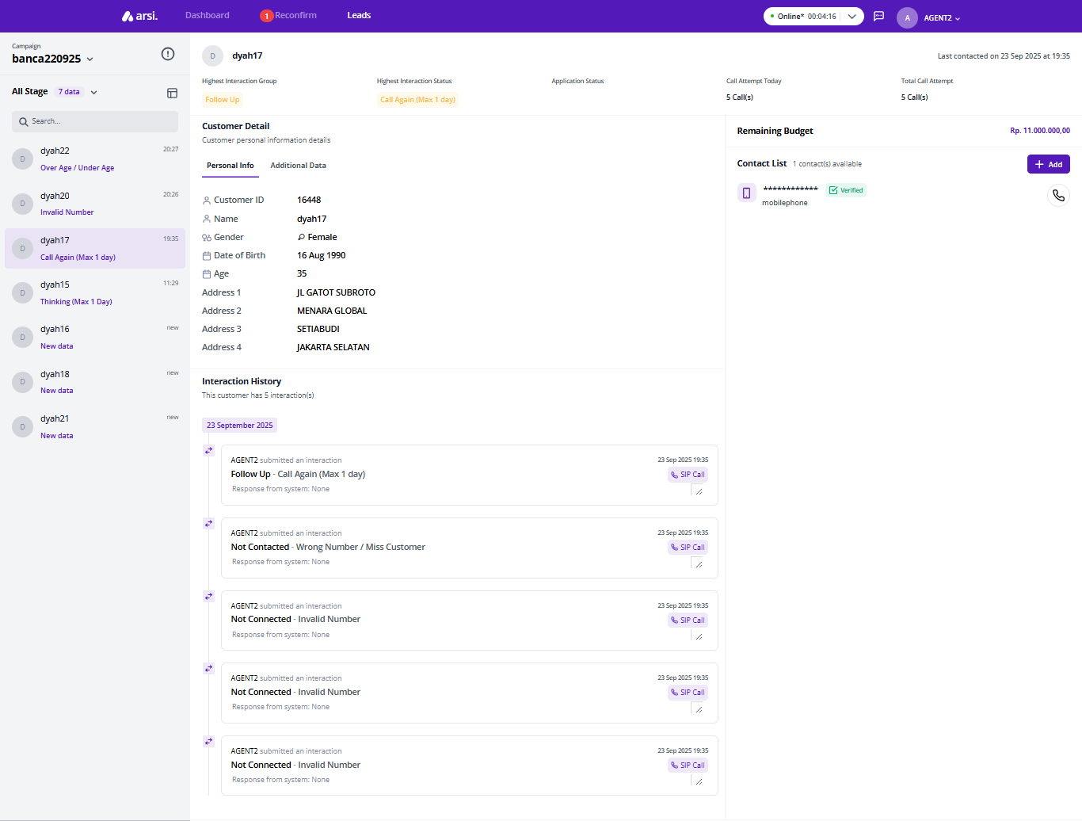

### Tab Reconfirm

[TC 4.2.3 - TC 4.2.6]

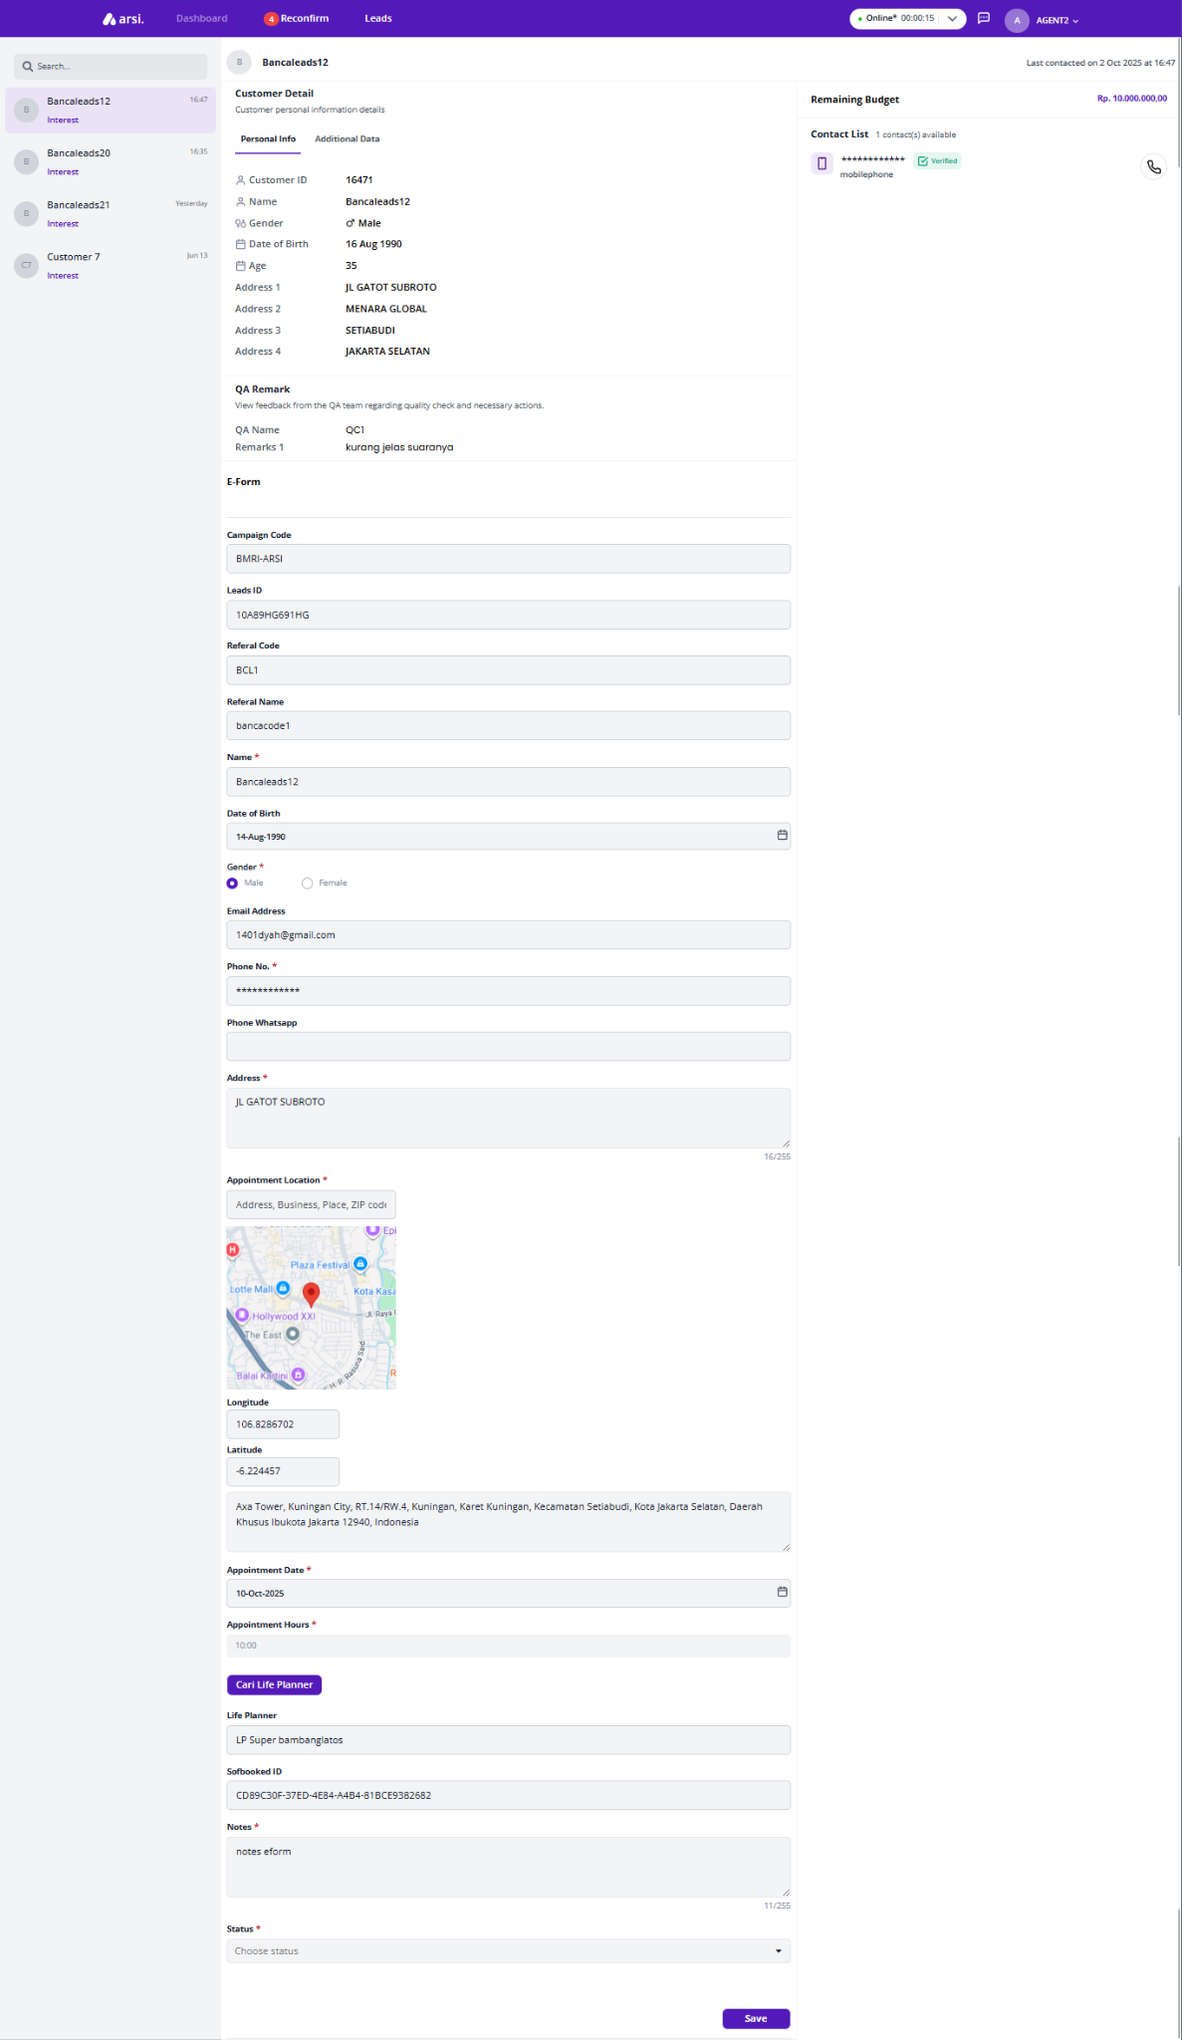

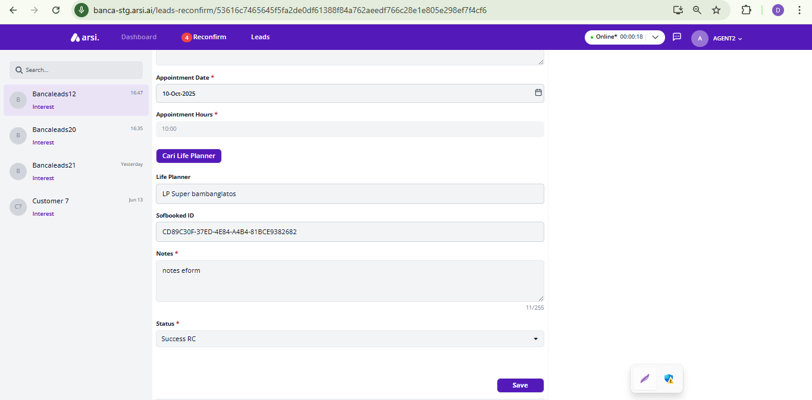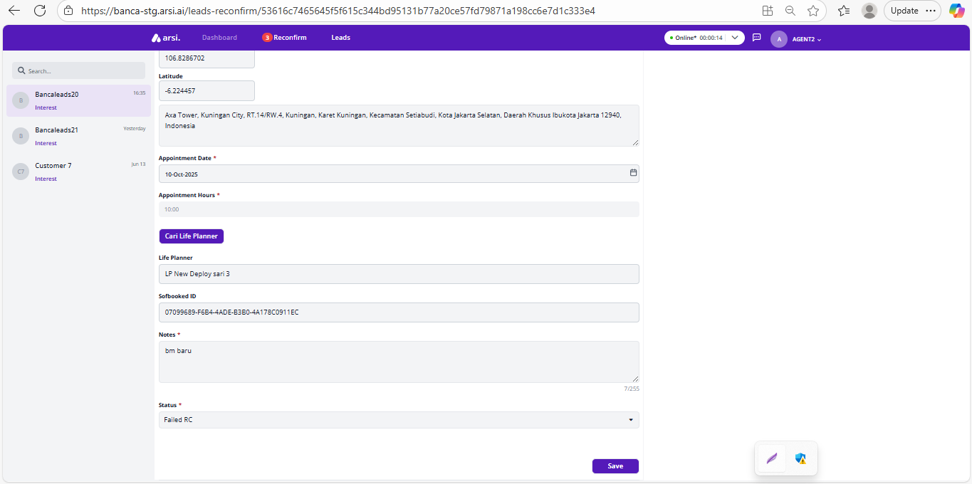

### 

## Search LP

[TC 4.3.1 - TC 4.3.5]

### Input Today Appointment

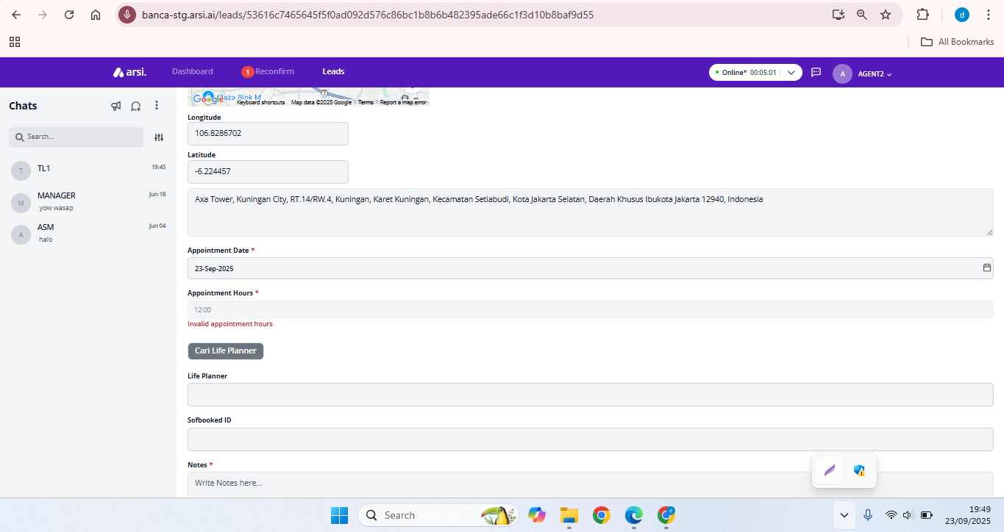

### Search LP two times

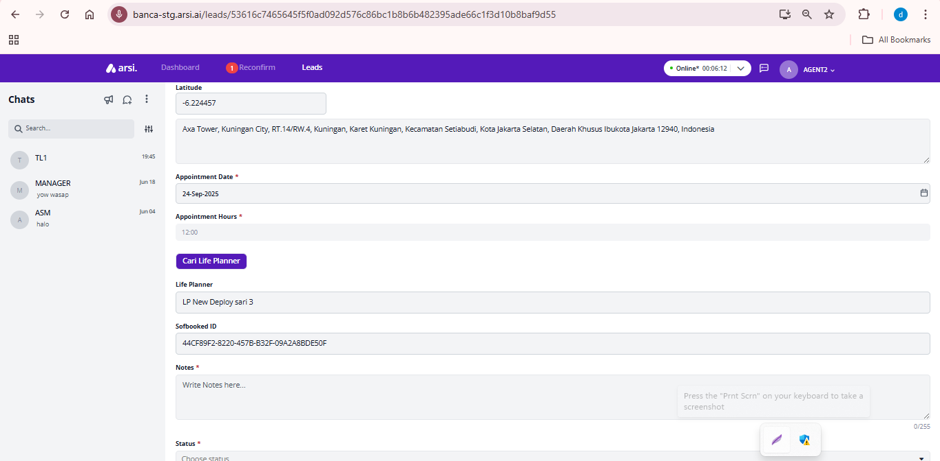

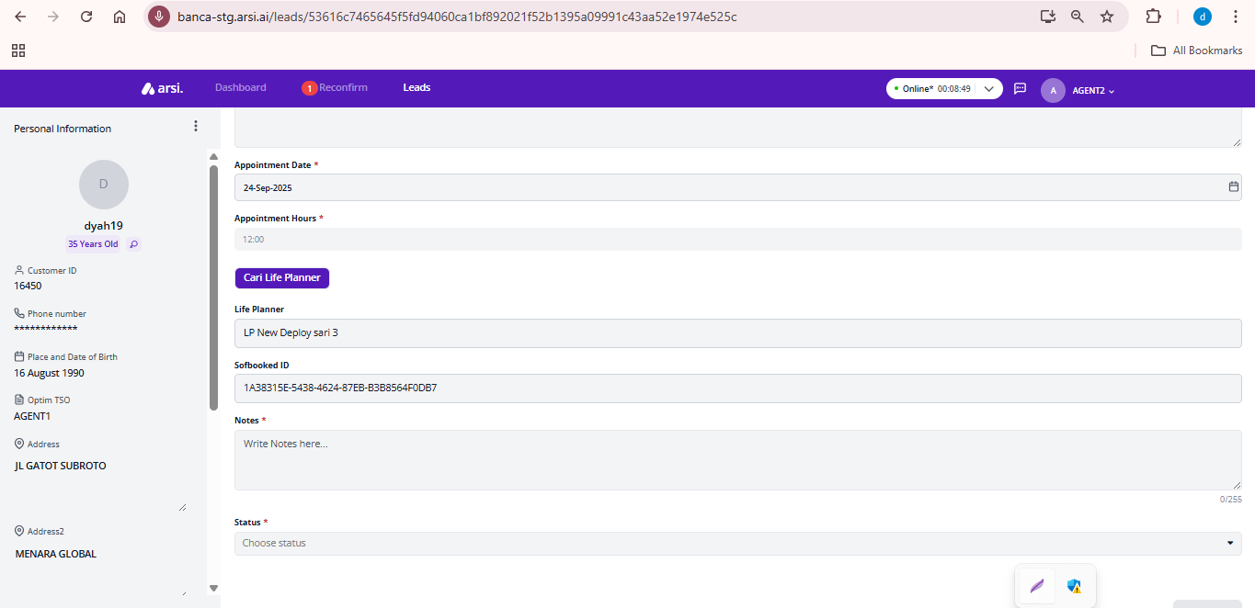



### Search LP force Condition/ clash

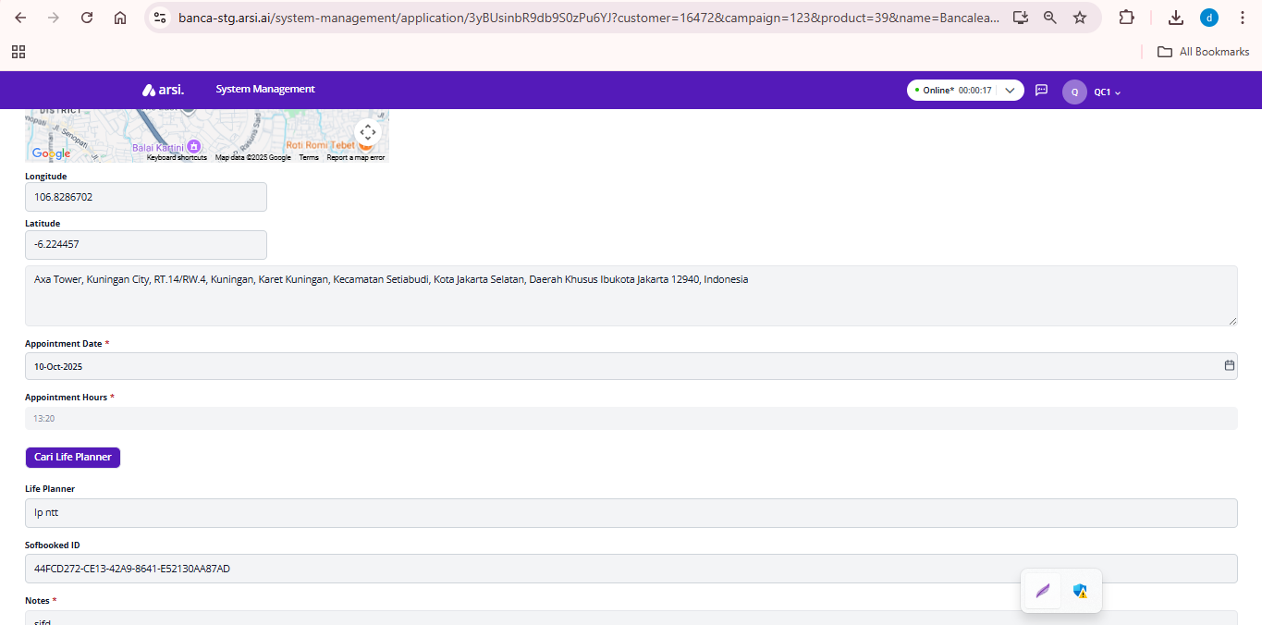

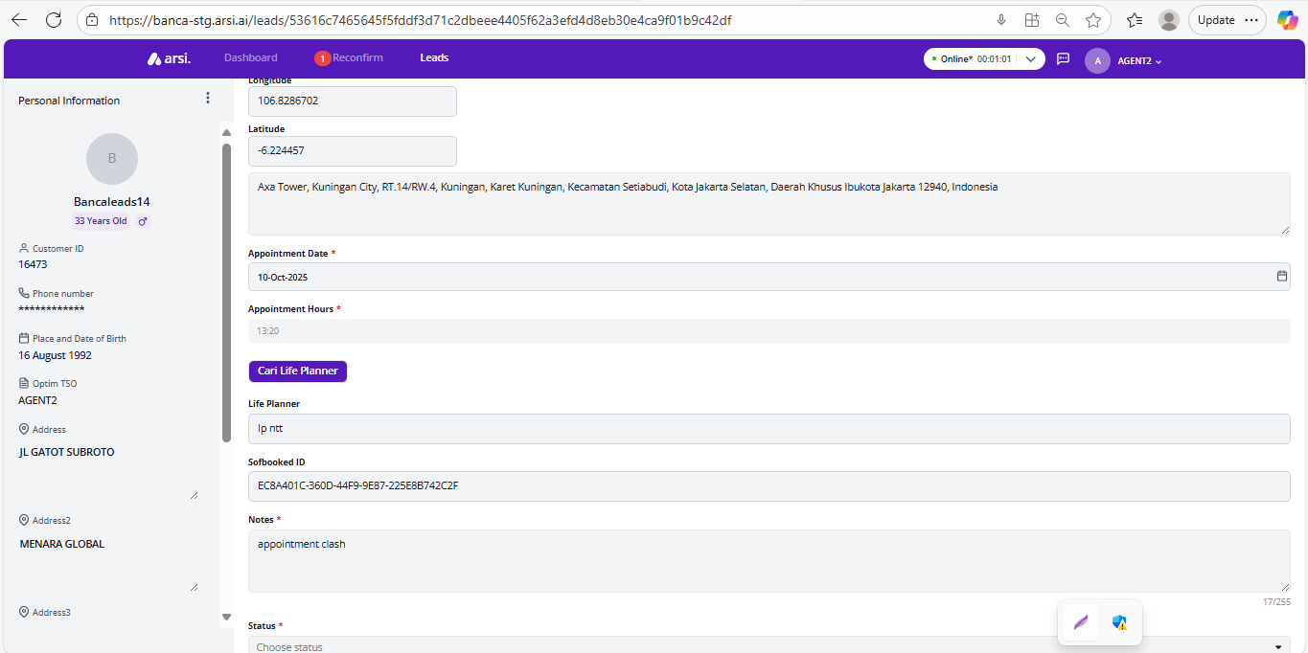

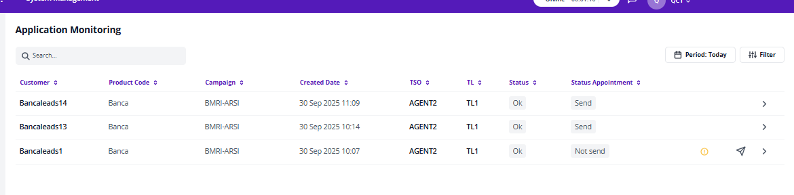

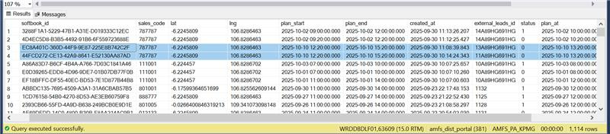

### Search LP out of max distance

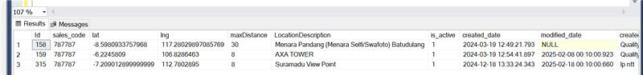

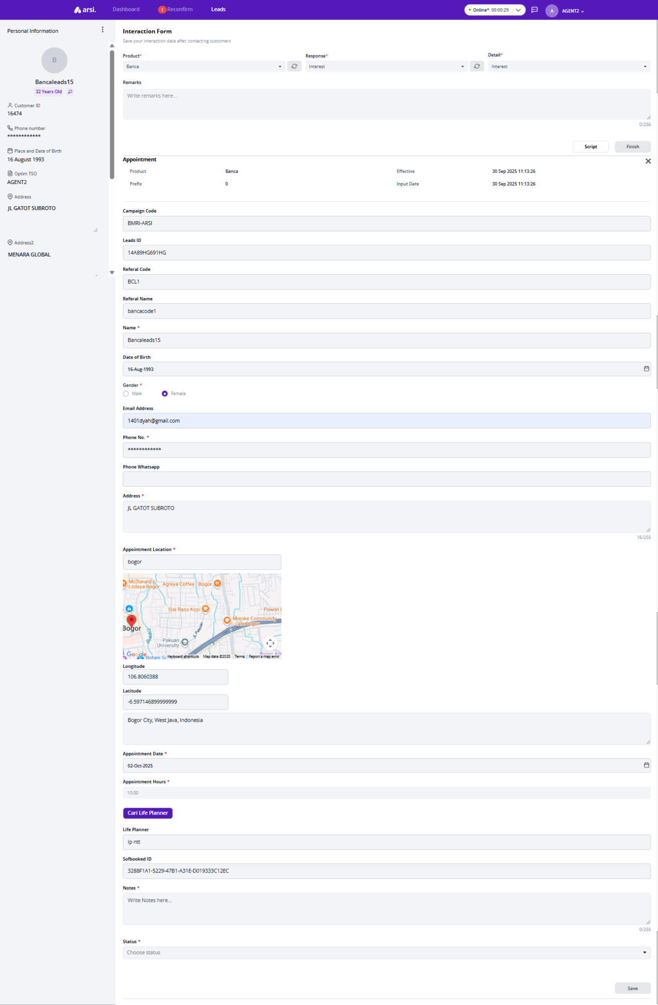

### Save Search LP



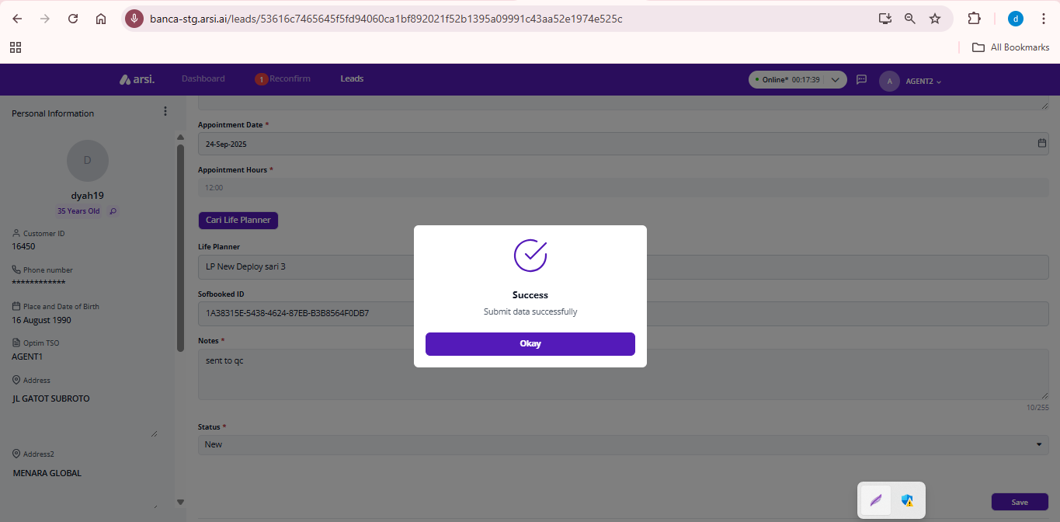

## Dasboard

[TC 4.4.1 - TC 4.4.2]

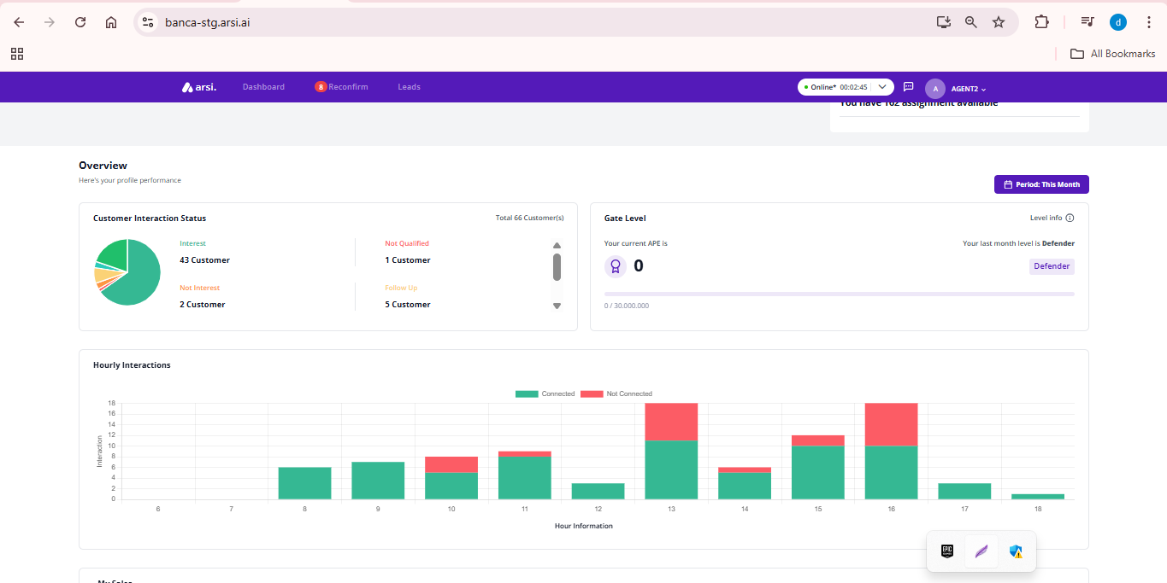

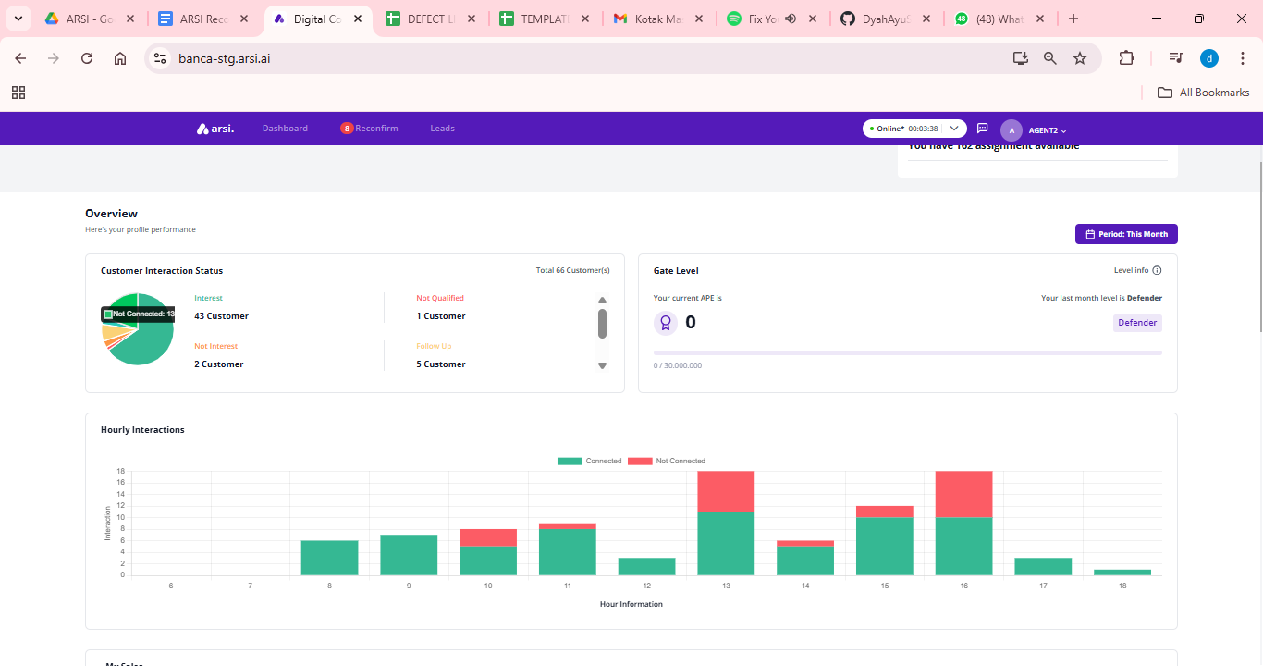

# ROLE : QC

## Accessing Application Monitoring

[TC 5.1.1 - TC 5.1.5]

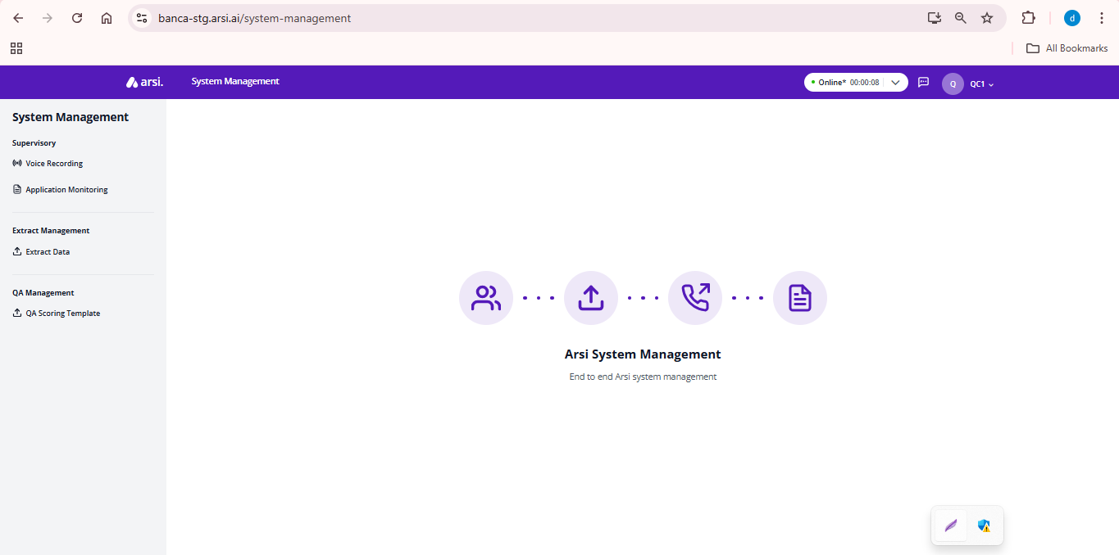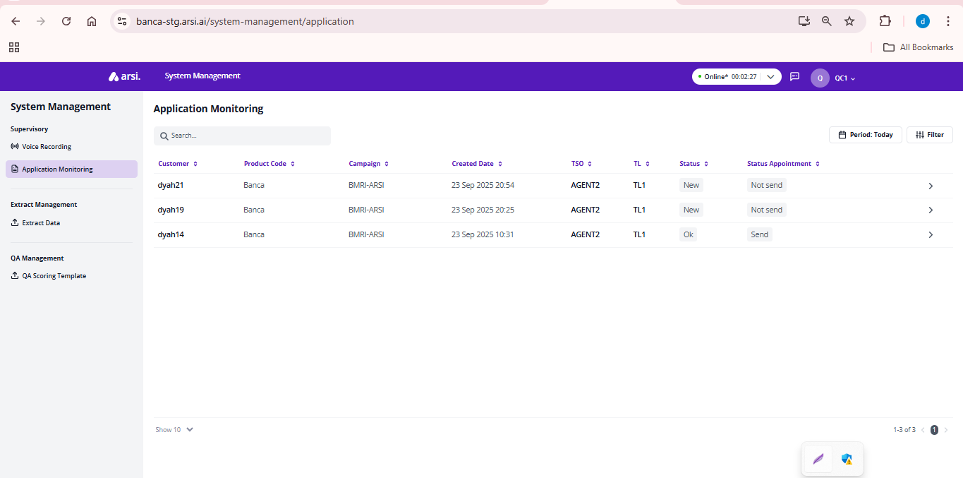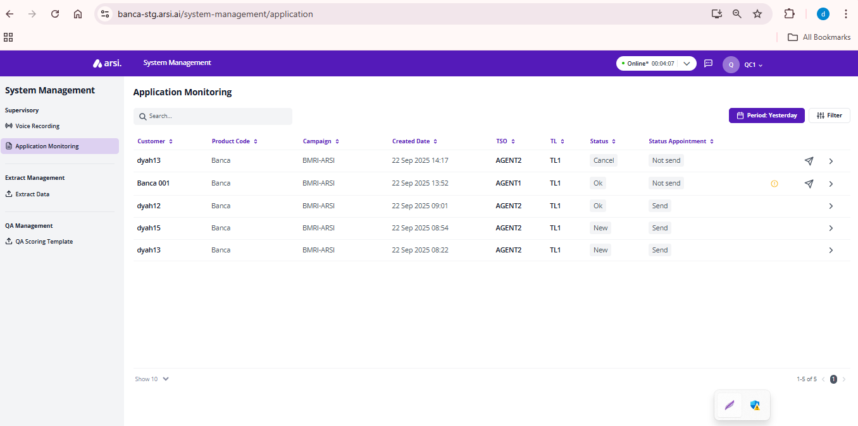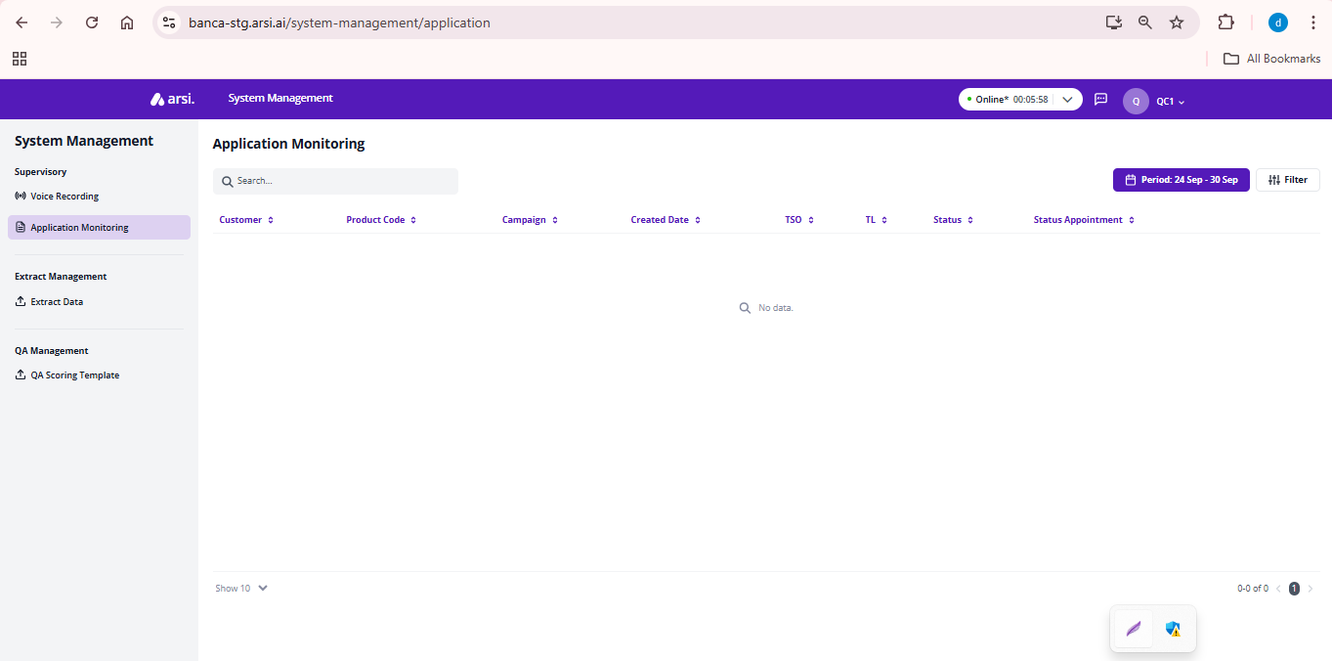

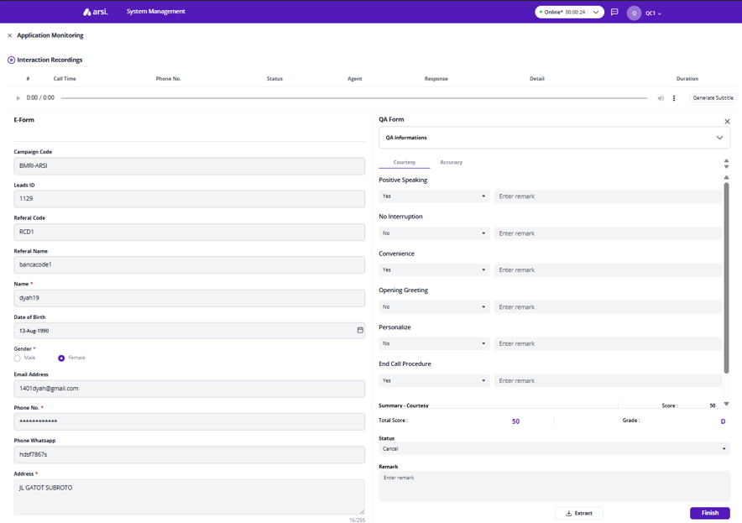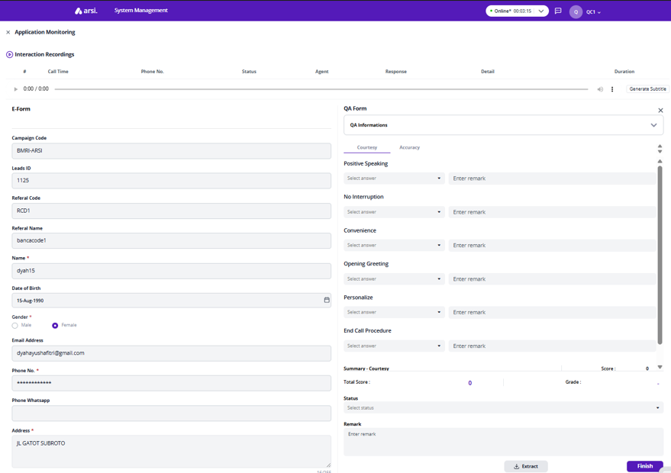

## Reviewing Interaction Recordings

[TC 5.2.1 - TC 5.2.3]

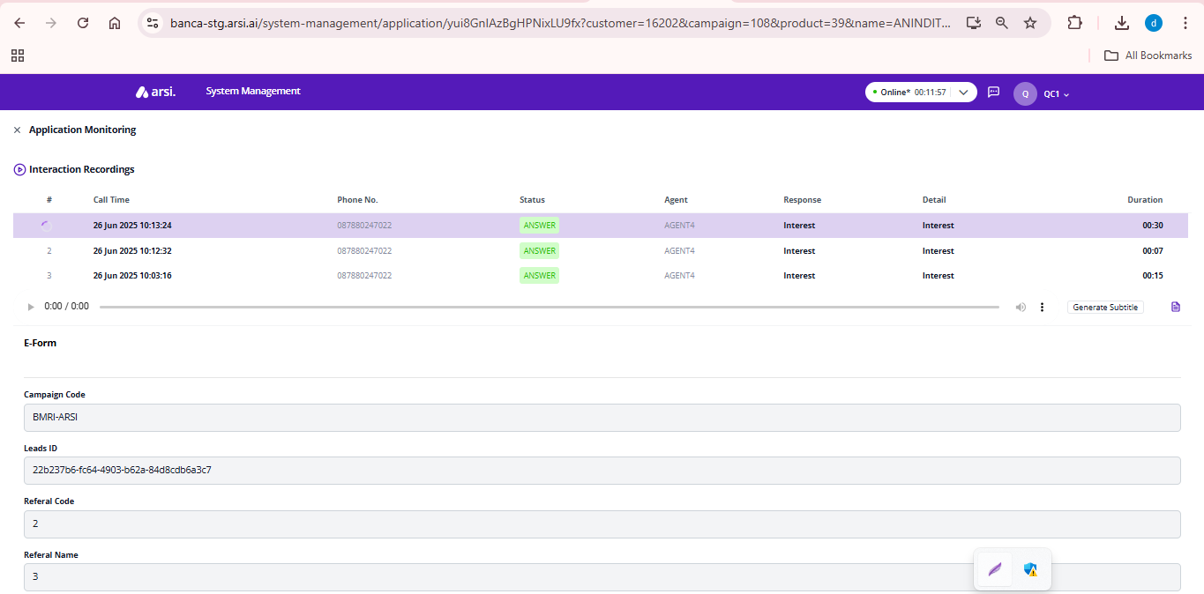

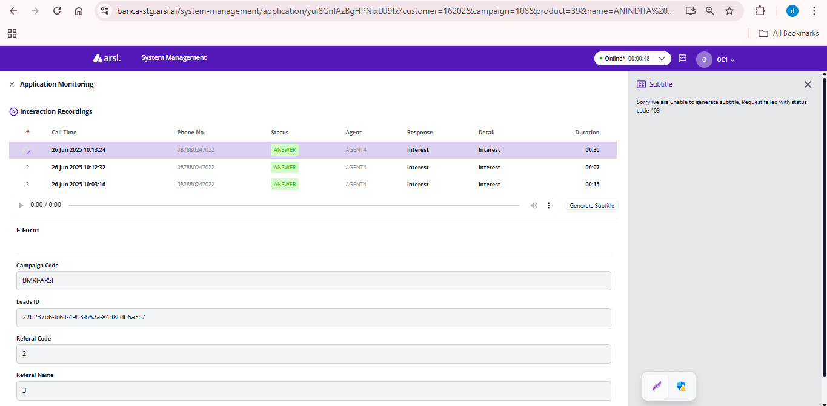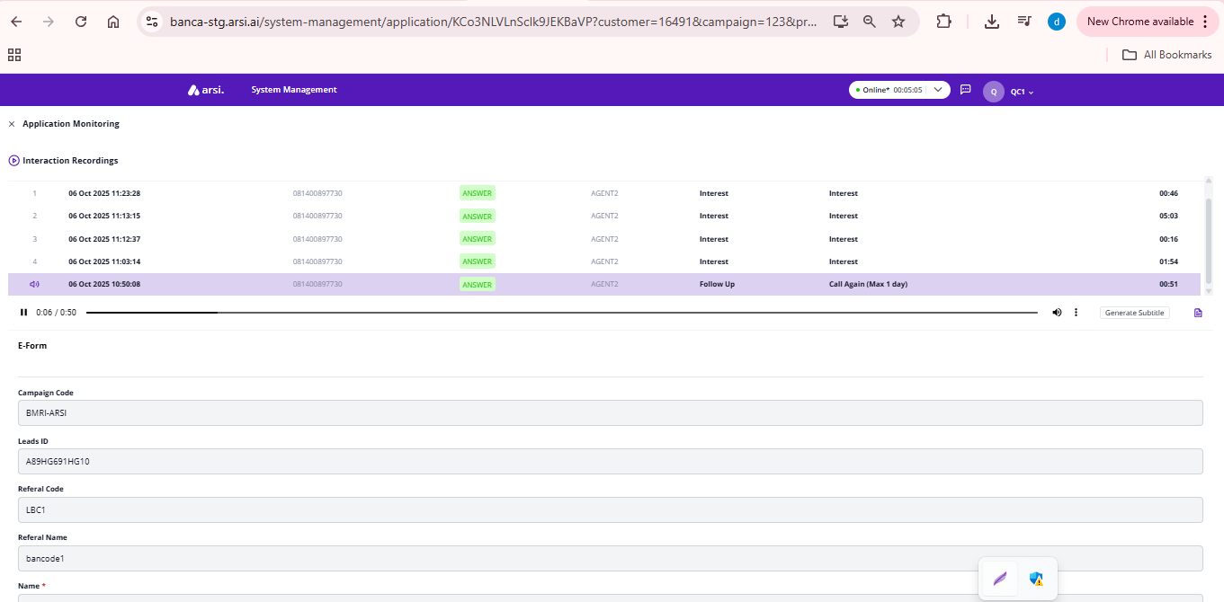

## Completing input Scoring Process

[TC 5.3.1 - TC 5.3.10]

### Open QA Form



### All Courtesy Criteria Passed

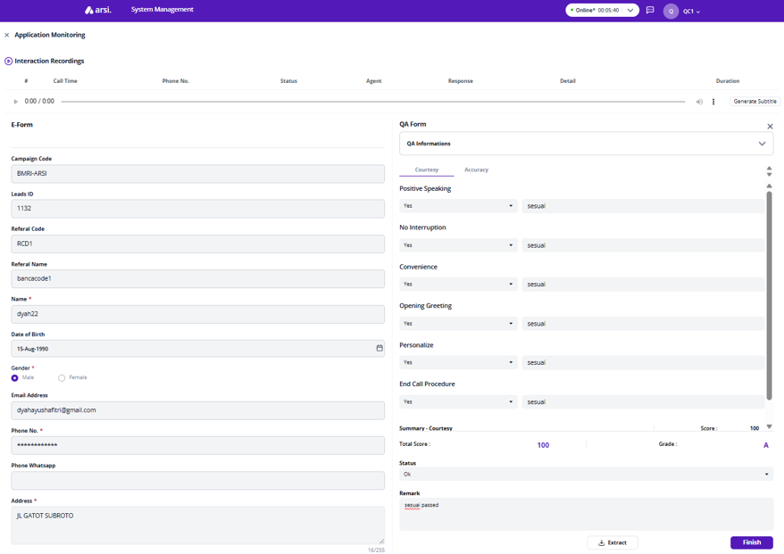

### Partial Courtesy Criteria Passed

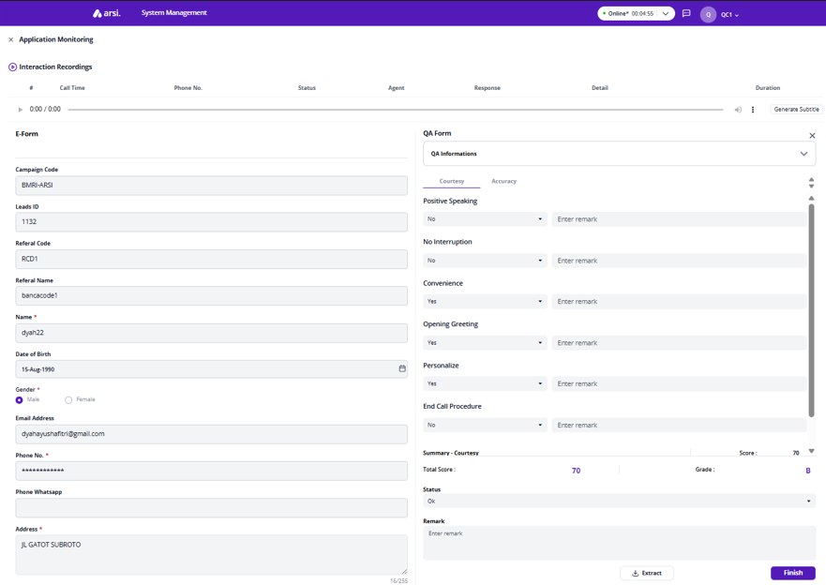

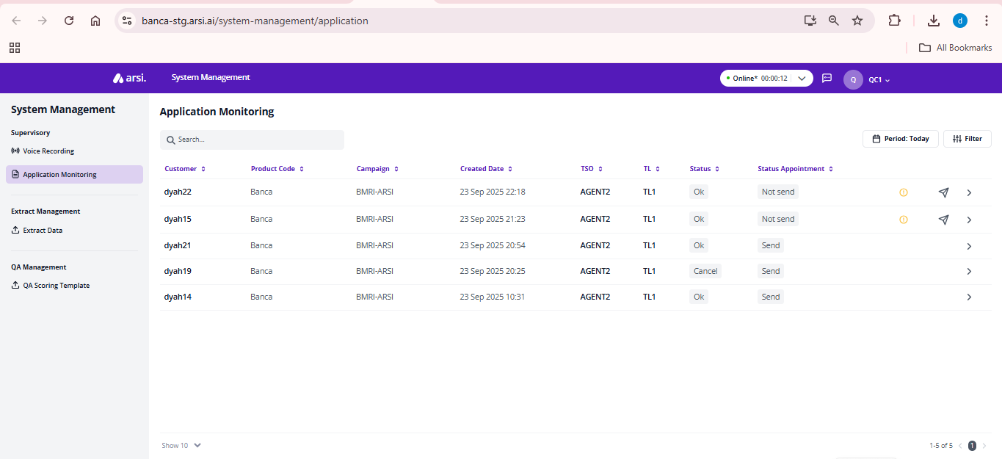

### Coutersy - Accuracy left blank

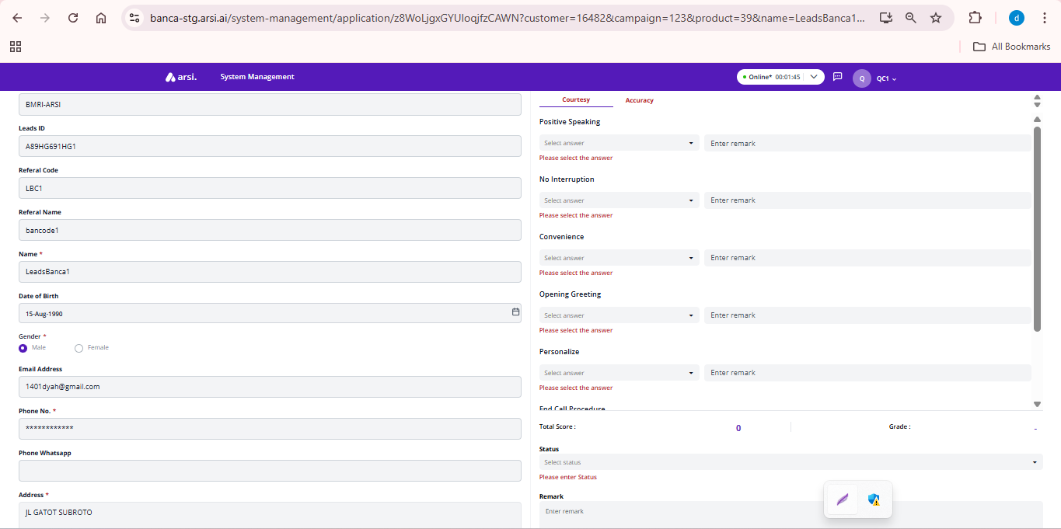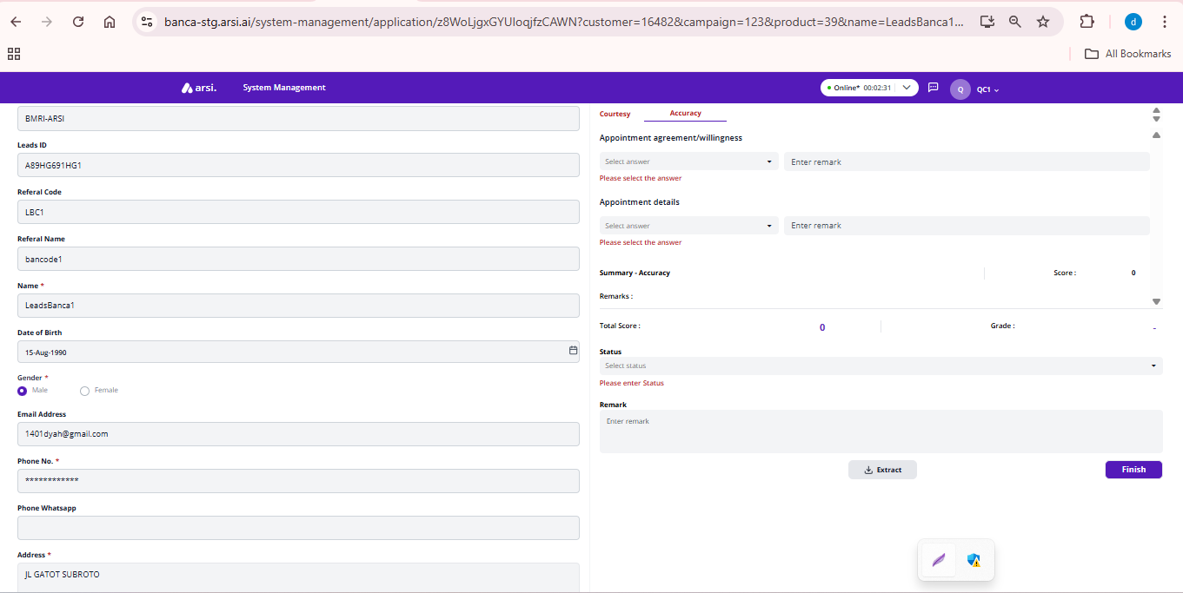

### Generate Report

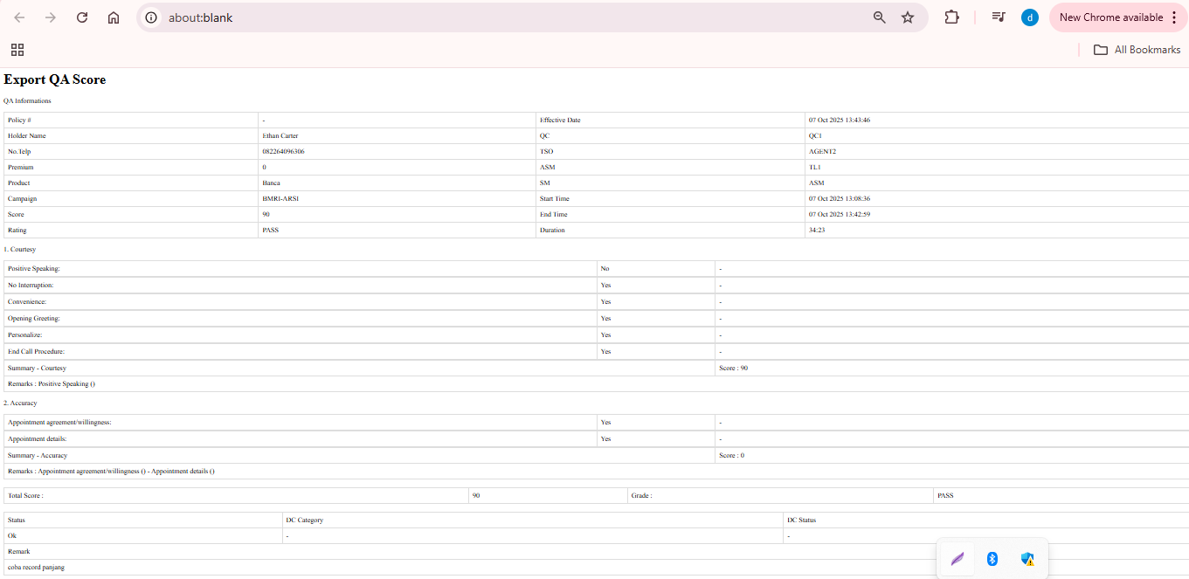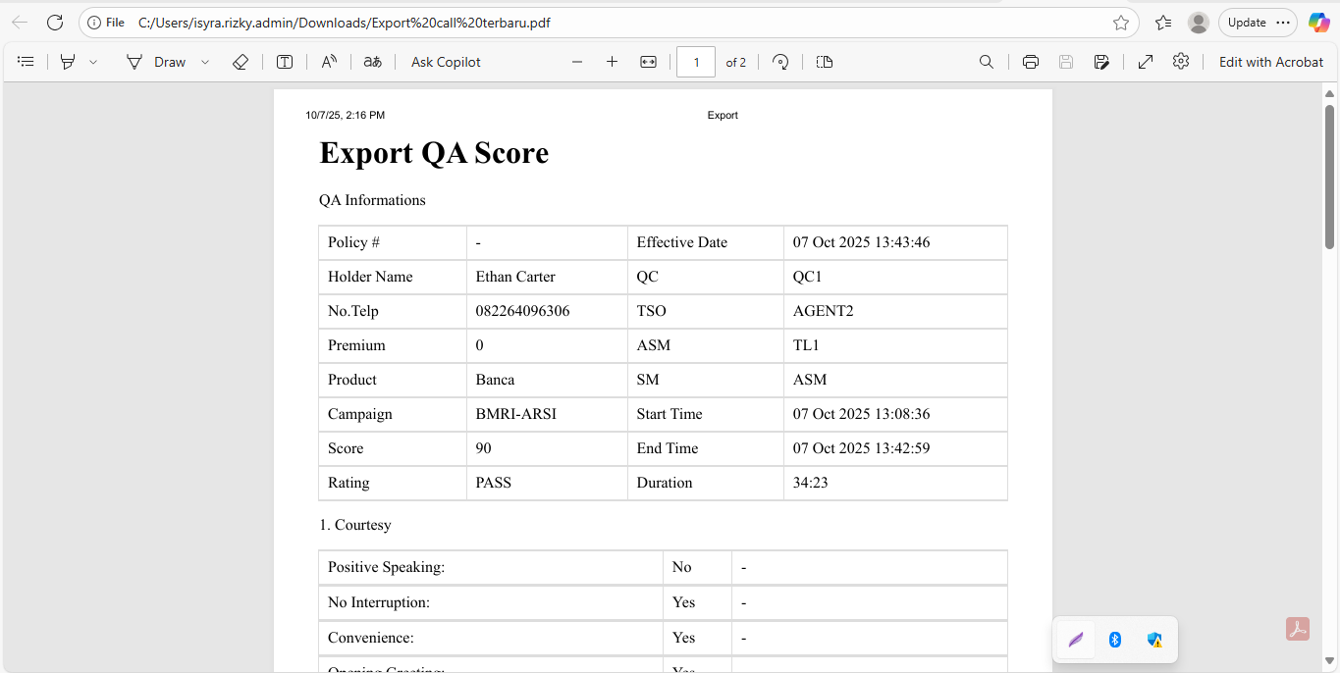

## Finish Scoring Processs

[TC 5.4.1 - TC 5.4.4]

### Status New

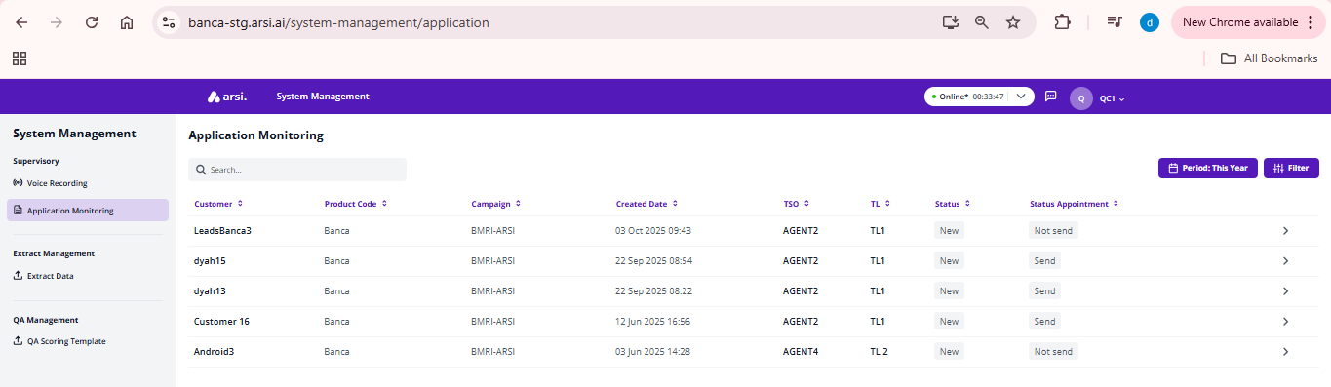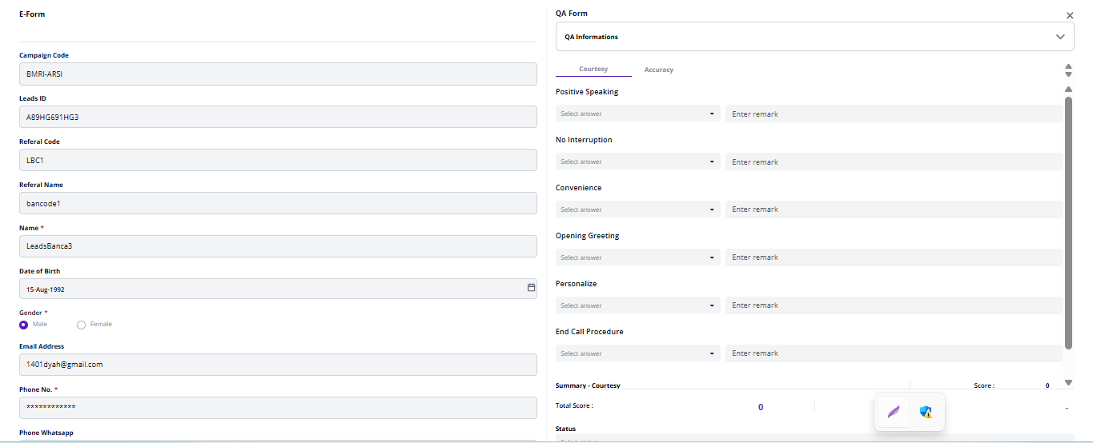

### Status OK

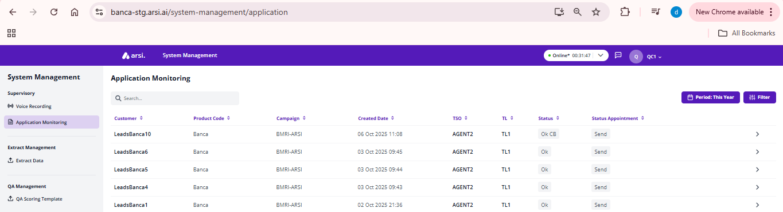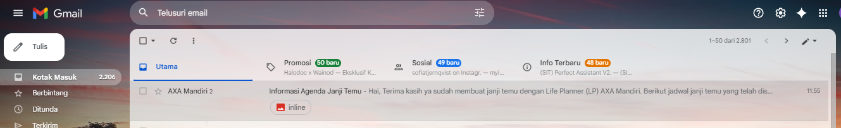

### Status Cancel

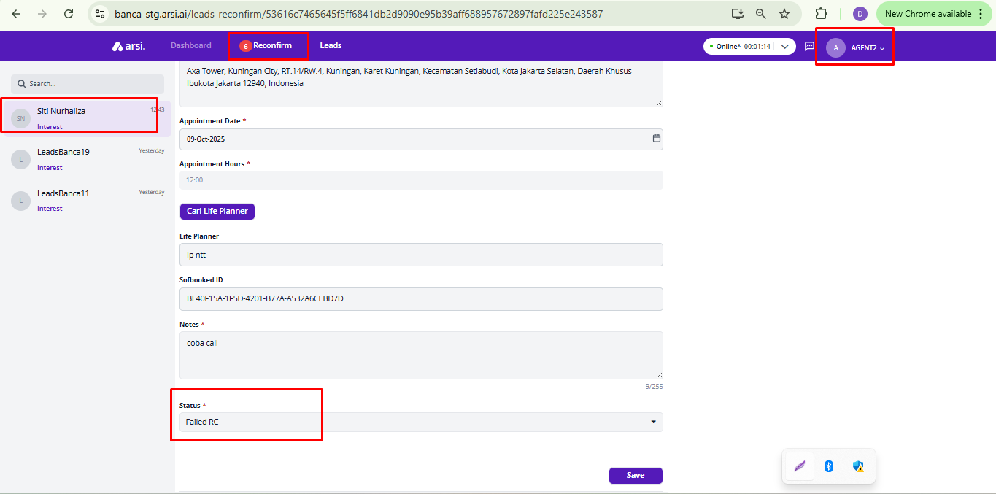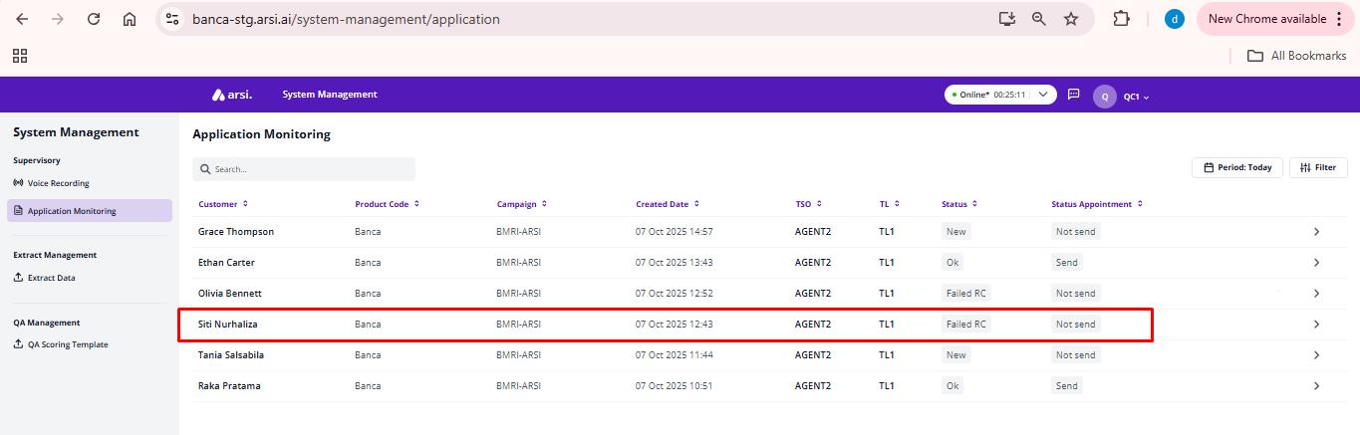

### Status Reconfirm

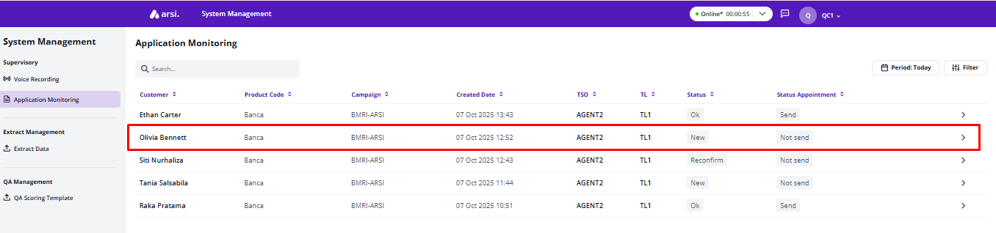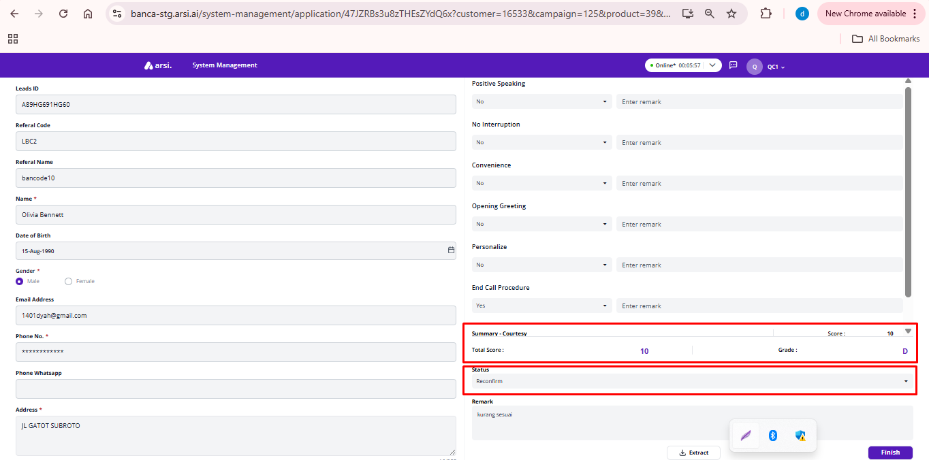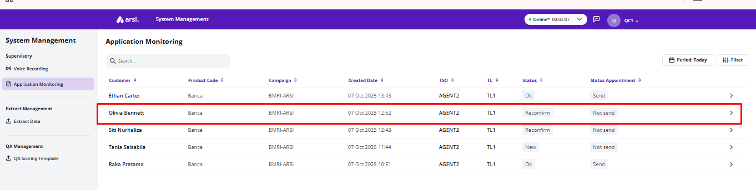

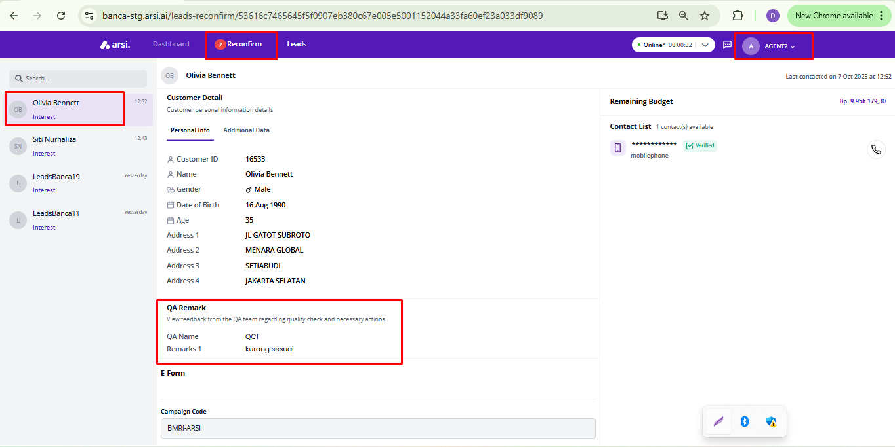

### Status Success RC to Cancel

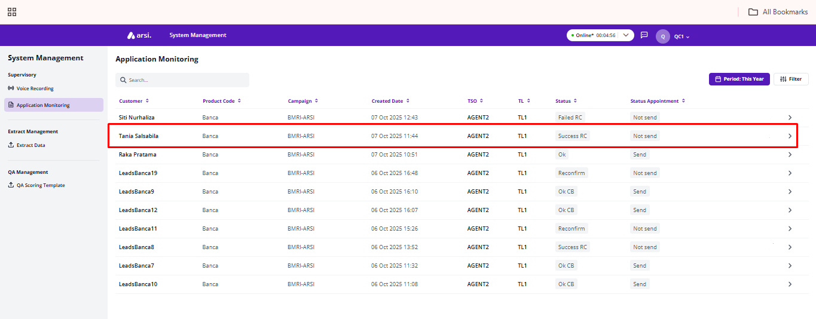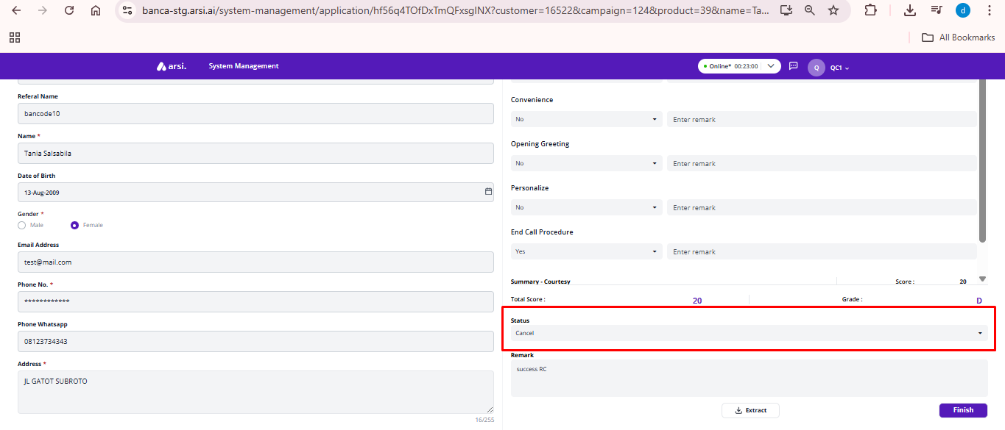

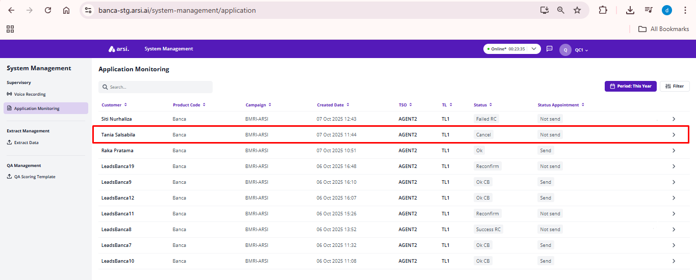

### Status Success RC to OK

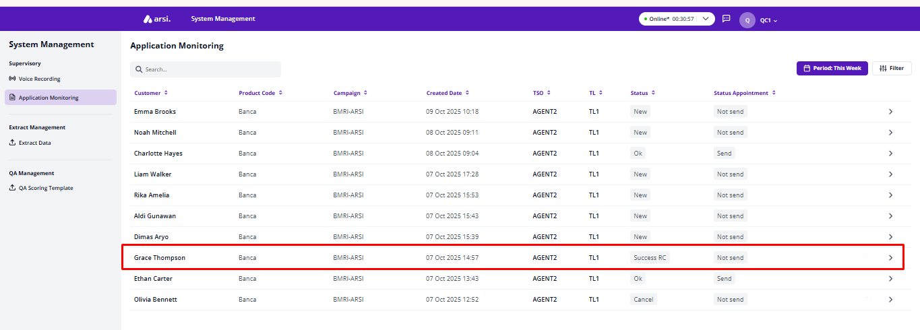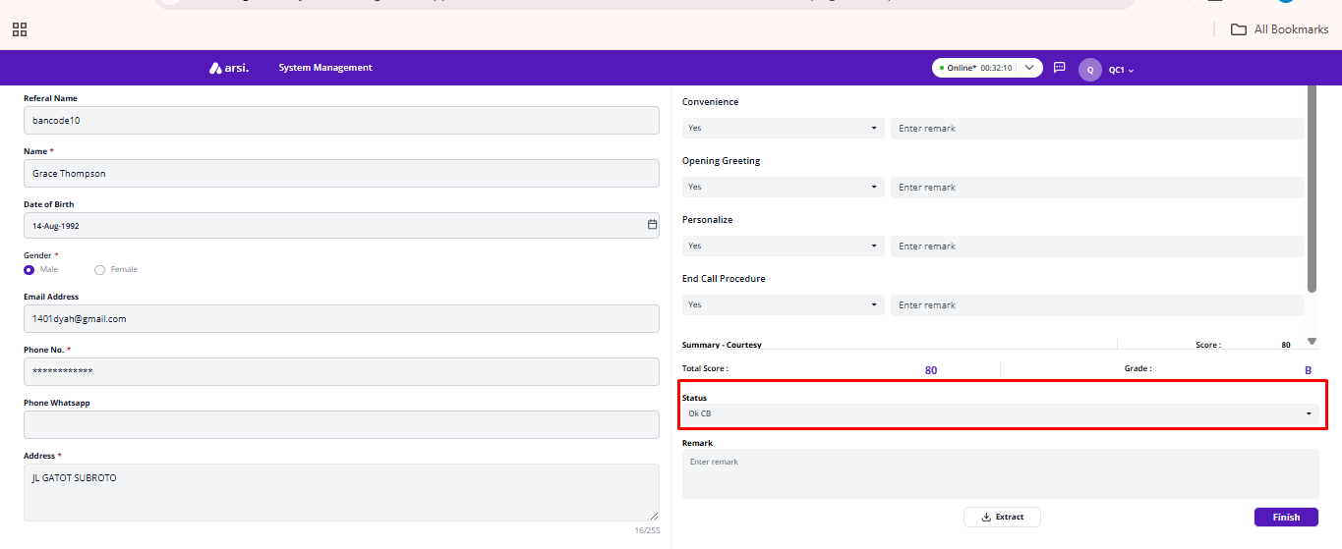

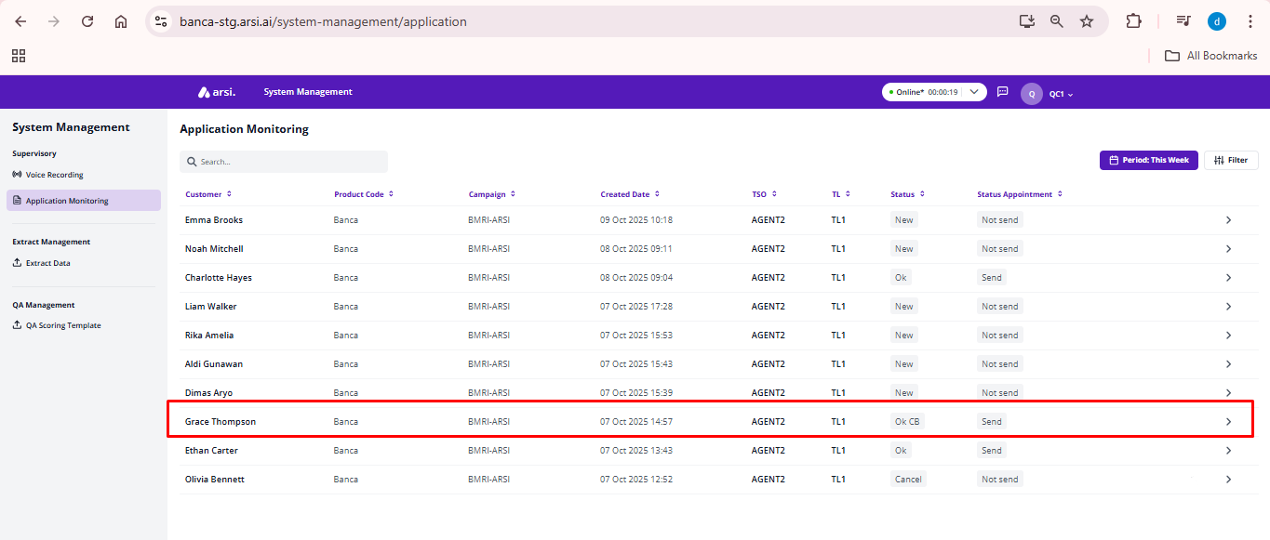

### Status Success RC to Reconfirm



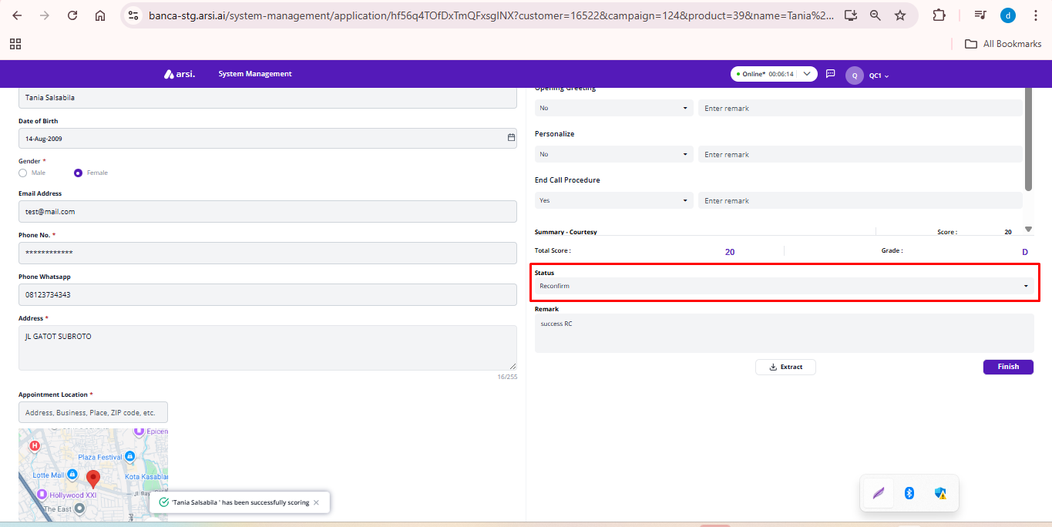

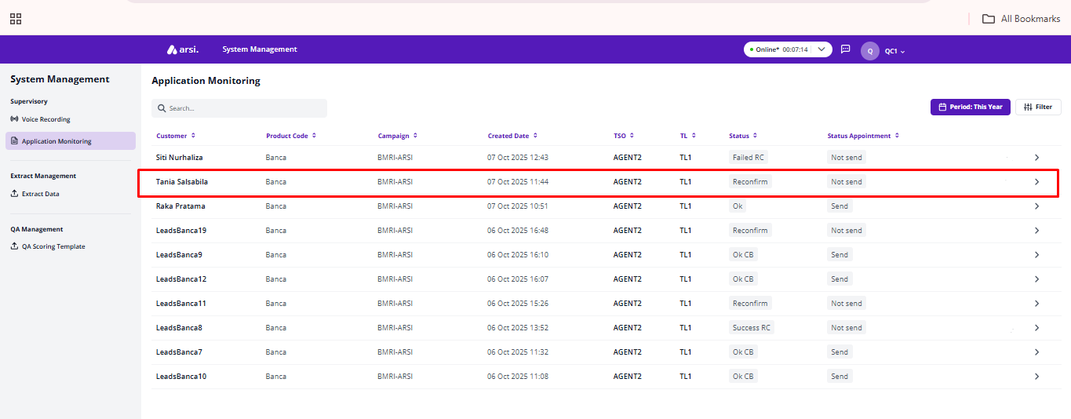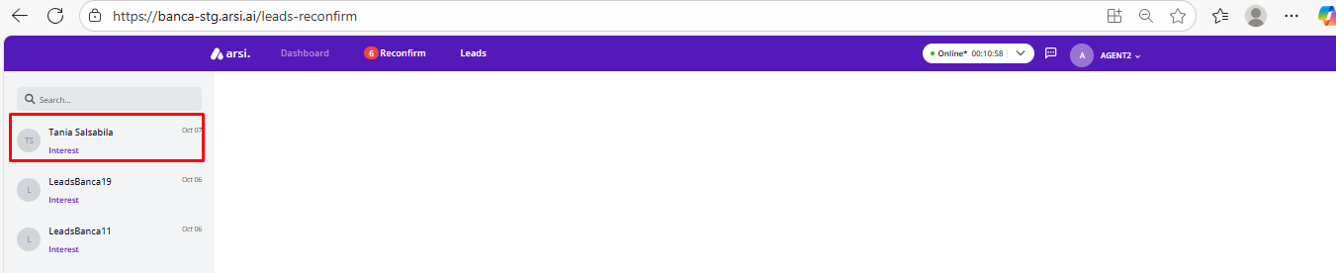

### Status Failed RC to OK

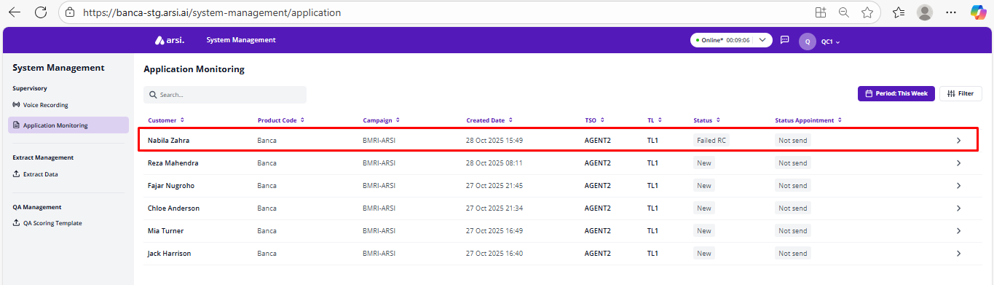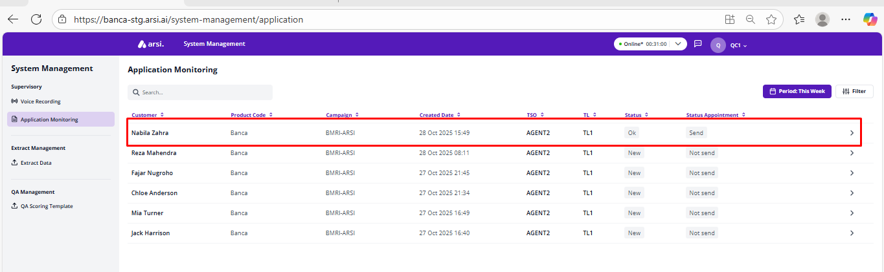

### Status Failed RC to Cancel

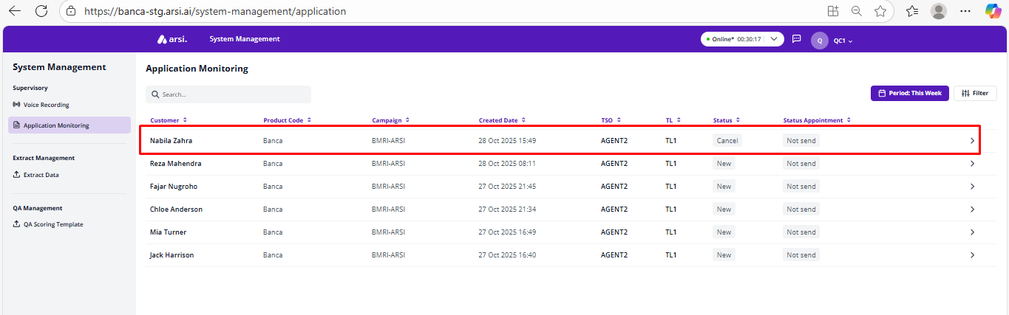

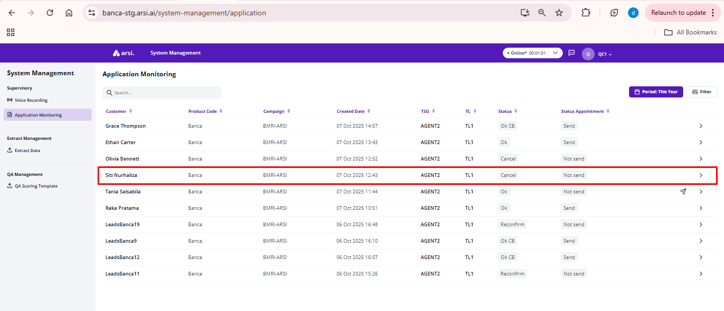

## Set Appointment

[TC 5.1.1 - TC 5.1.4]

### Scoring mandatory

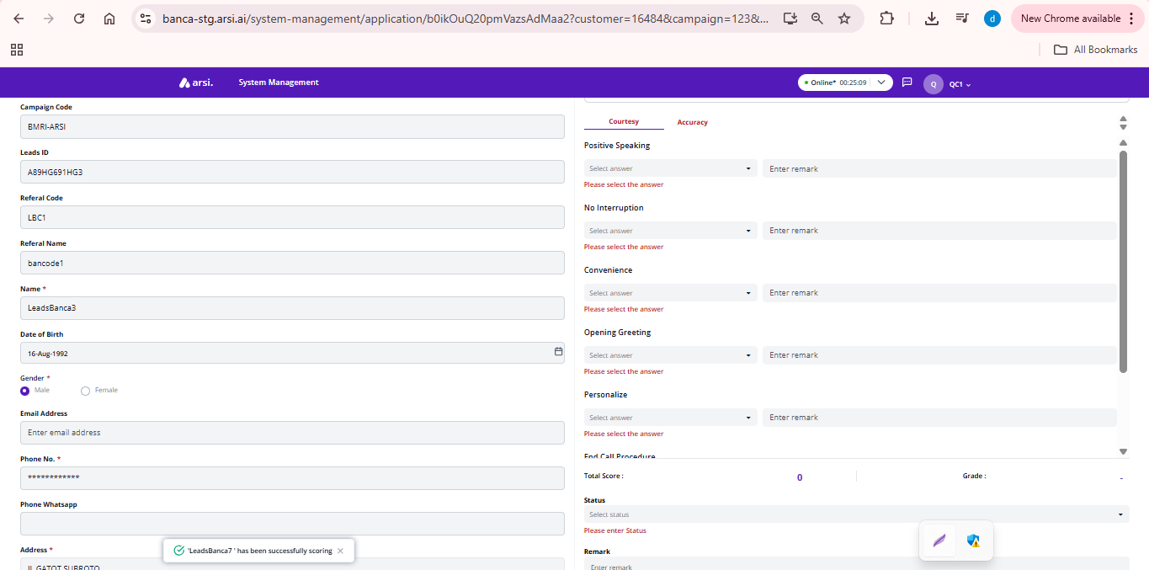

### Scoring Not mandatory

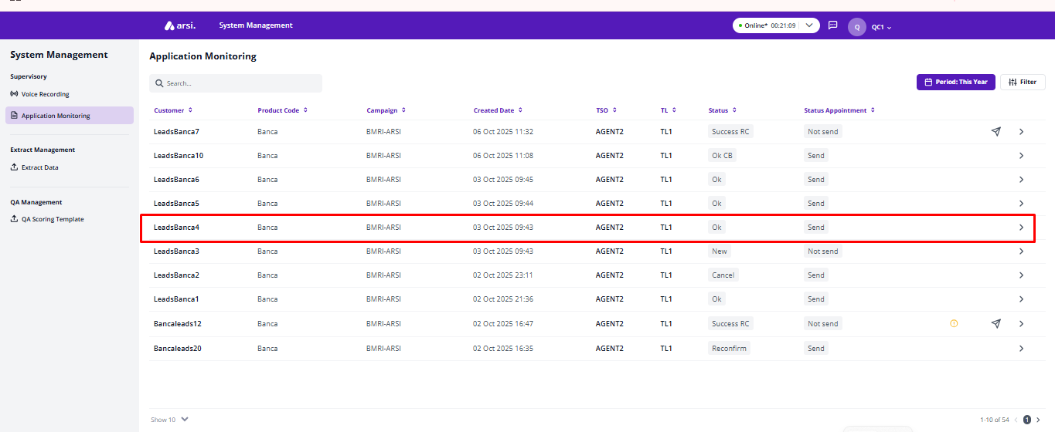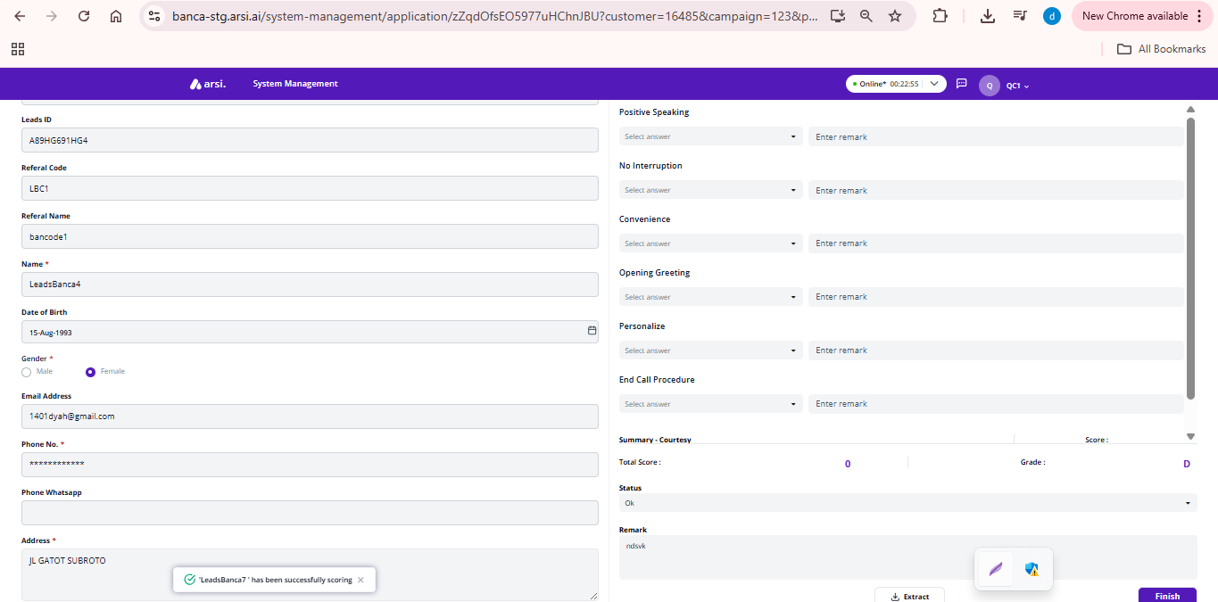

## Phone Number

[TC 5.1.1 - TC 5.1.4]

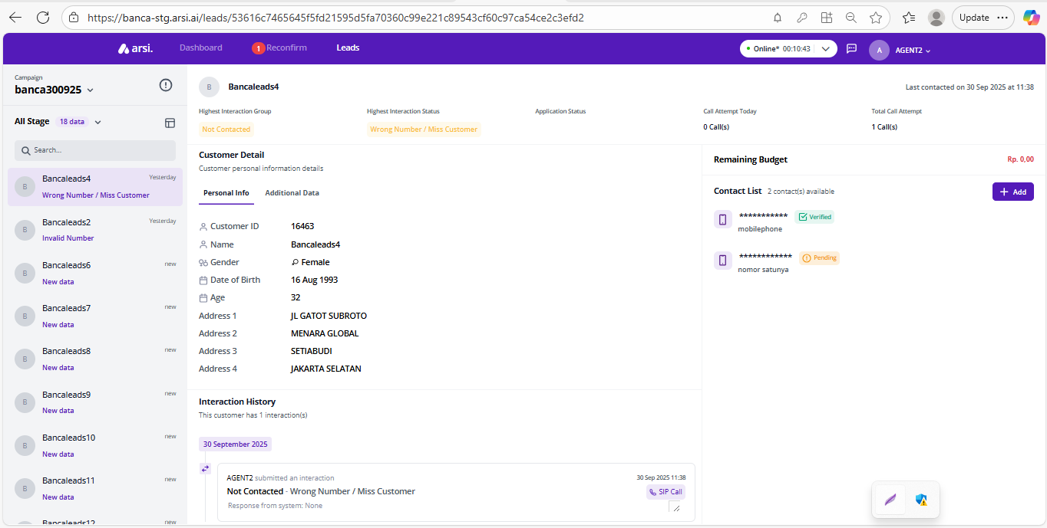

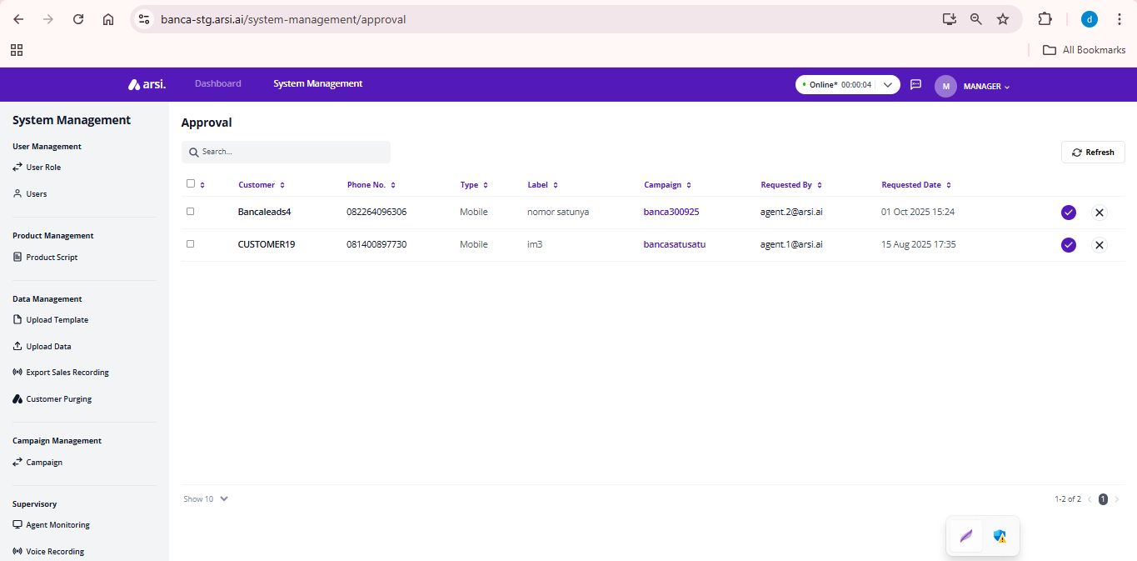

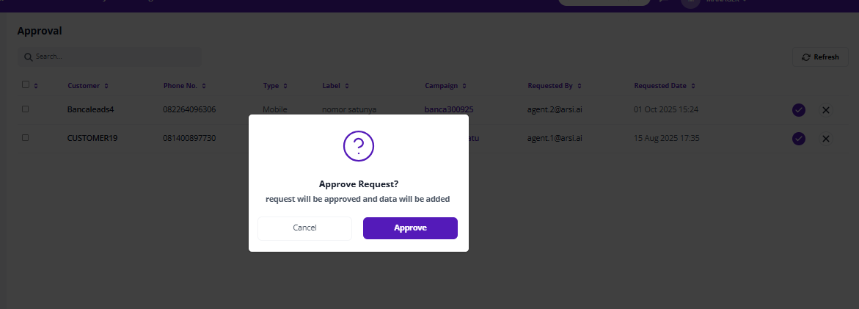

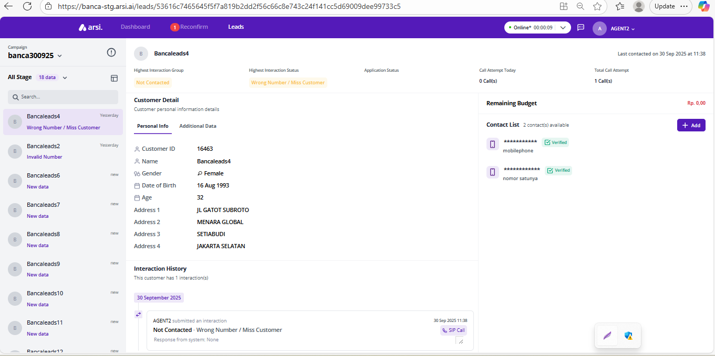

# Sync Leads Monitoring

### Leads Monitoring

[TC 6.1.1 - TC 6.1.4]

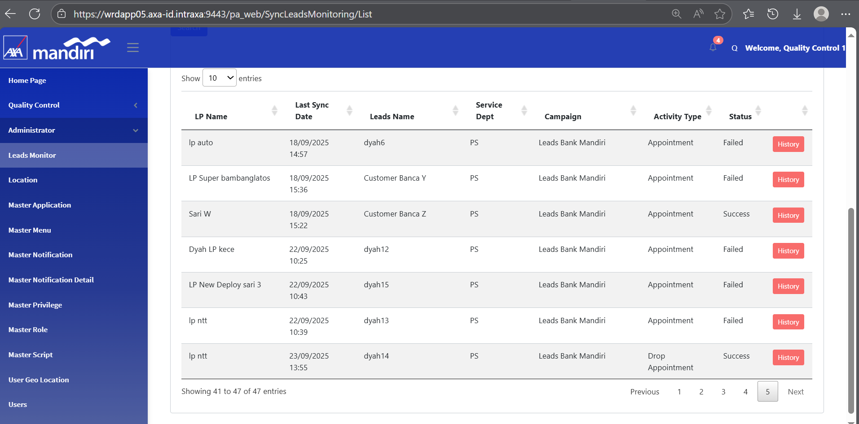

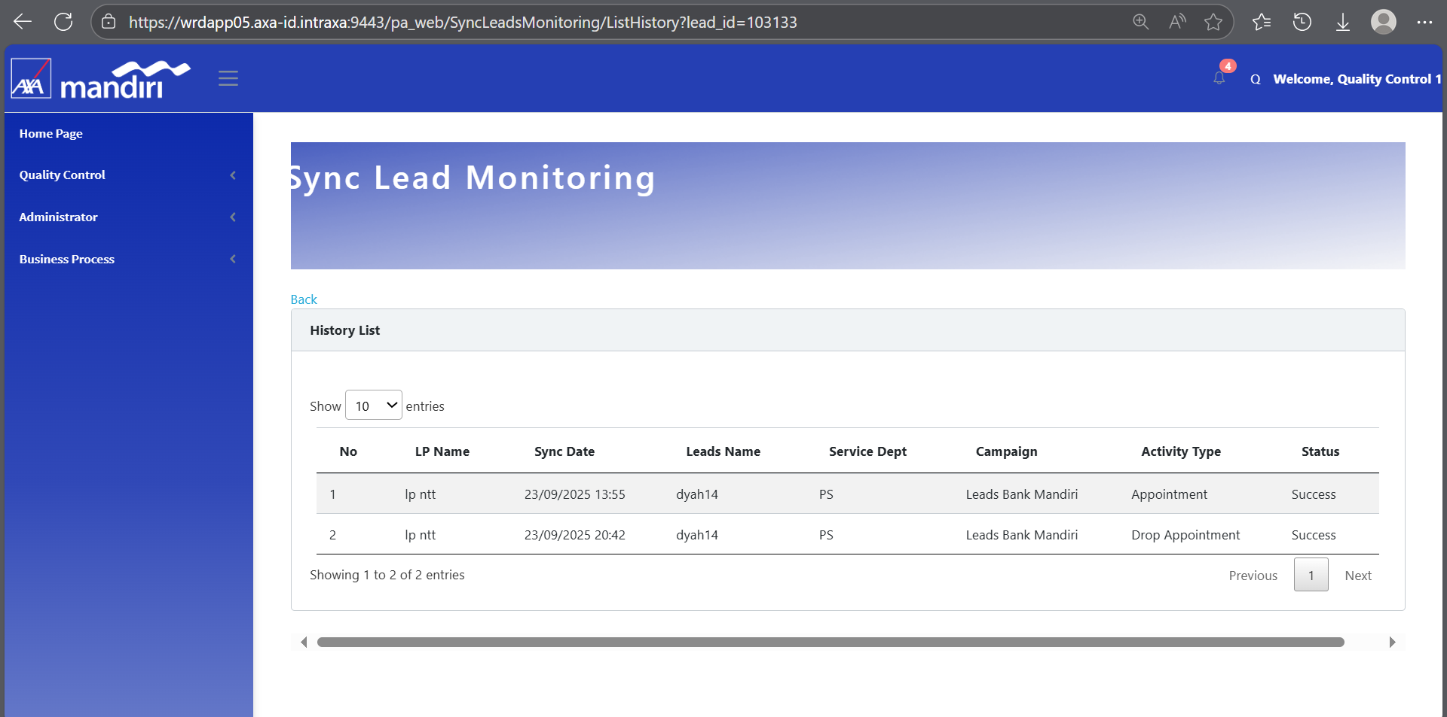

# ROLE : LIFE PLANNER

## Dashboard page

### Total Leads

[TC 7.1.1 - TC 7.1.5]

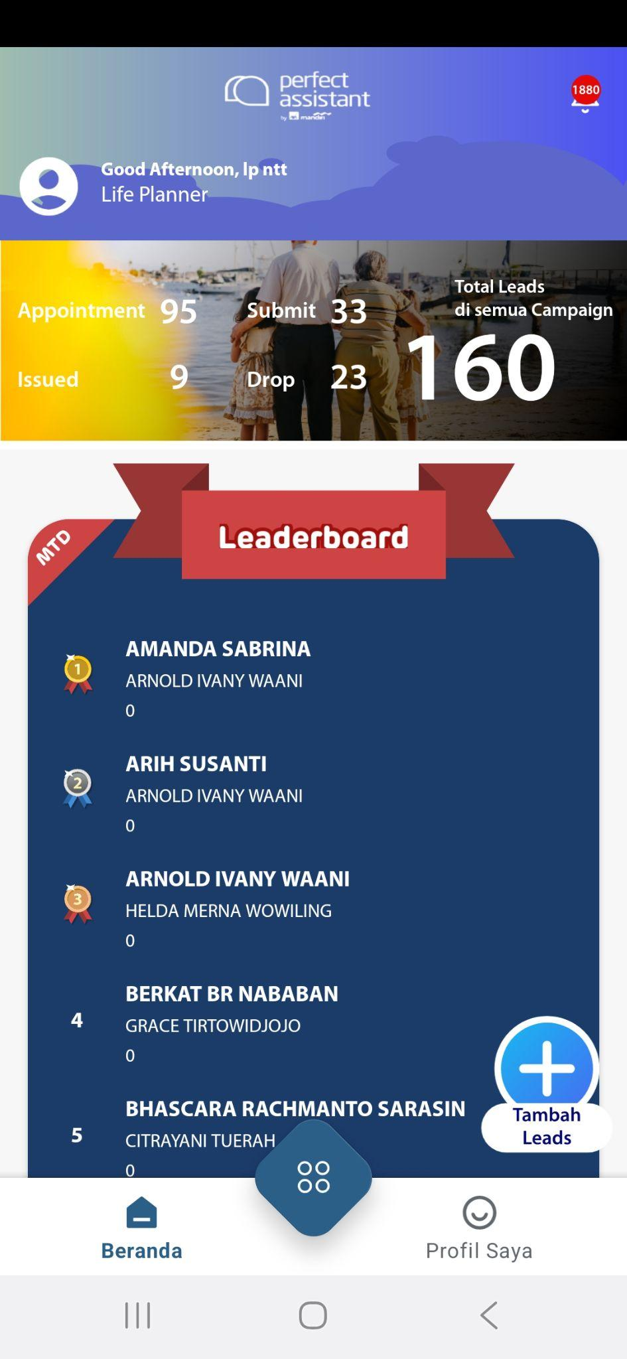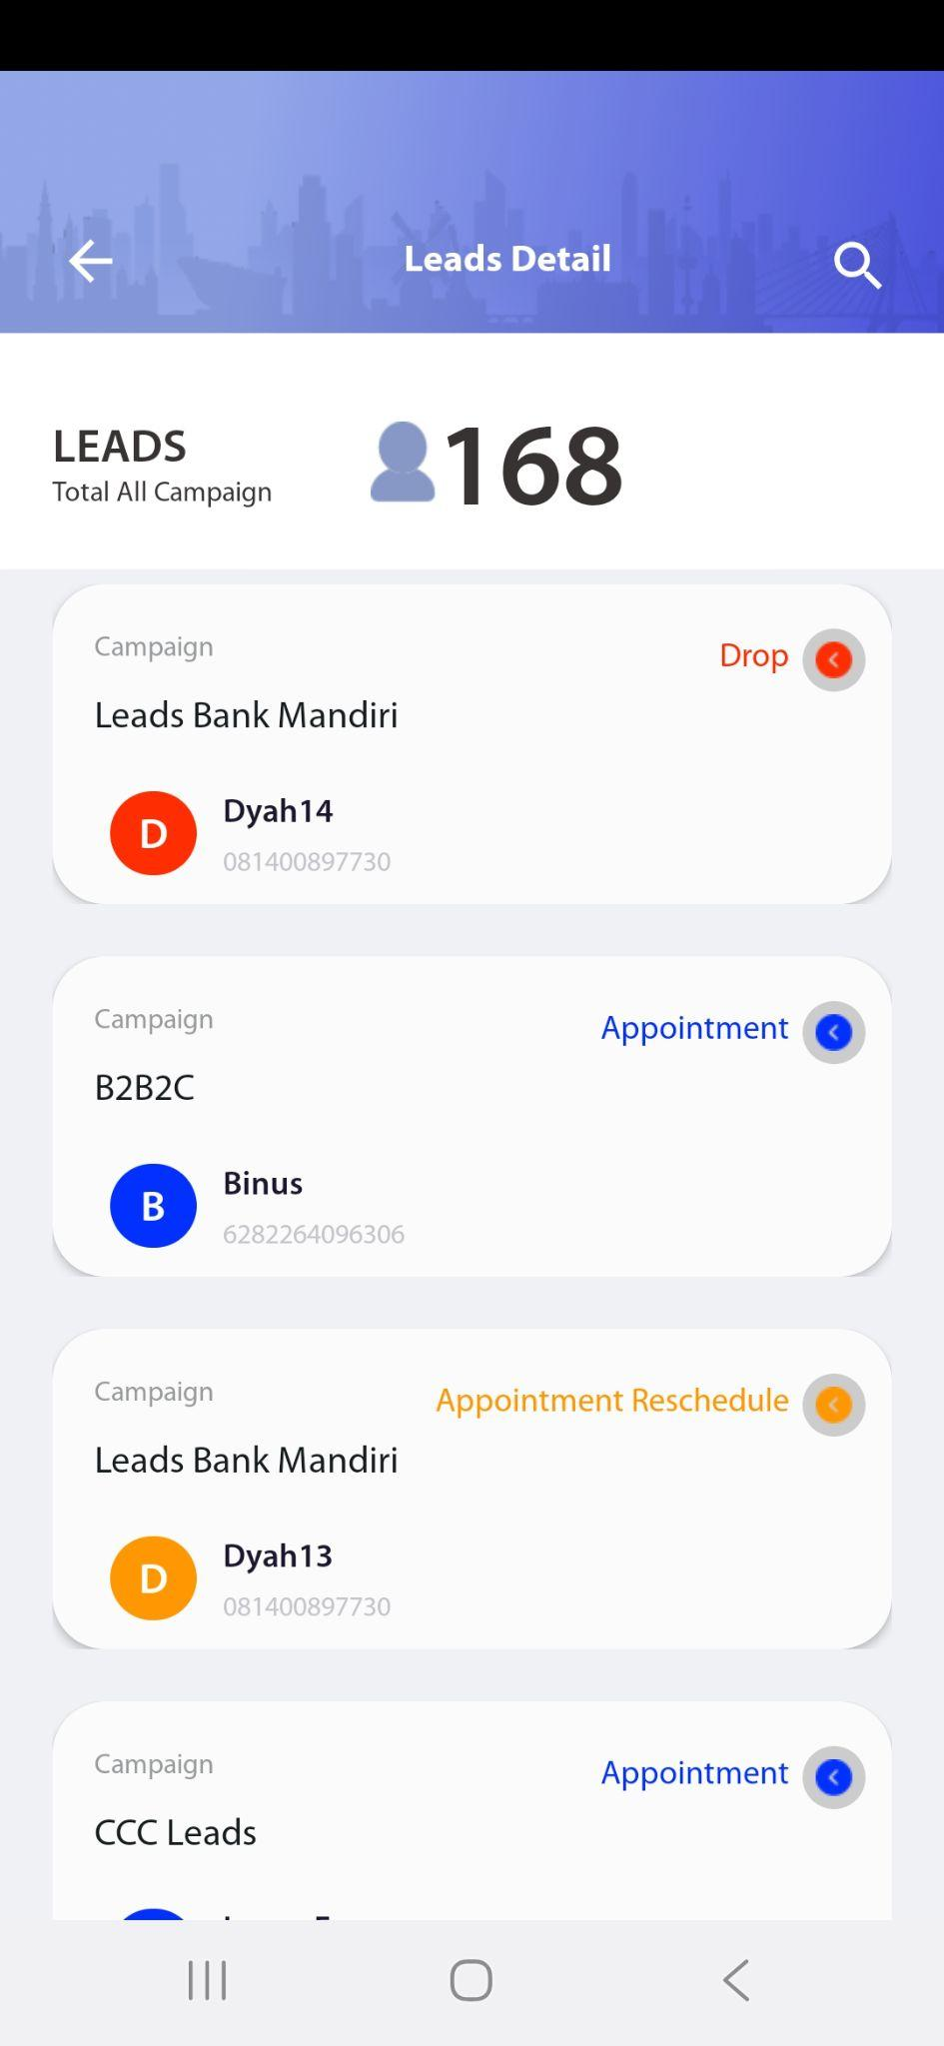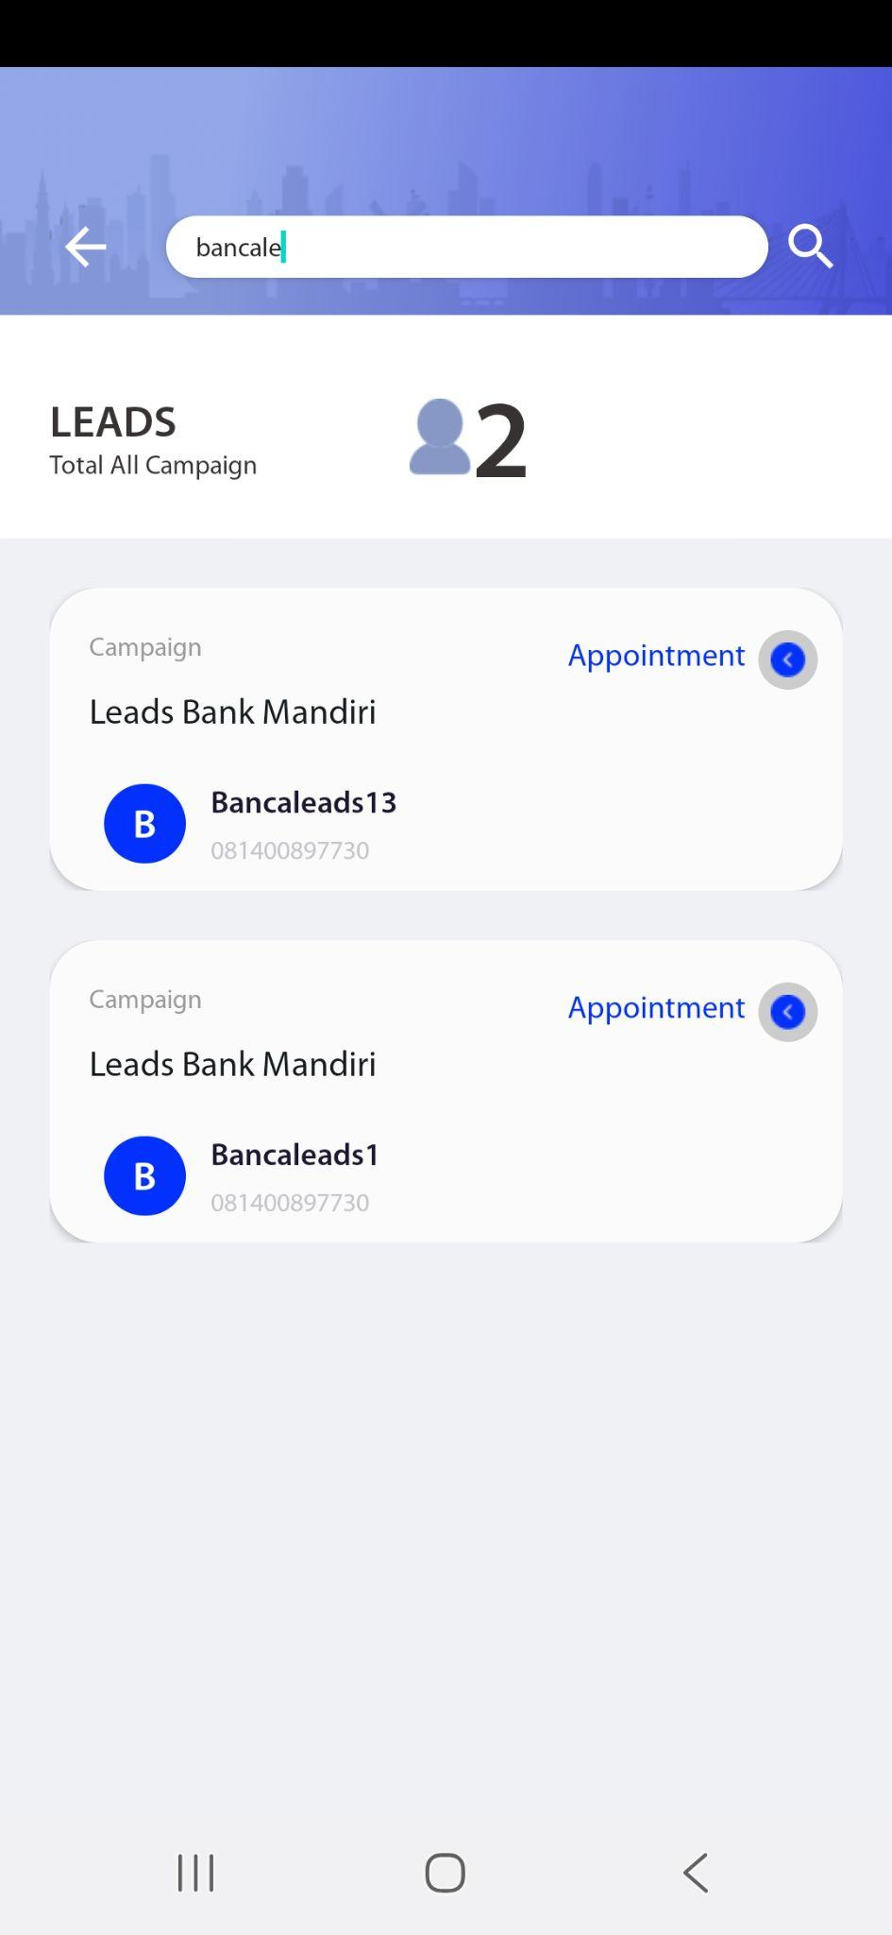

### Bucket Campaign

[TC 2.1.1 - TC 2.1.7]

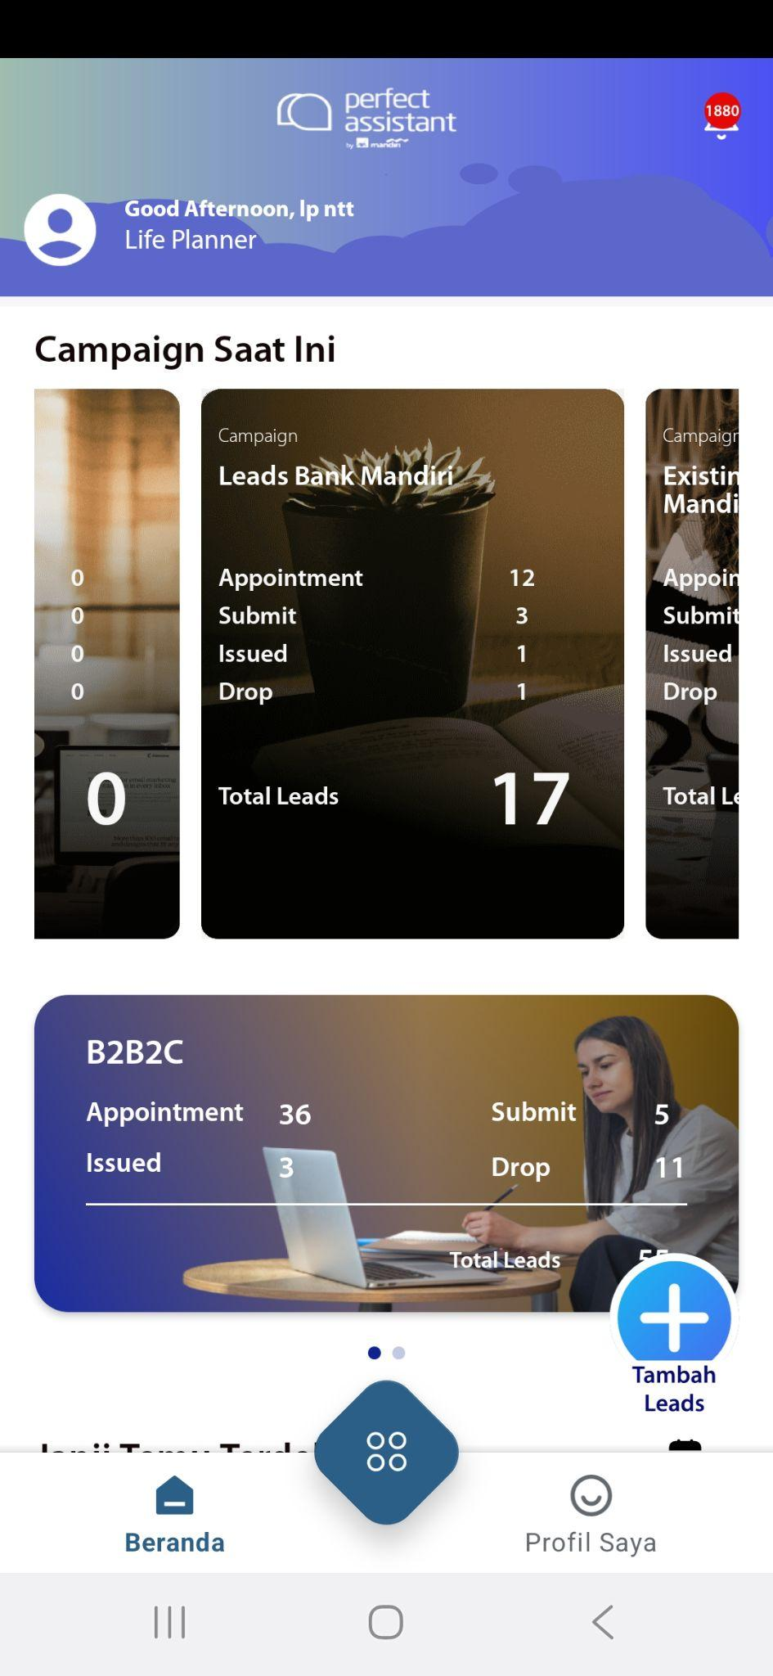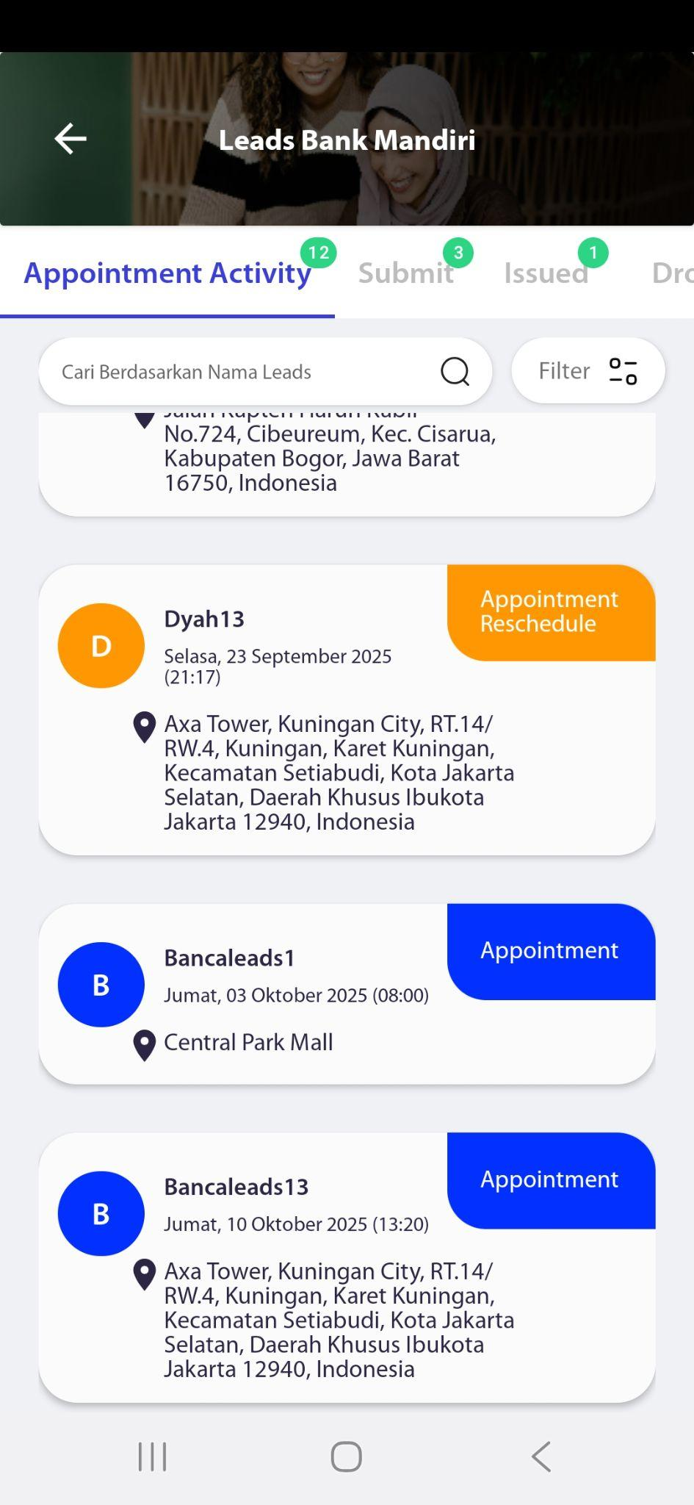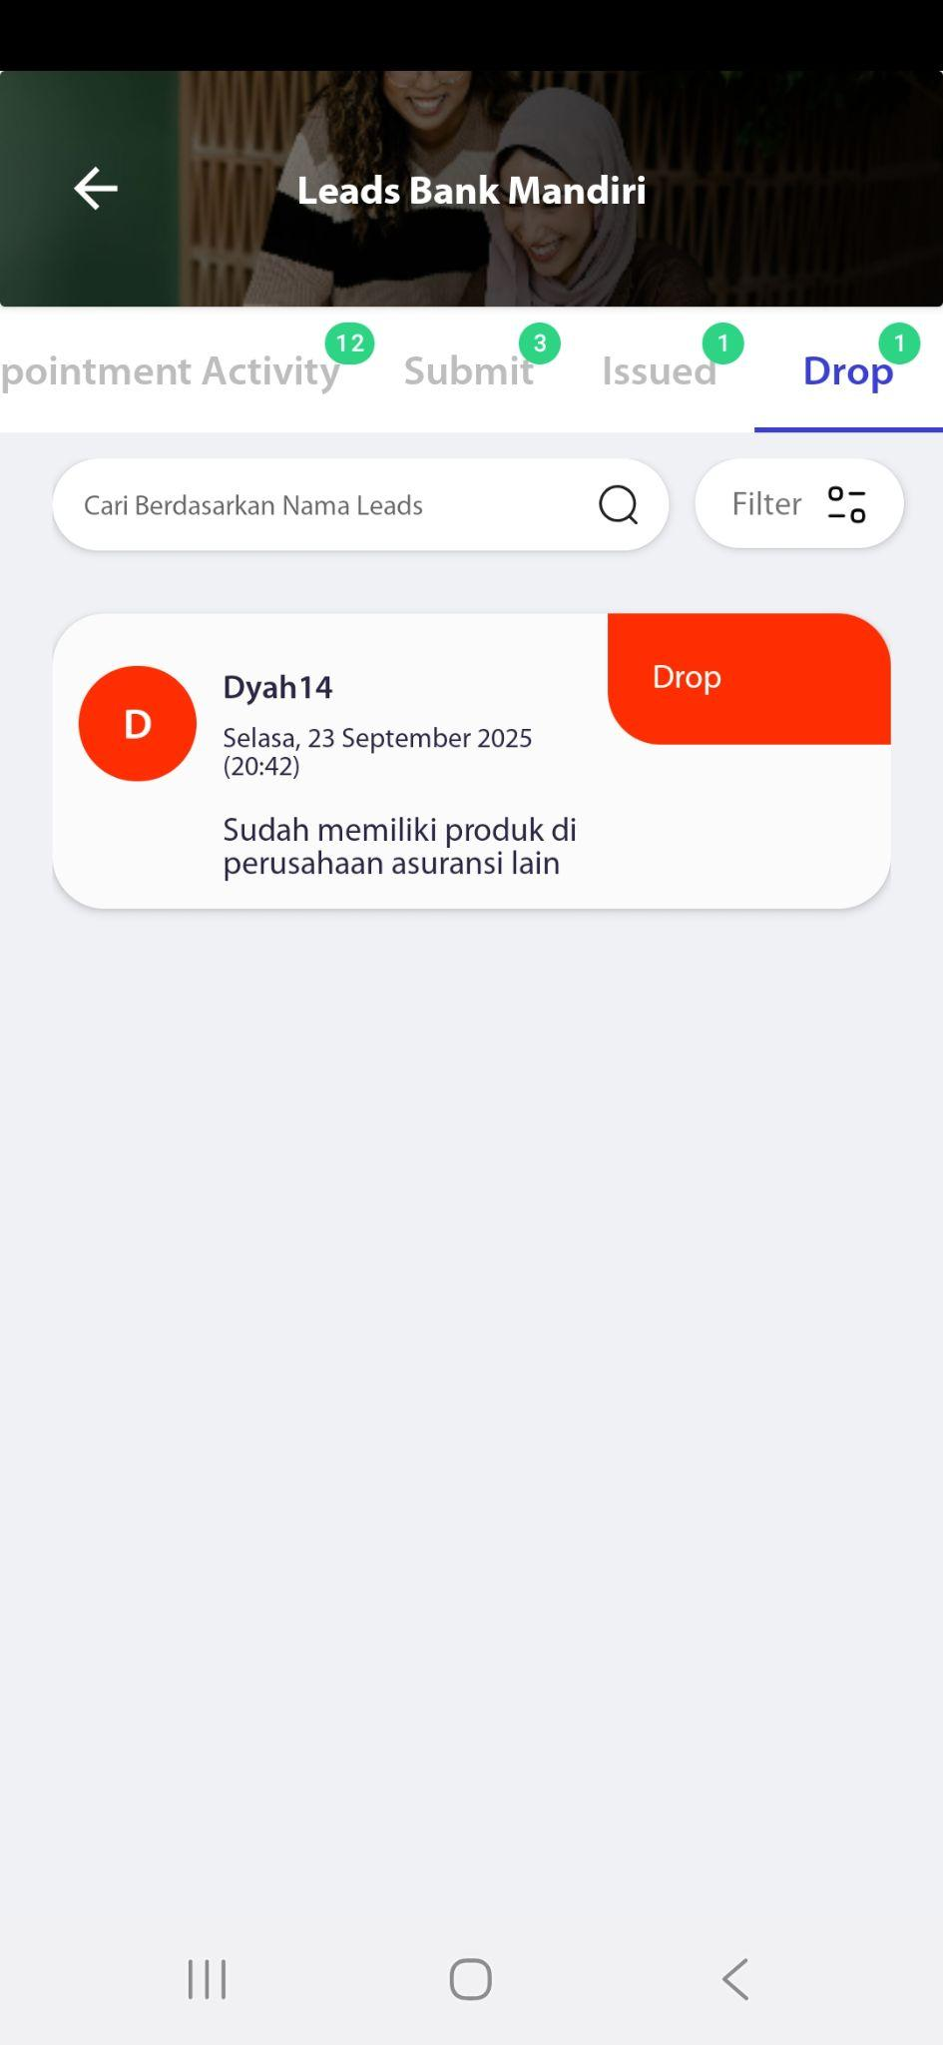

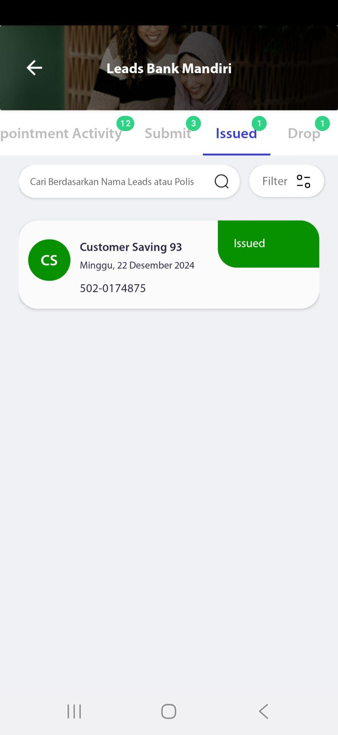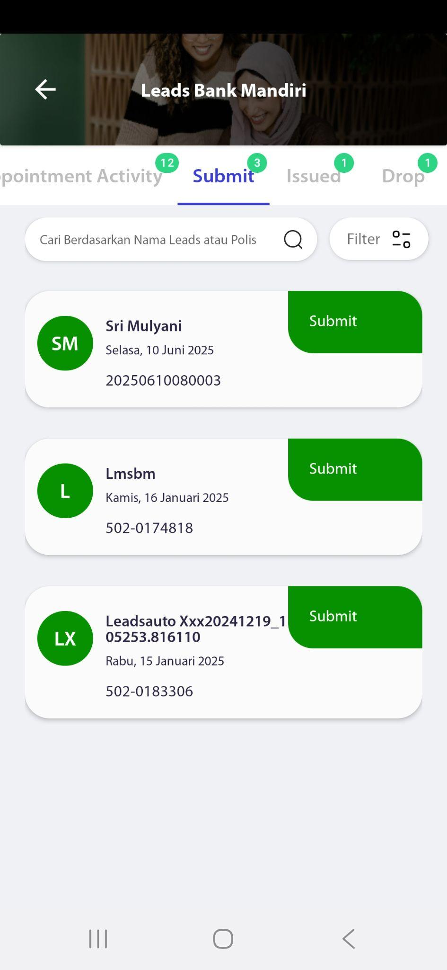

## Leads list

[TC 2.2.1, TC 2.2.8, TC 2.2.9]



## Change Status Leads

[TC 2.2.1, TC 2.2.8, TC 2.2.9]

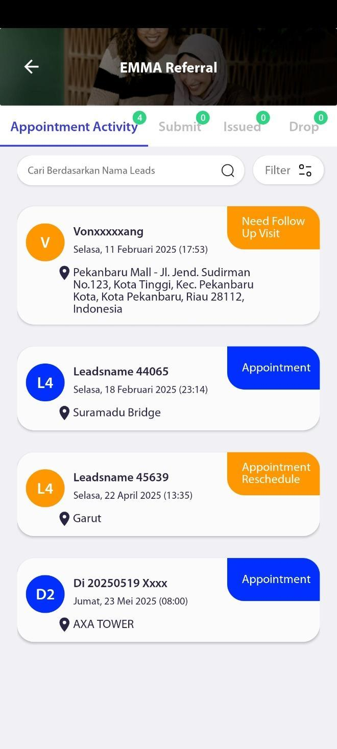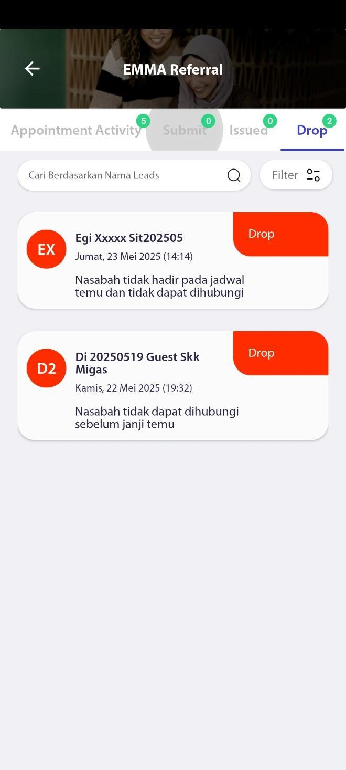

### Change Leads Status – Reschedule

[TC 2.3.2,TC 2.3.3,TC 2.3.4,TC 2.3.5,TC 2.3.6]

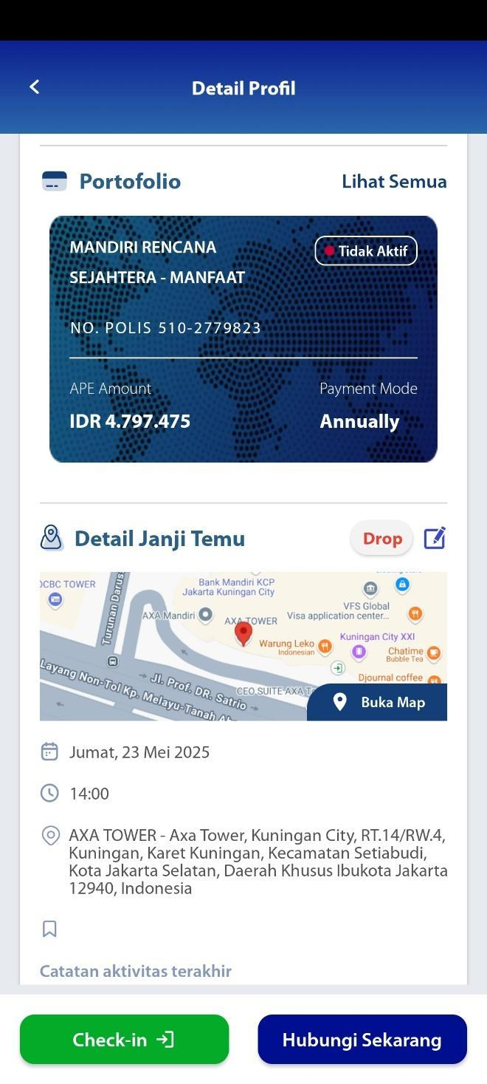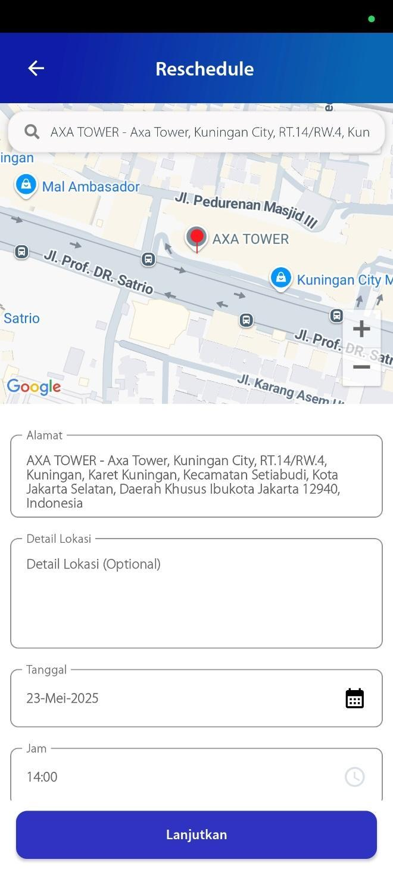

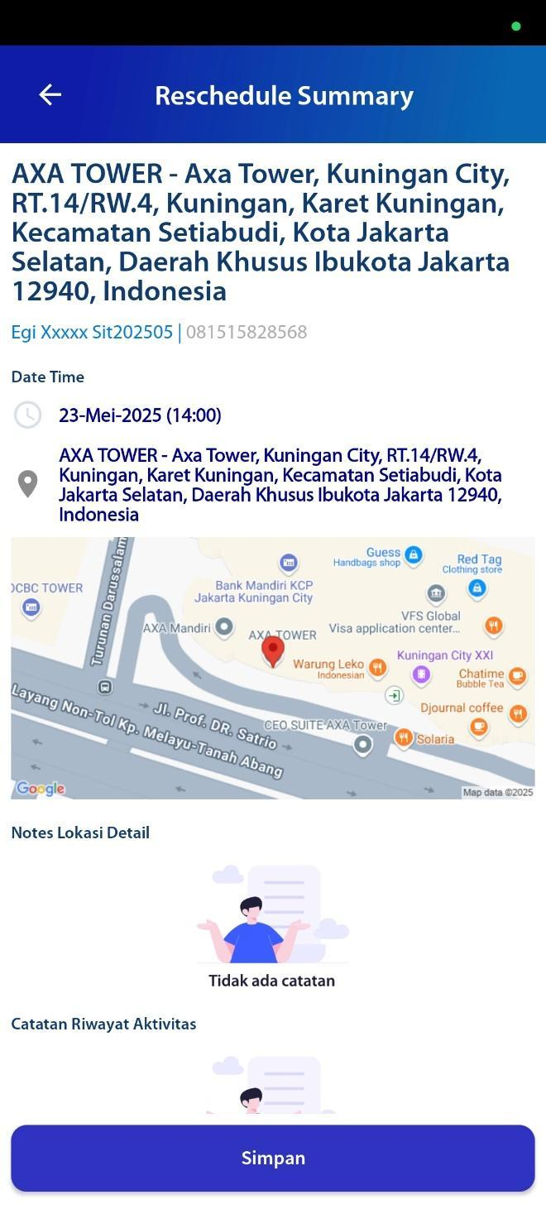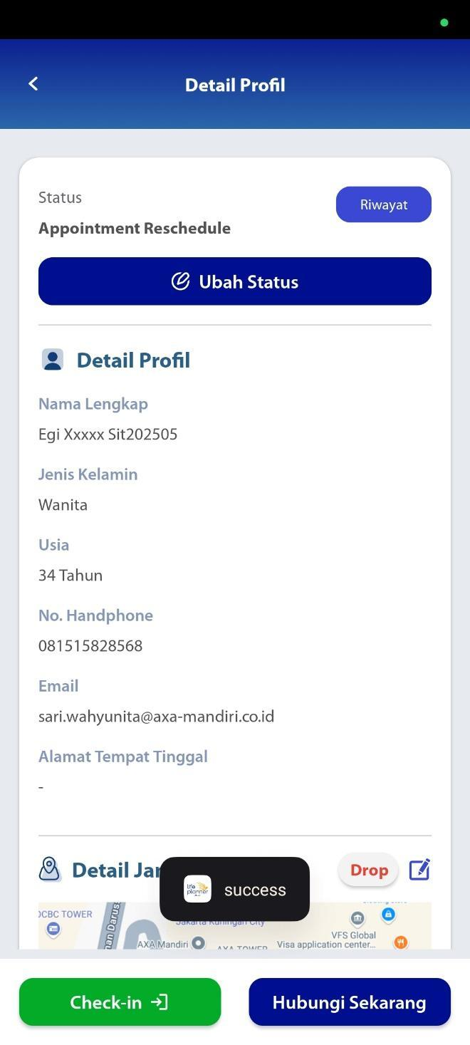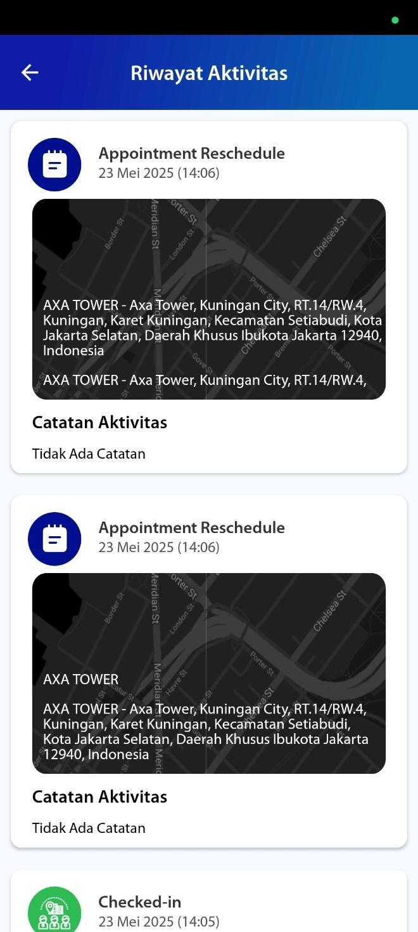

### Change Leads Status – Check-in

[TC 2.3.7,TC 2.3.8,TC 2.3.9]

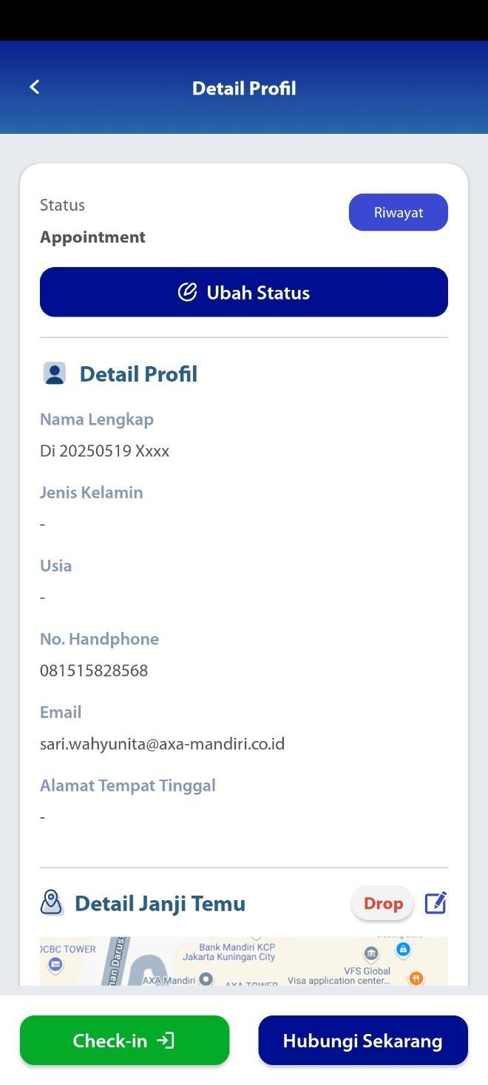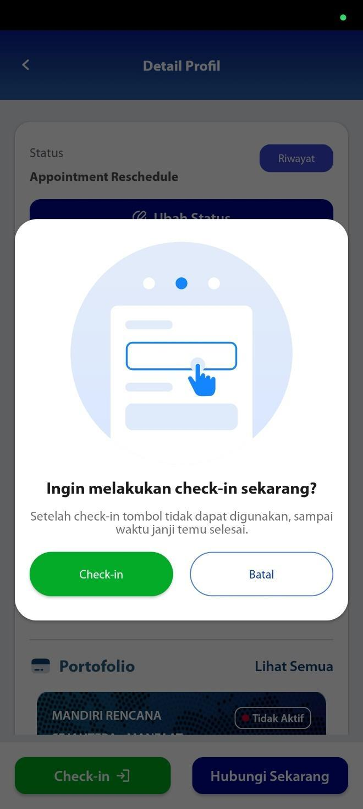

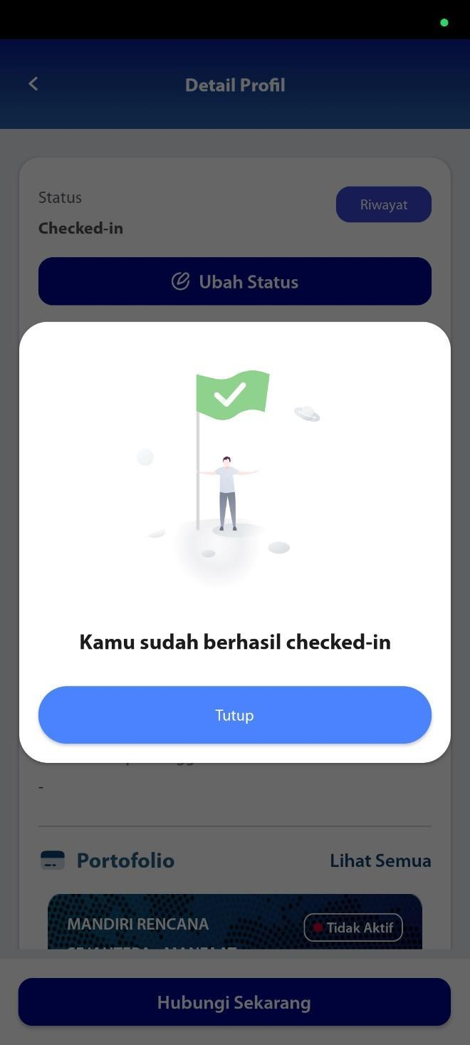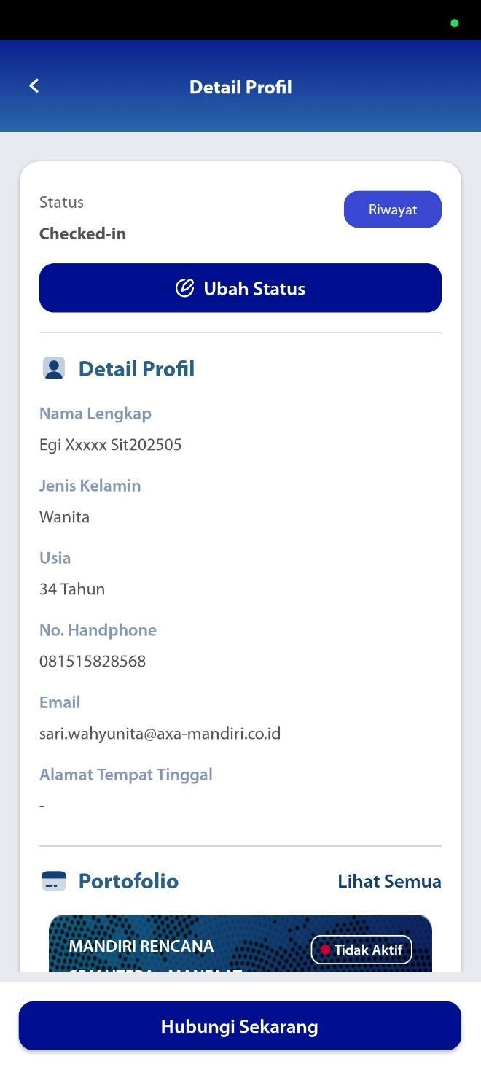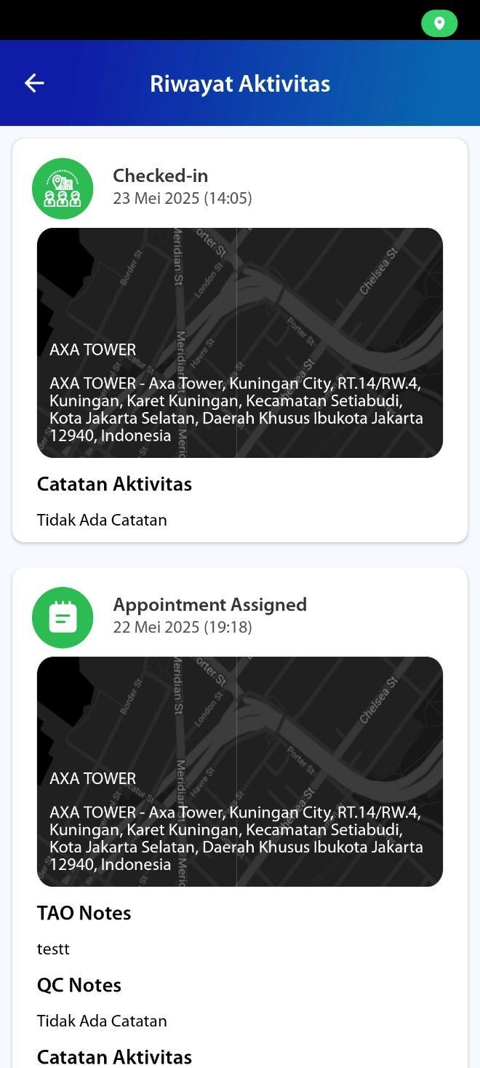

### Change Leads Status – Need Follow Up Visit

[TC 2.3.10,TC 2.3.11,TC 2.3.12,TC 2.3.13,TC 2.3.14]

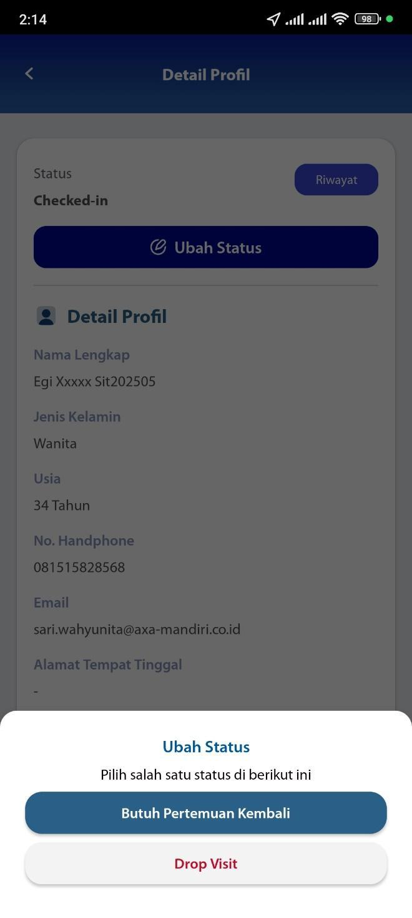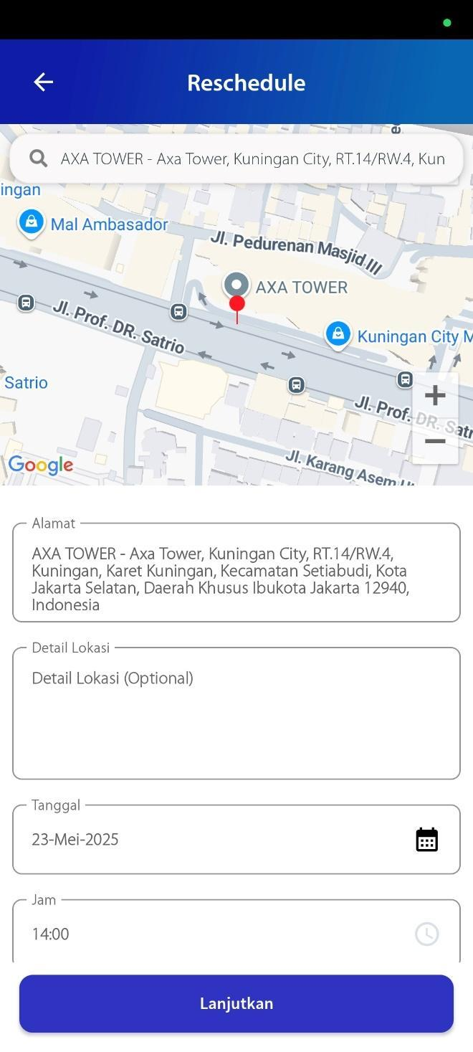

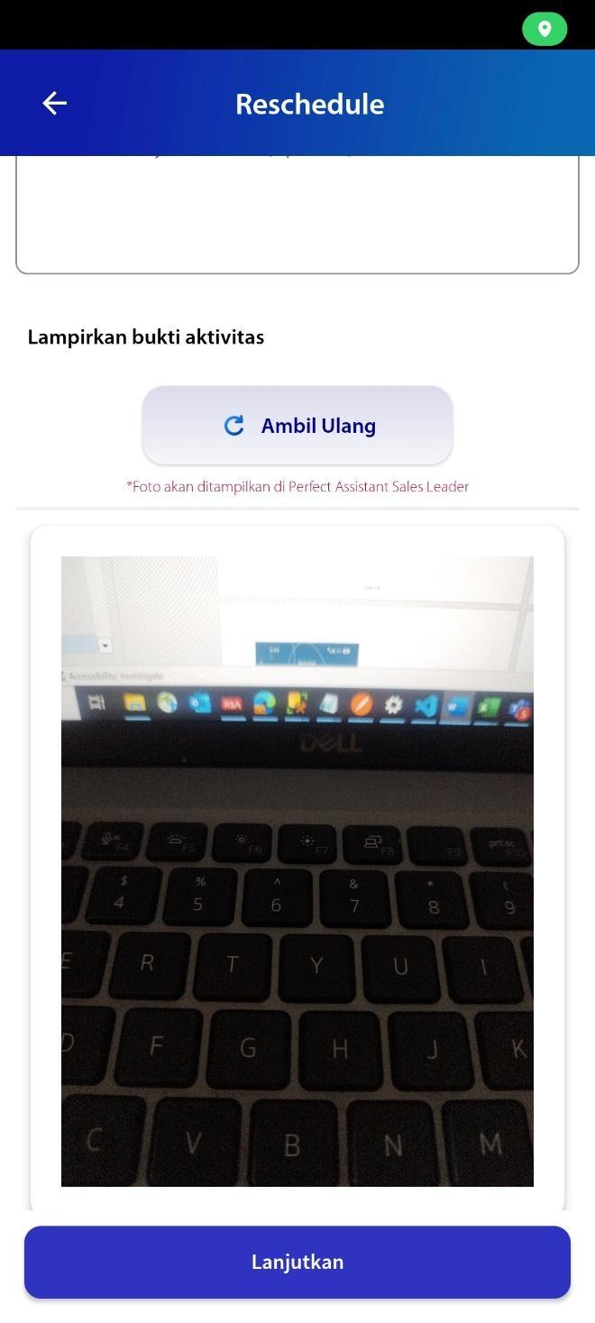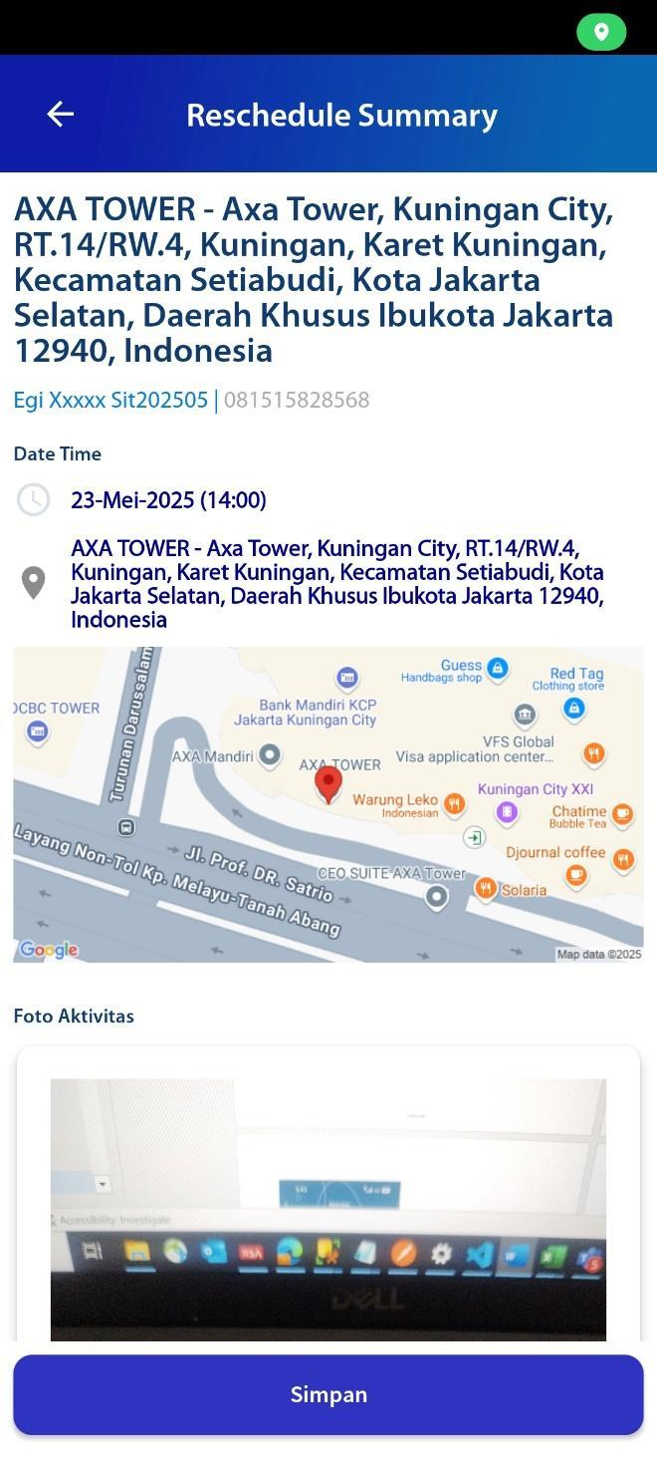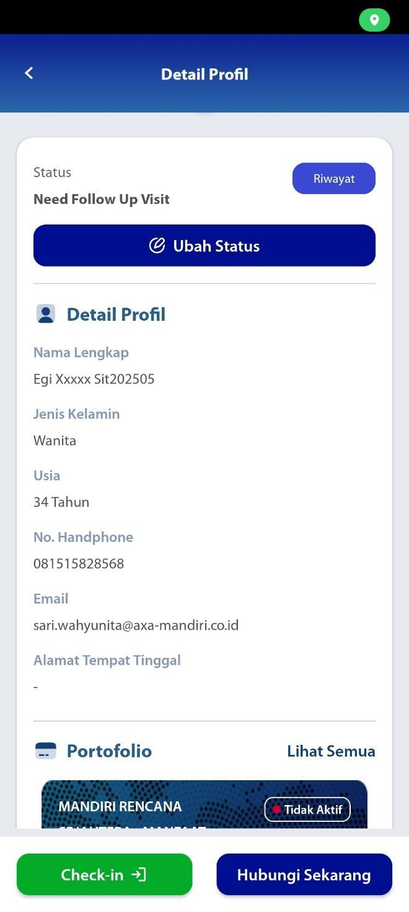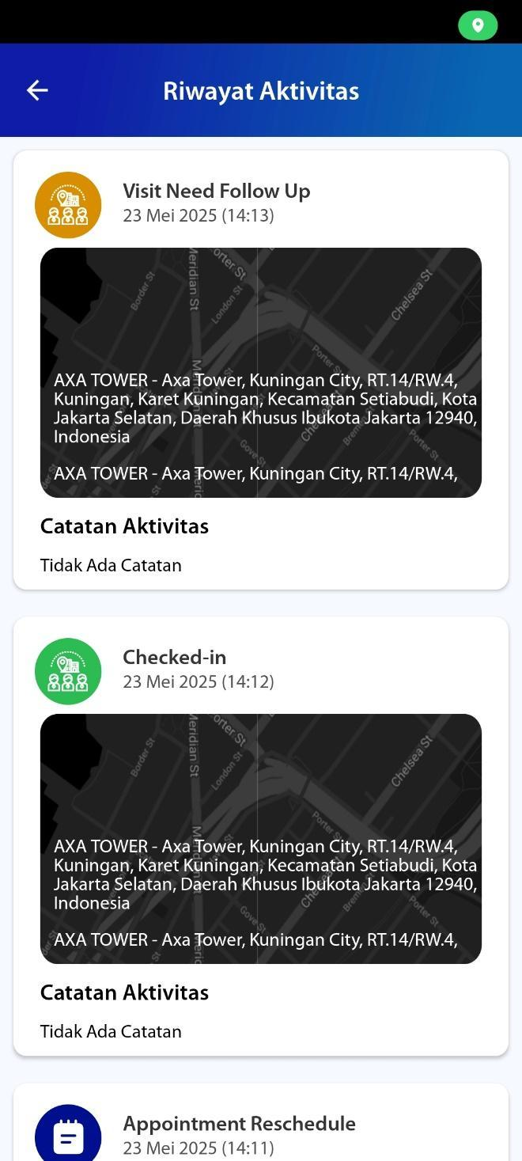

### Change Leads Status - Drop

[TC 2.3.15,TC 2.3.16,TC 2.3.17,TC 2.3.18]

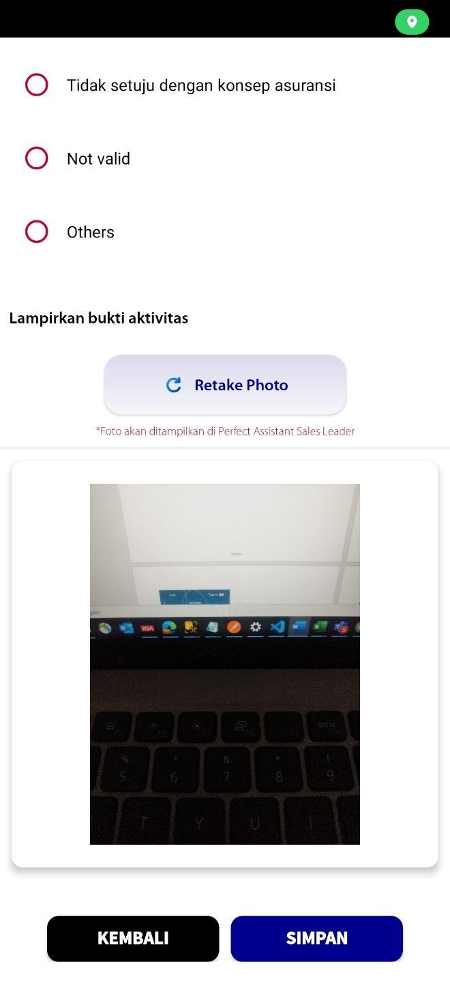

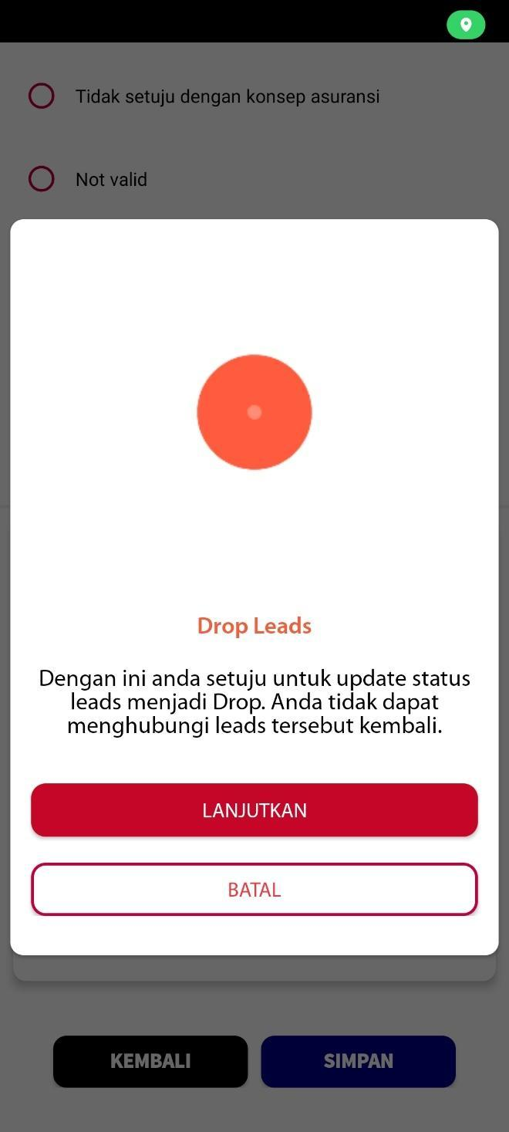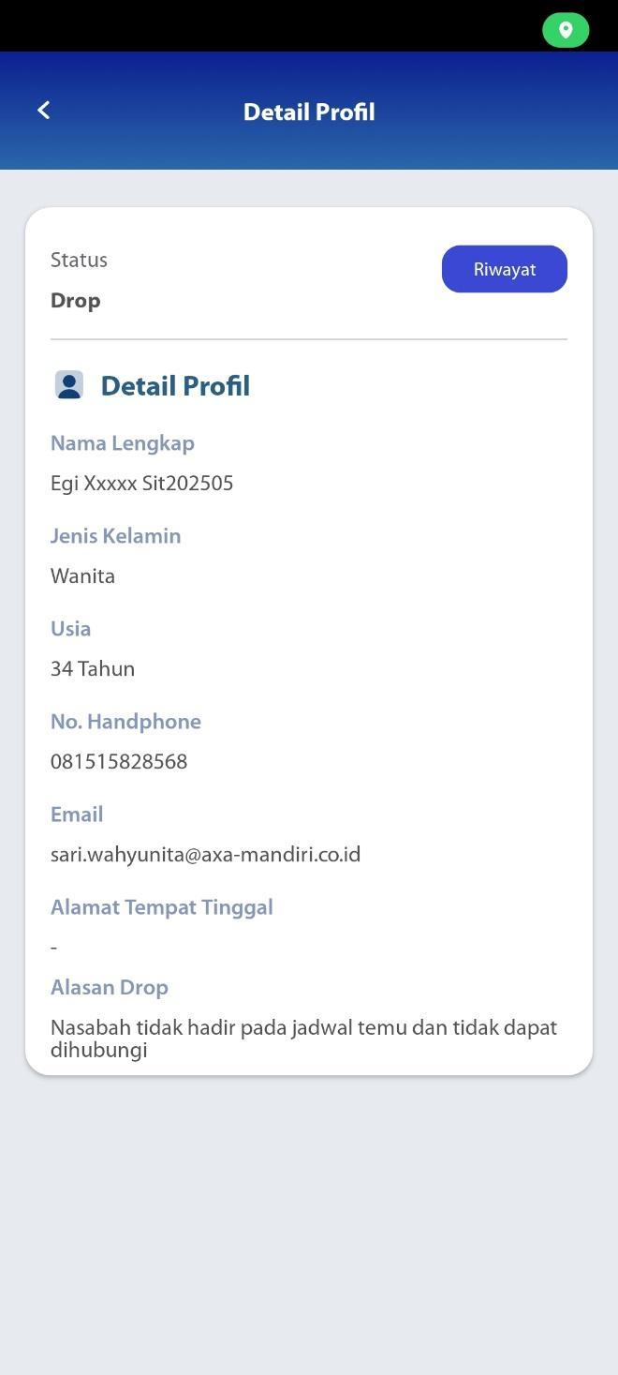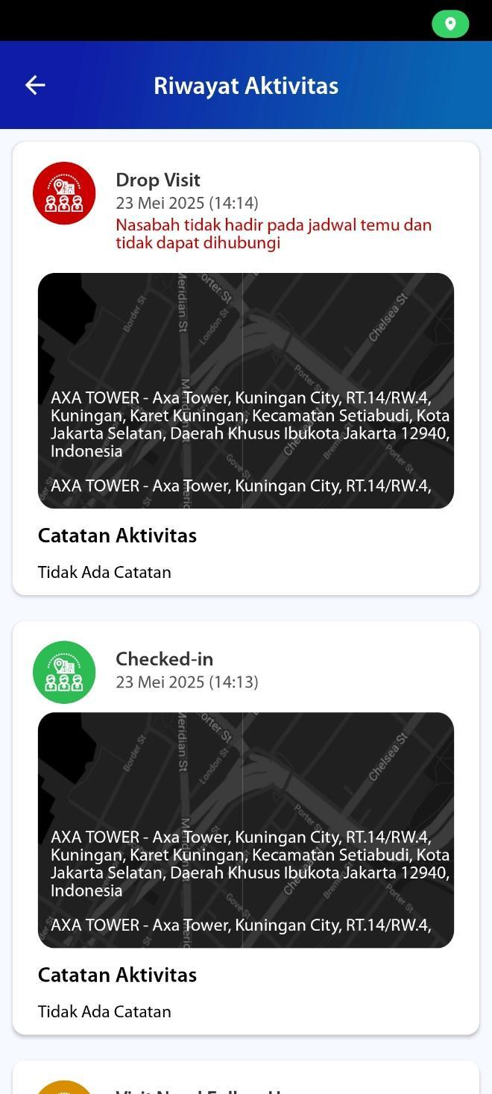

## Call Leads

[TC 7.5.1 - TC 7.5.8]

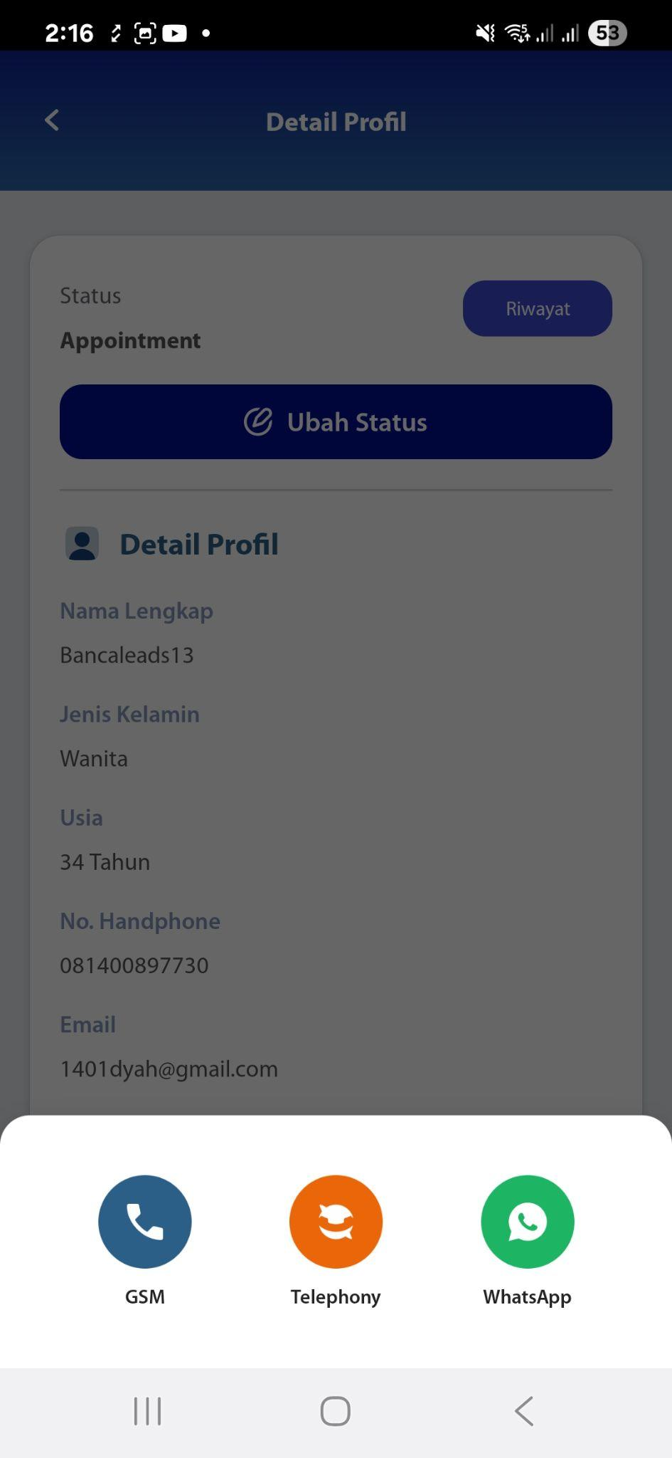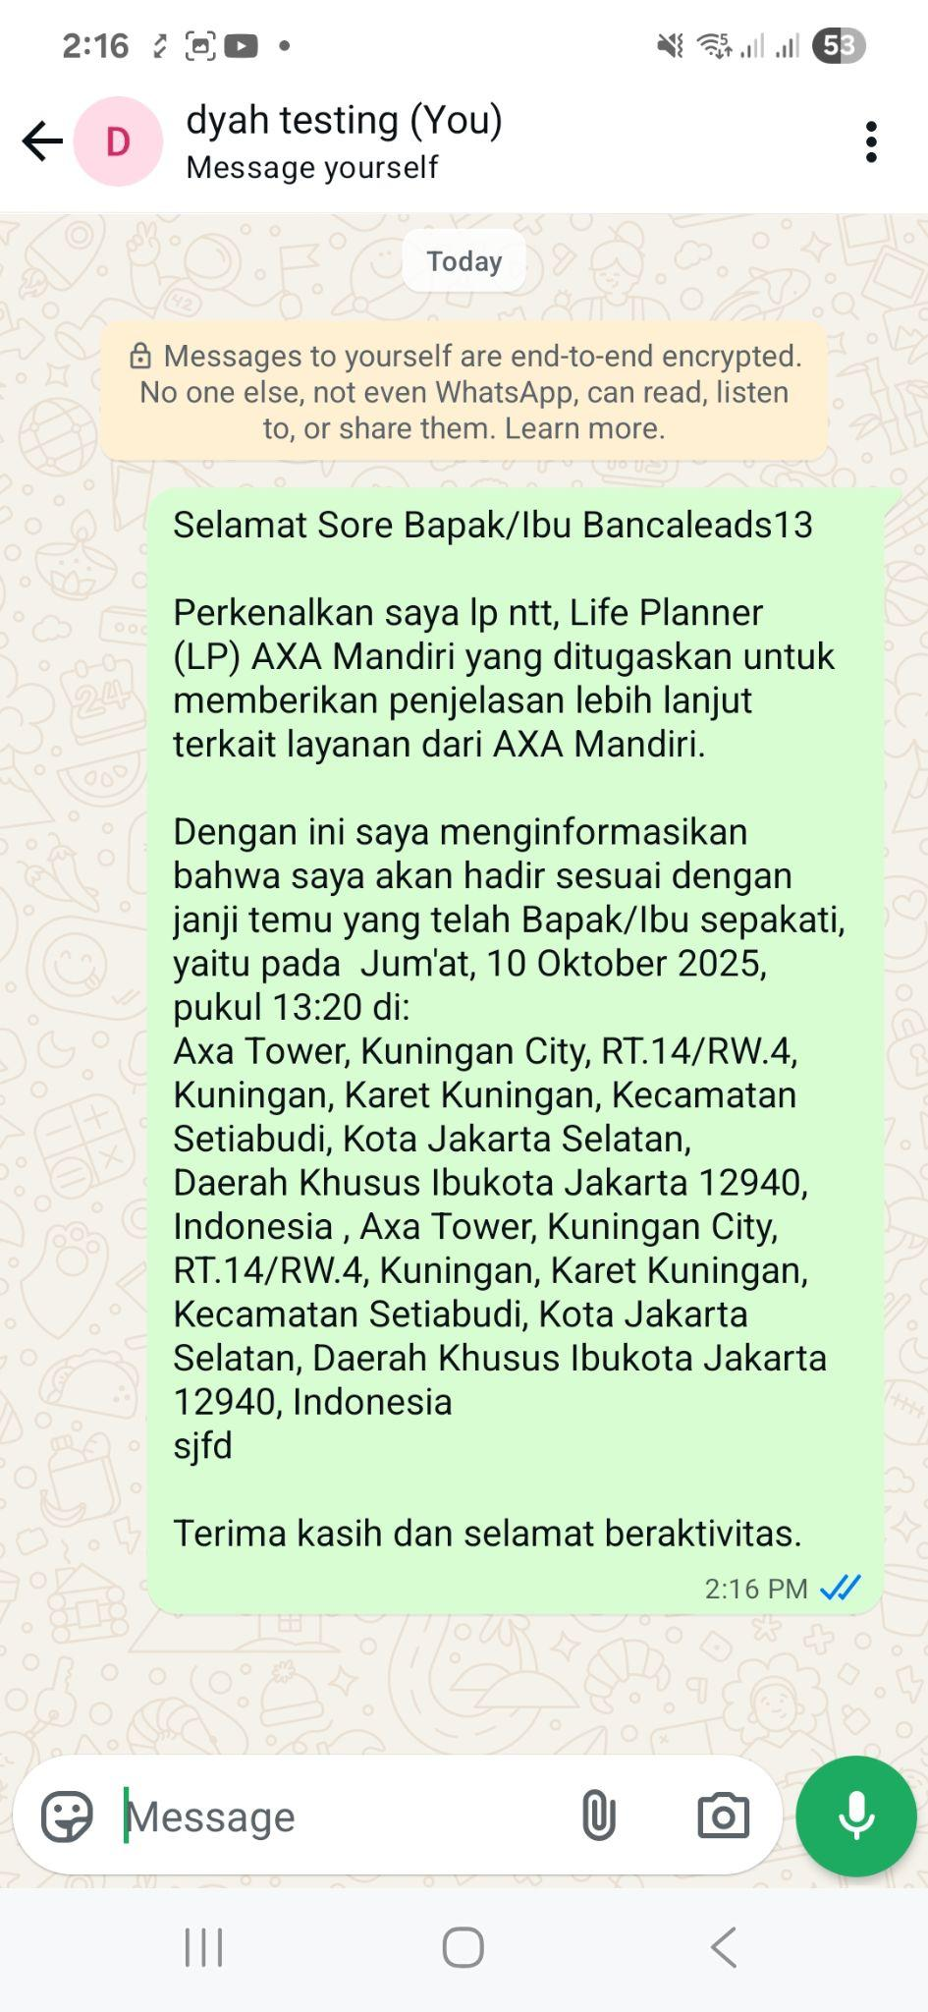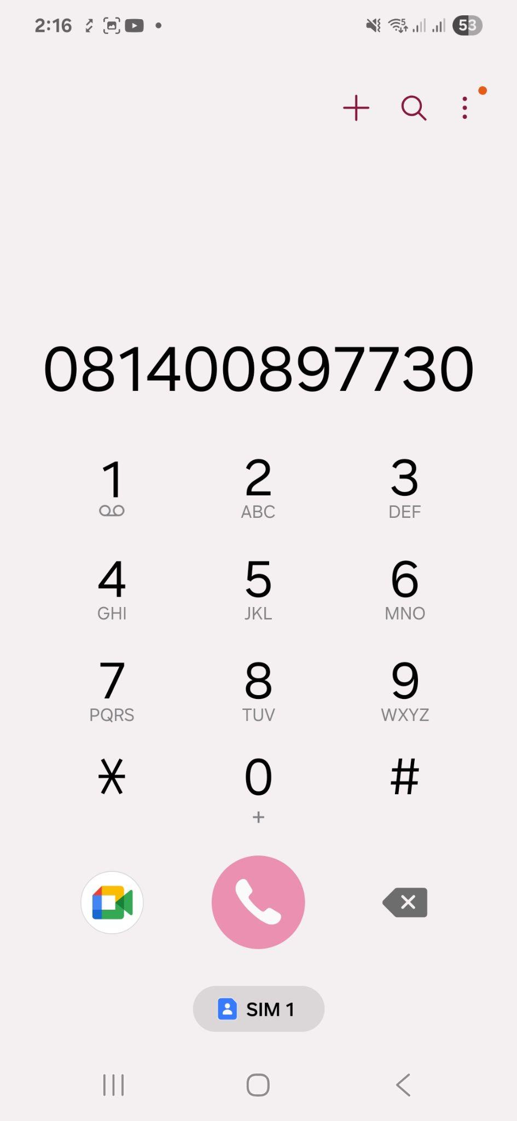

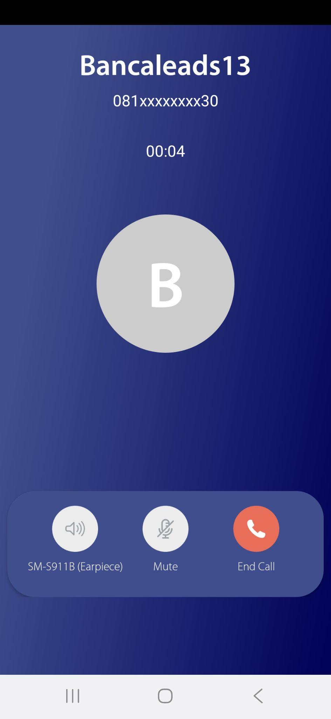5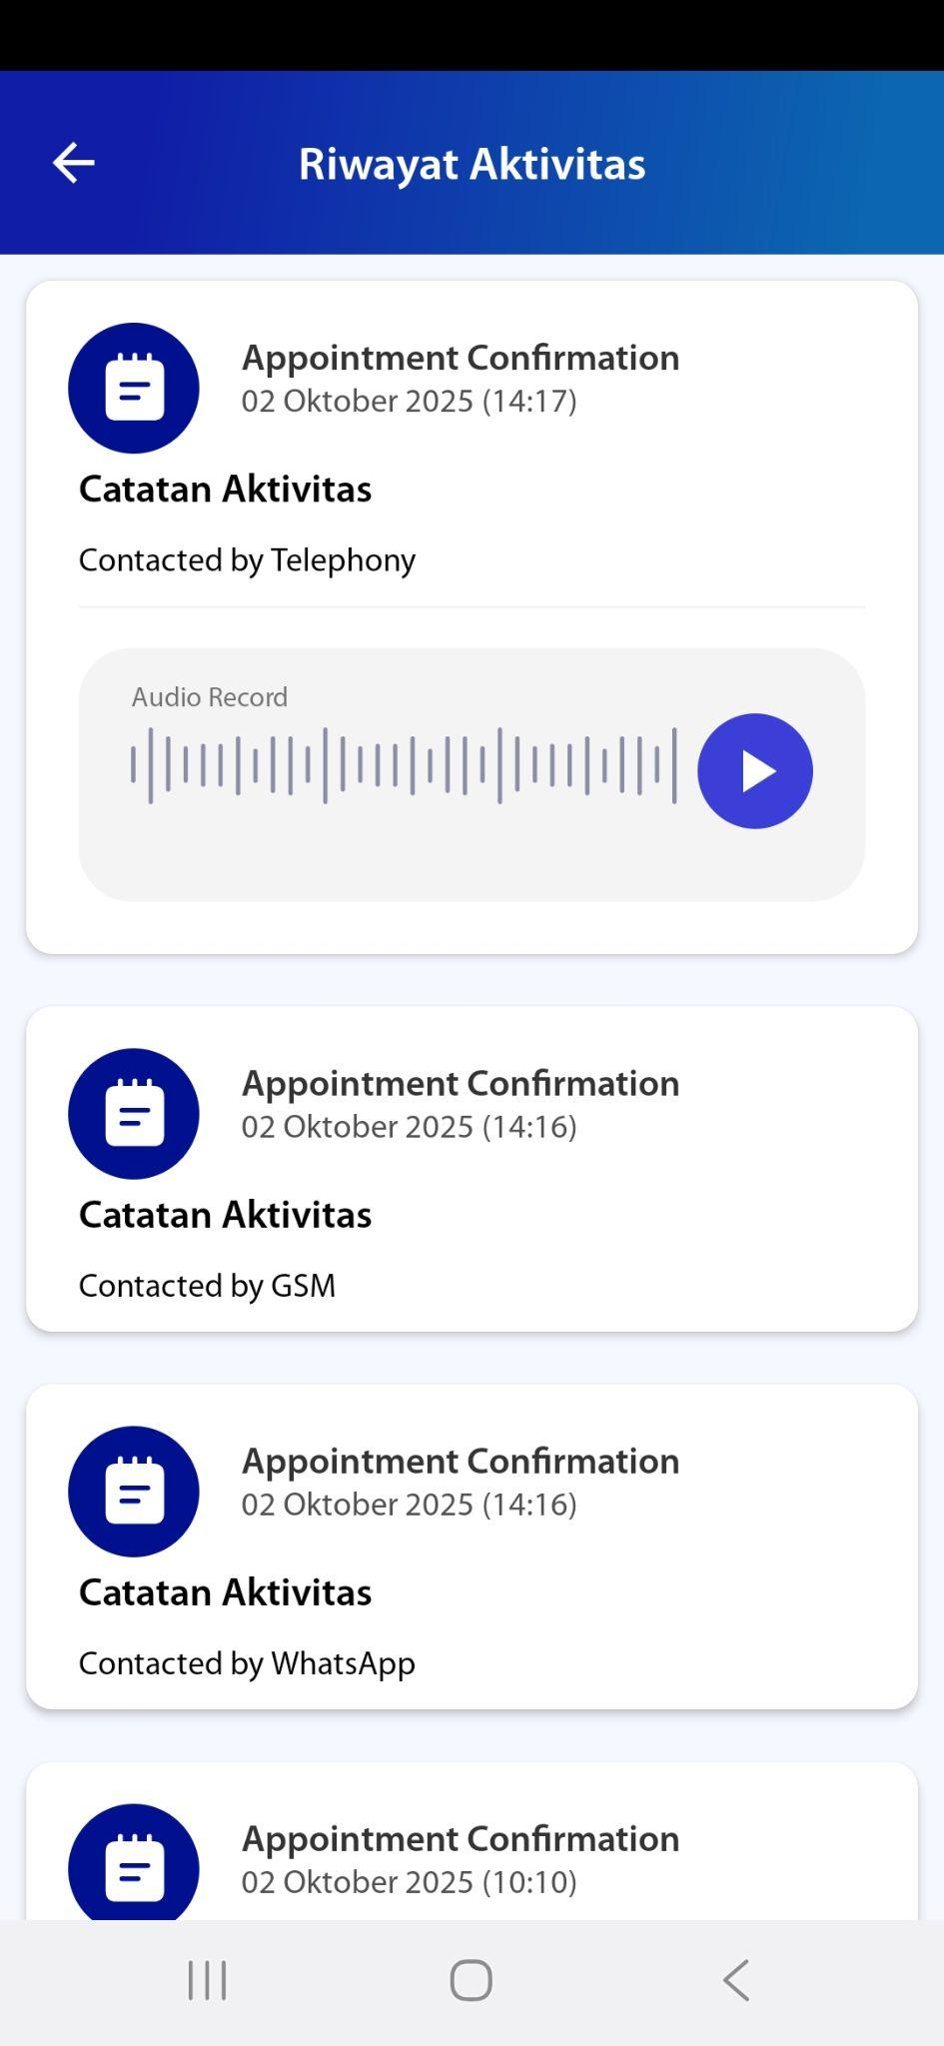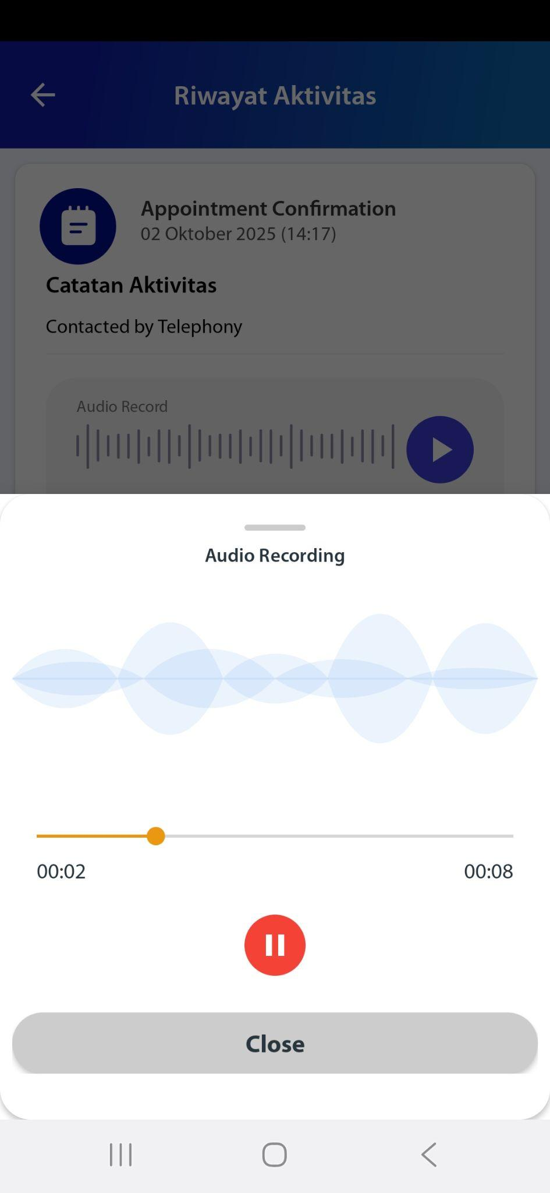

## Maps

[TC 2.5.1]

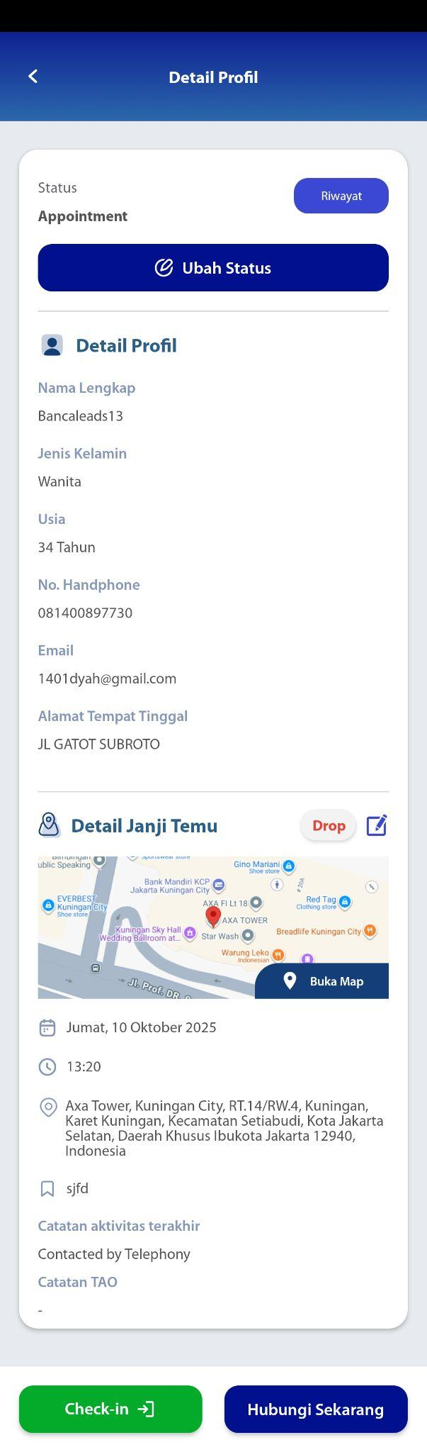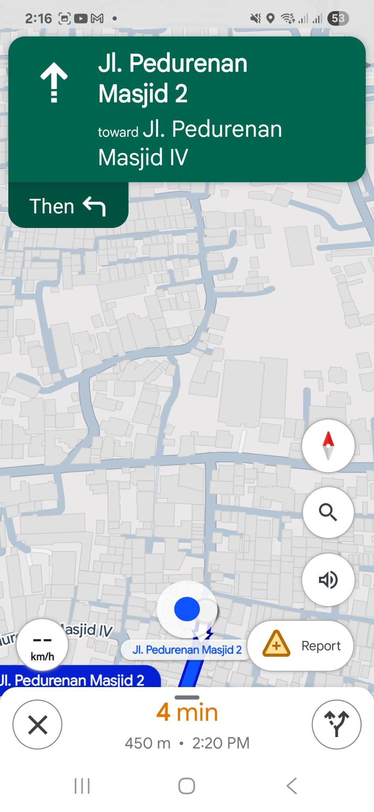

## Calendar Activity

[TC 7.7.1 - TC 7.7.3]

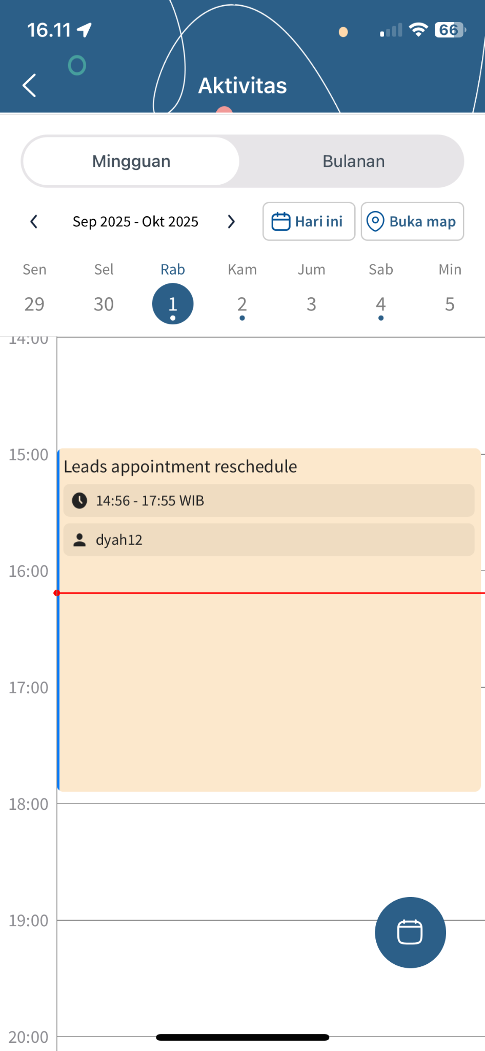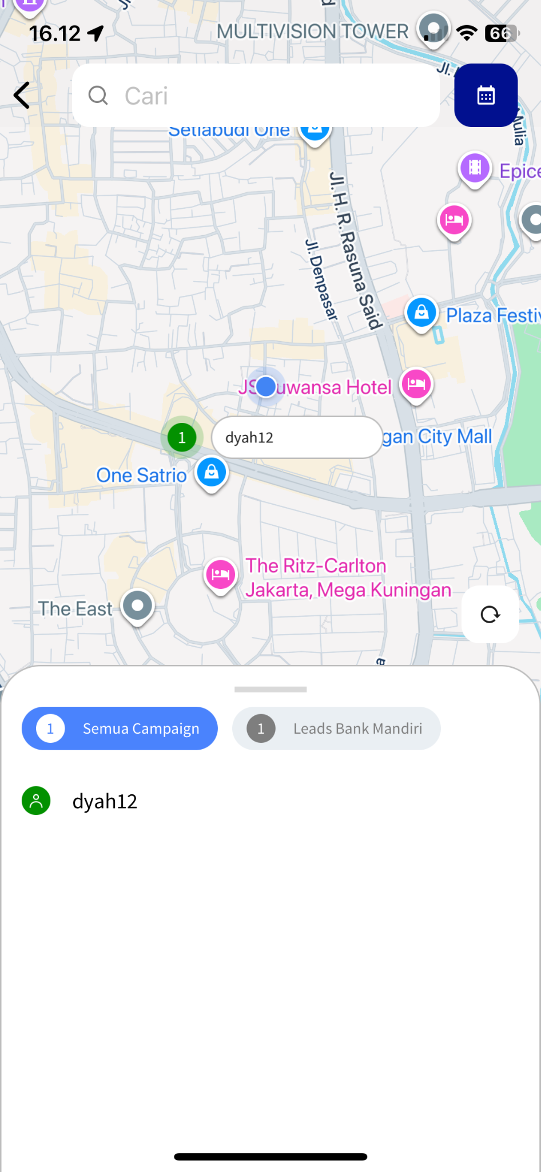

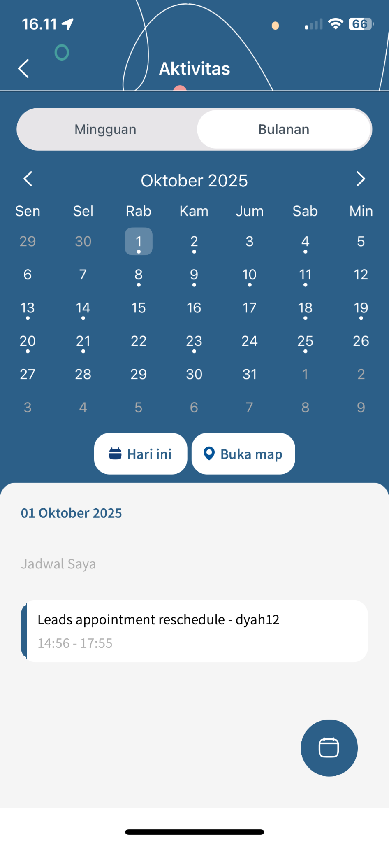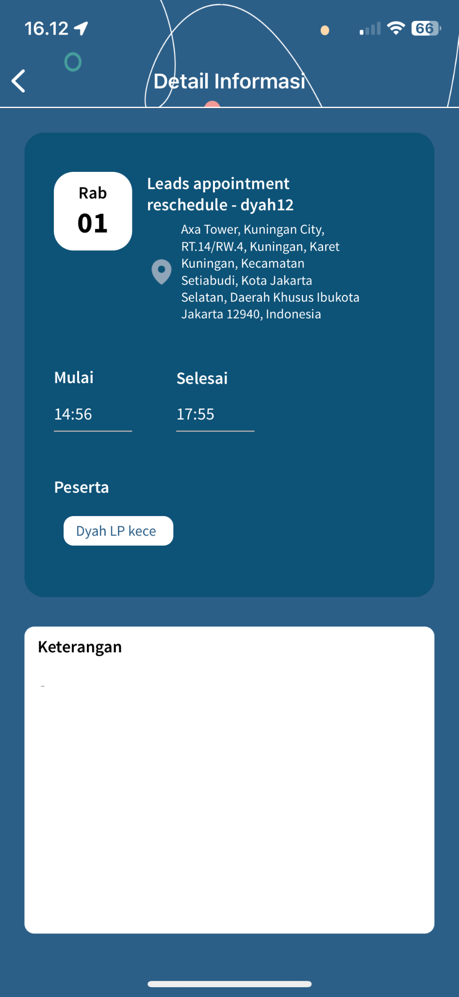

## Notification

[TC 7.8.1 – TC 7.8.7]

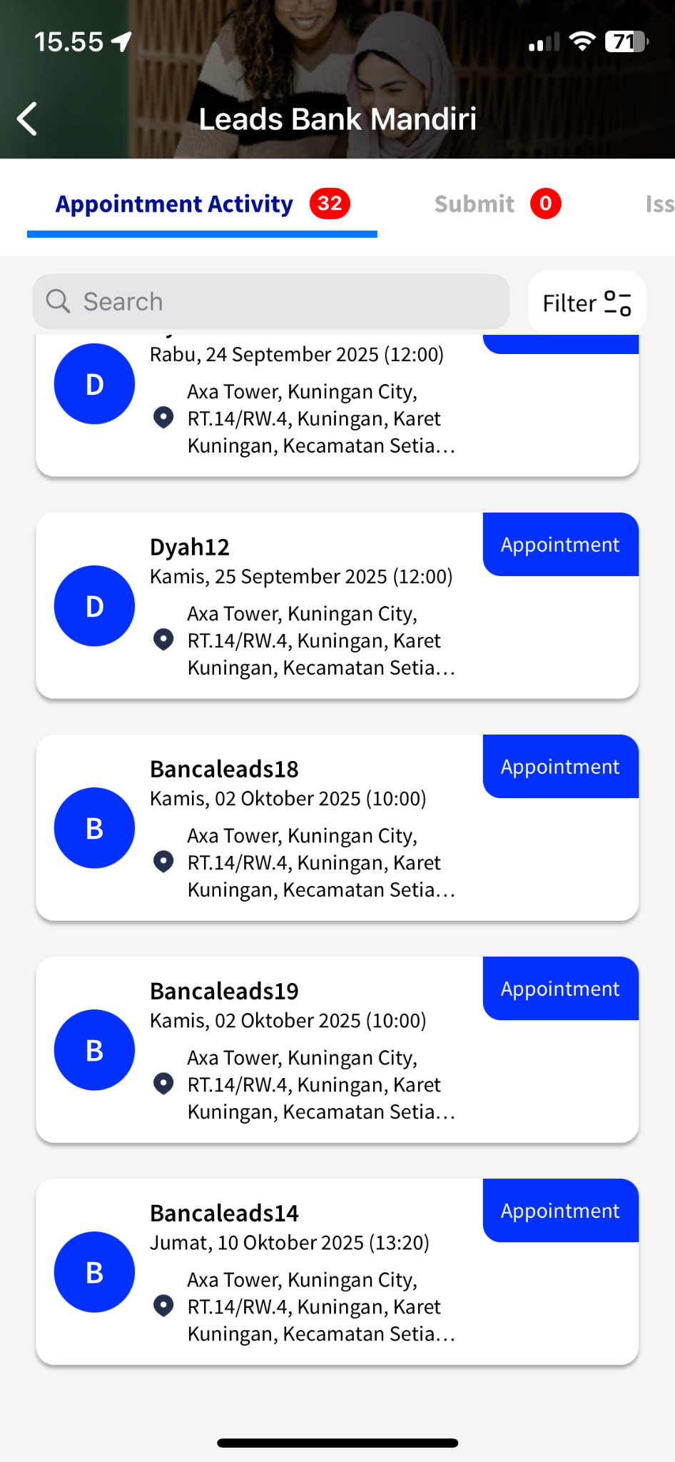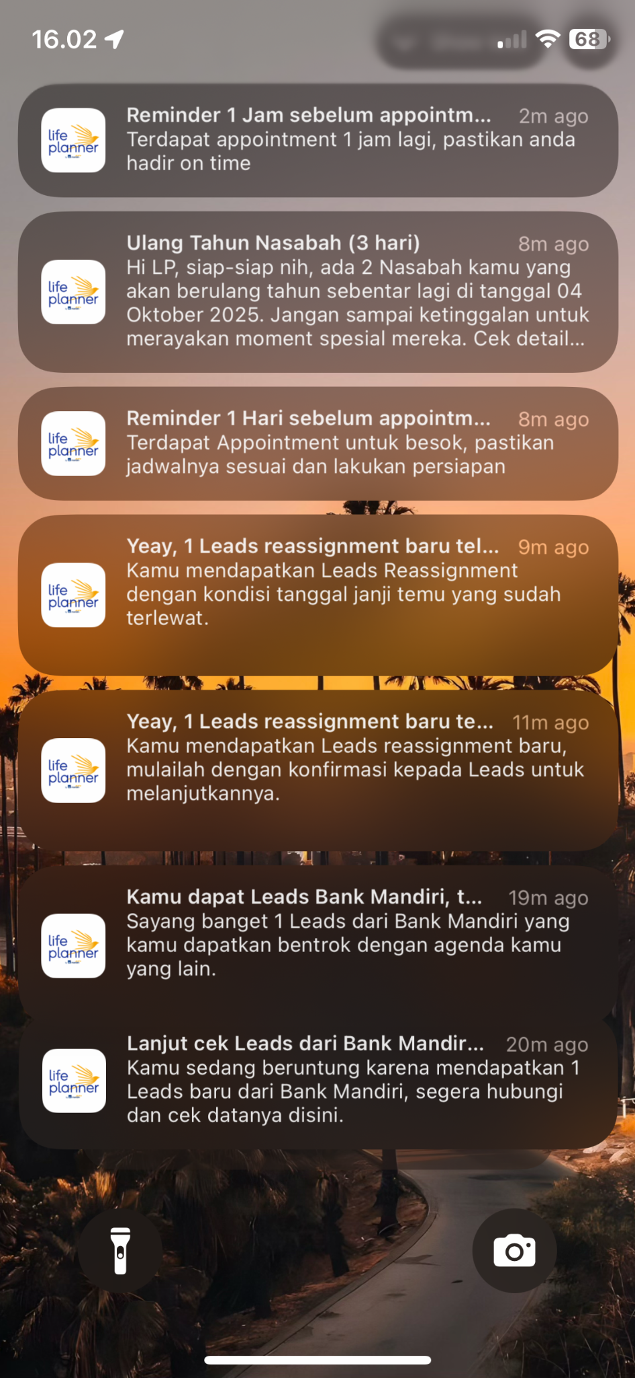

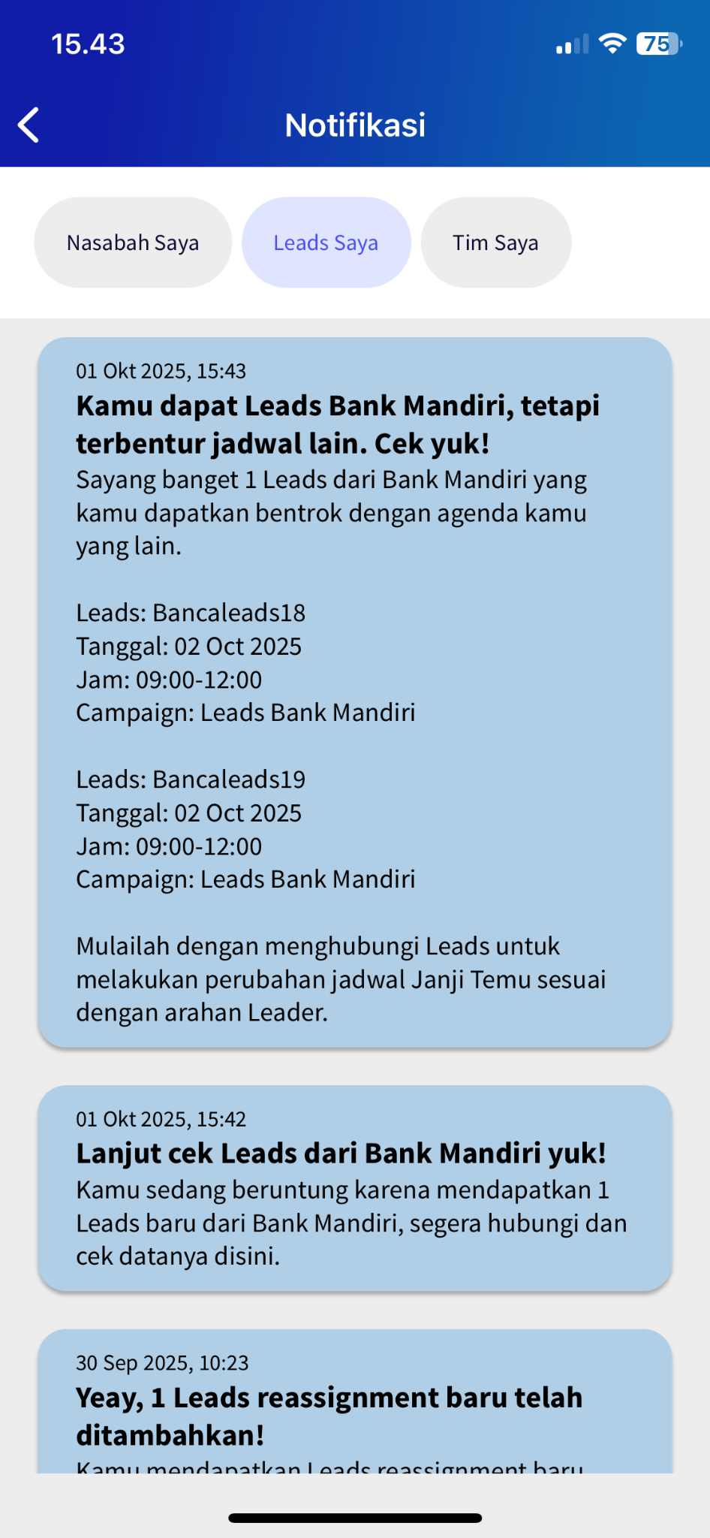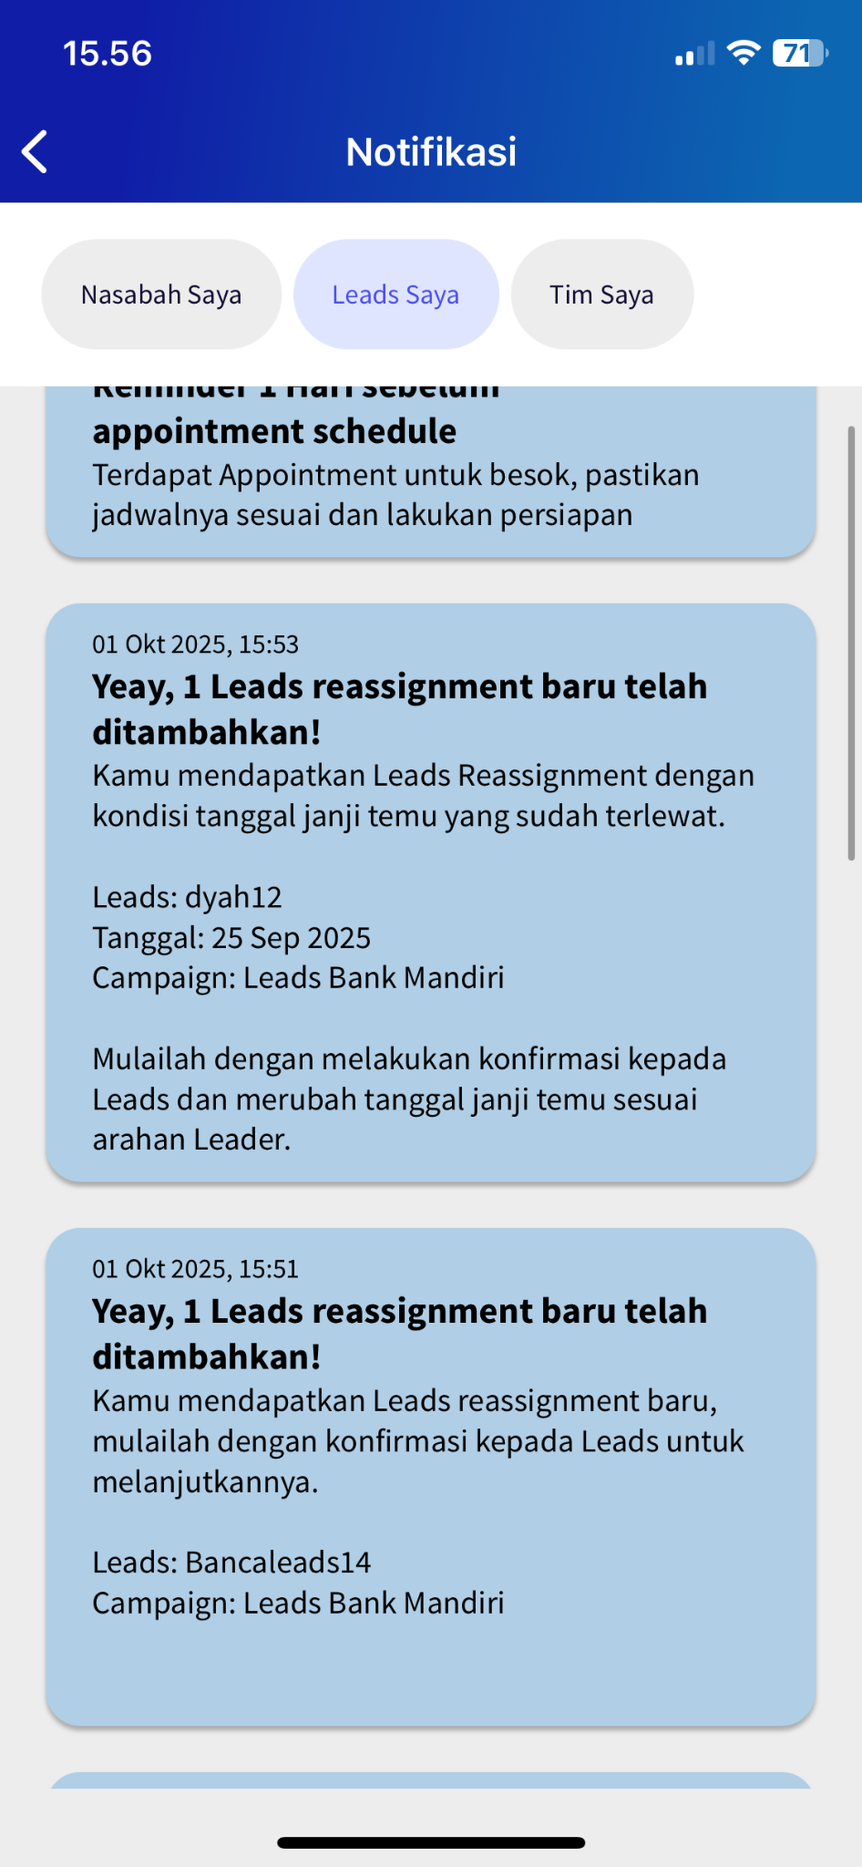

## Lokasi Janji Temu

[TC 2.8.1 - TC 2.8.3]

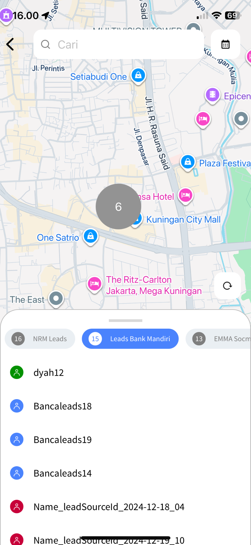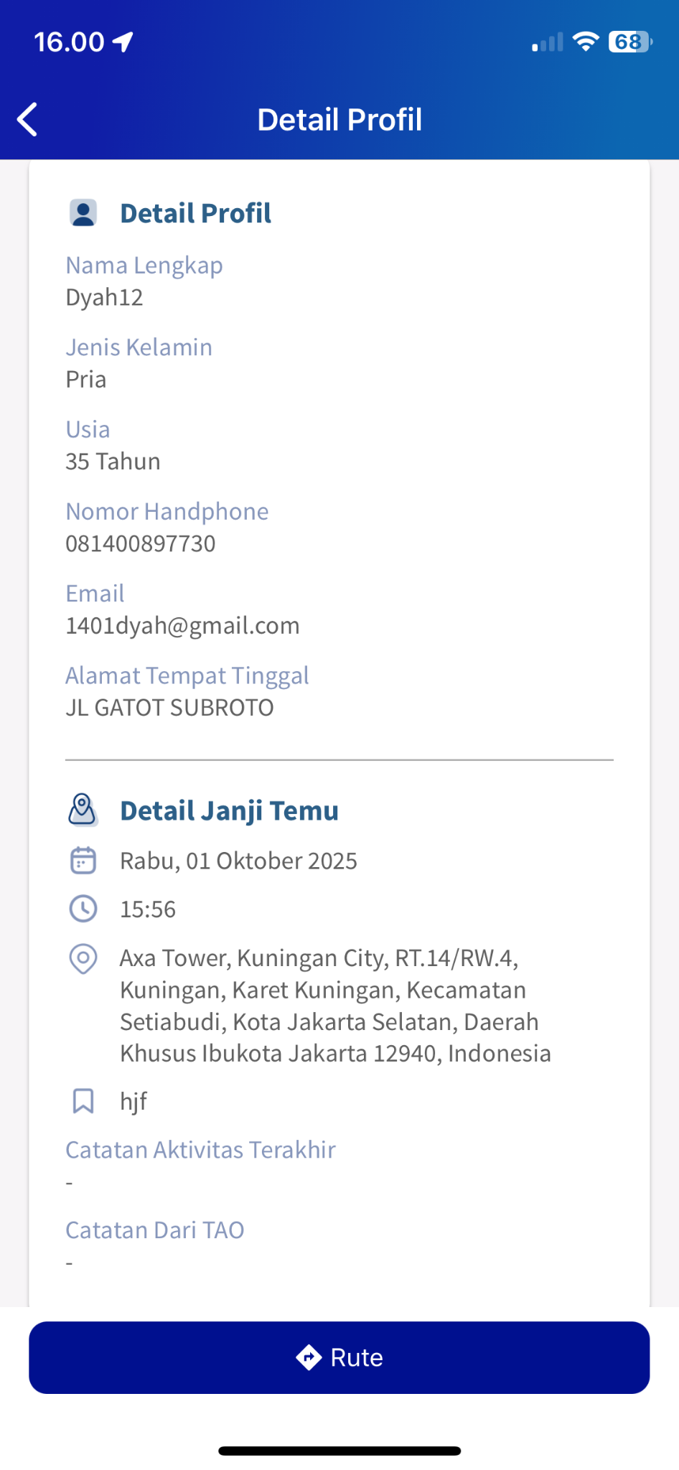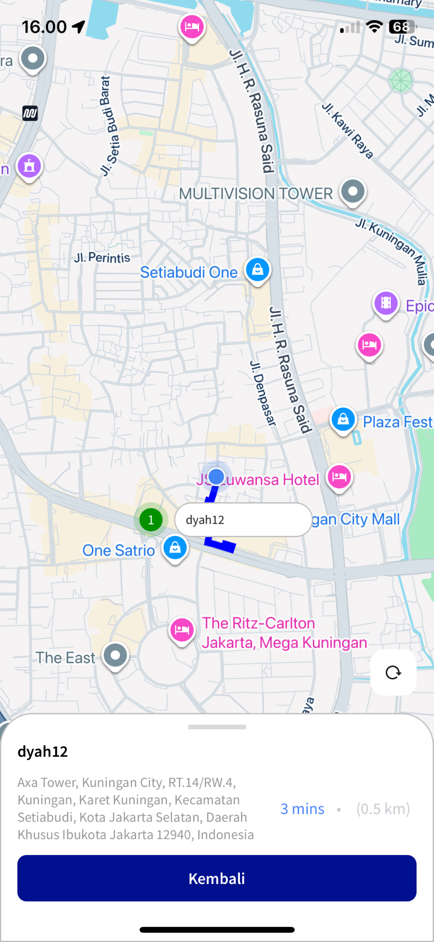

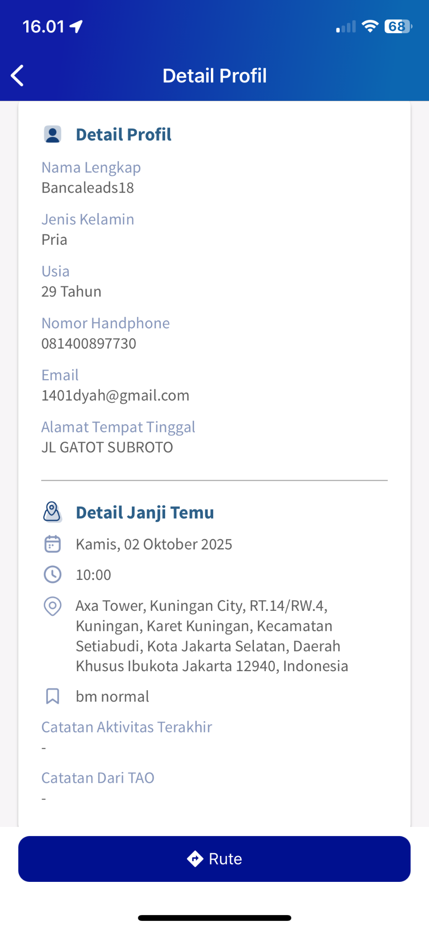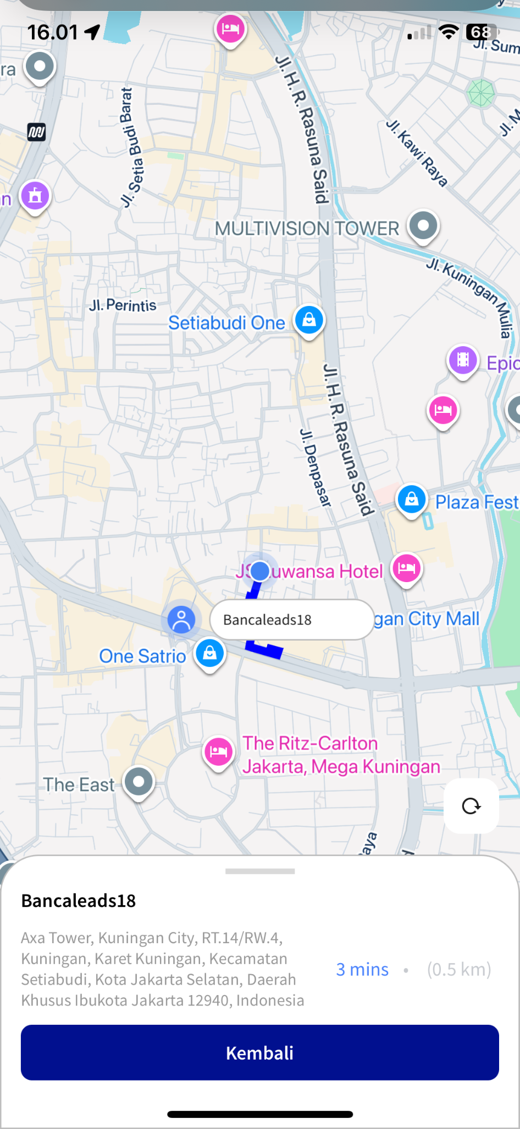

## Receive Email Nasabah

[TC 7.10.1 - TC 7.10.6]

### 

### Informasi Janji Temu

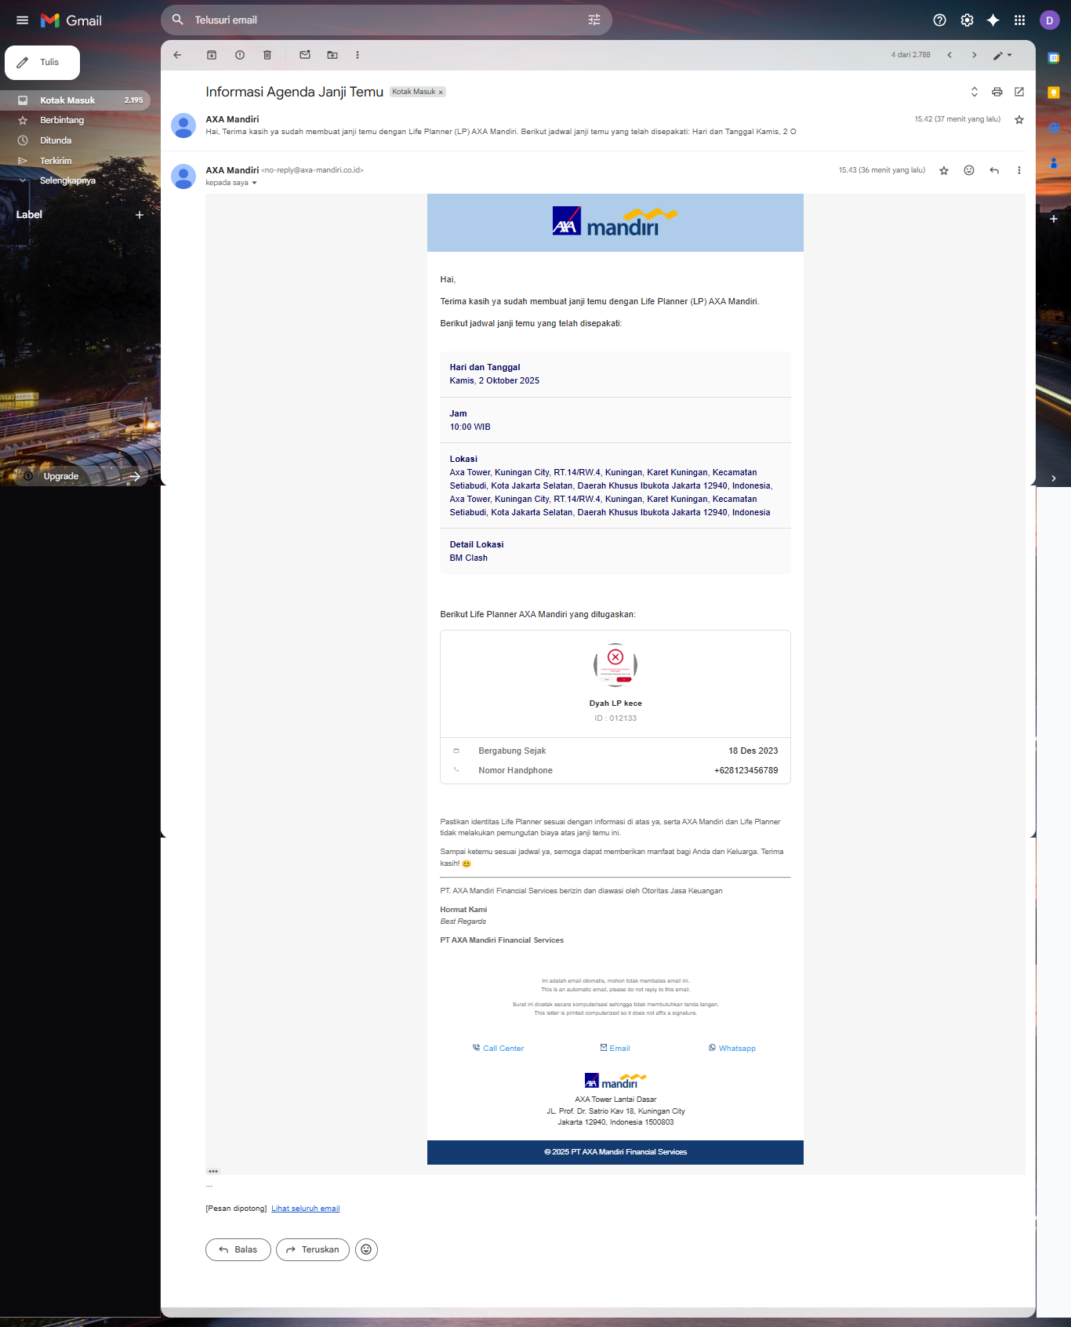

### Informasi Perubahan Agent Life Planner

### Informasi Perubahan Jadwal Janji Temu

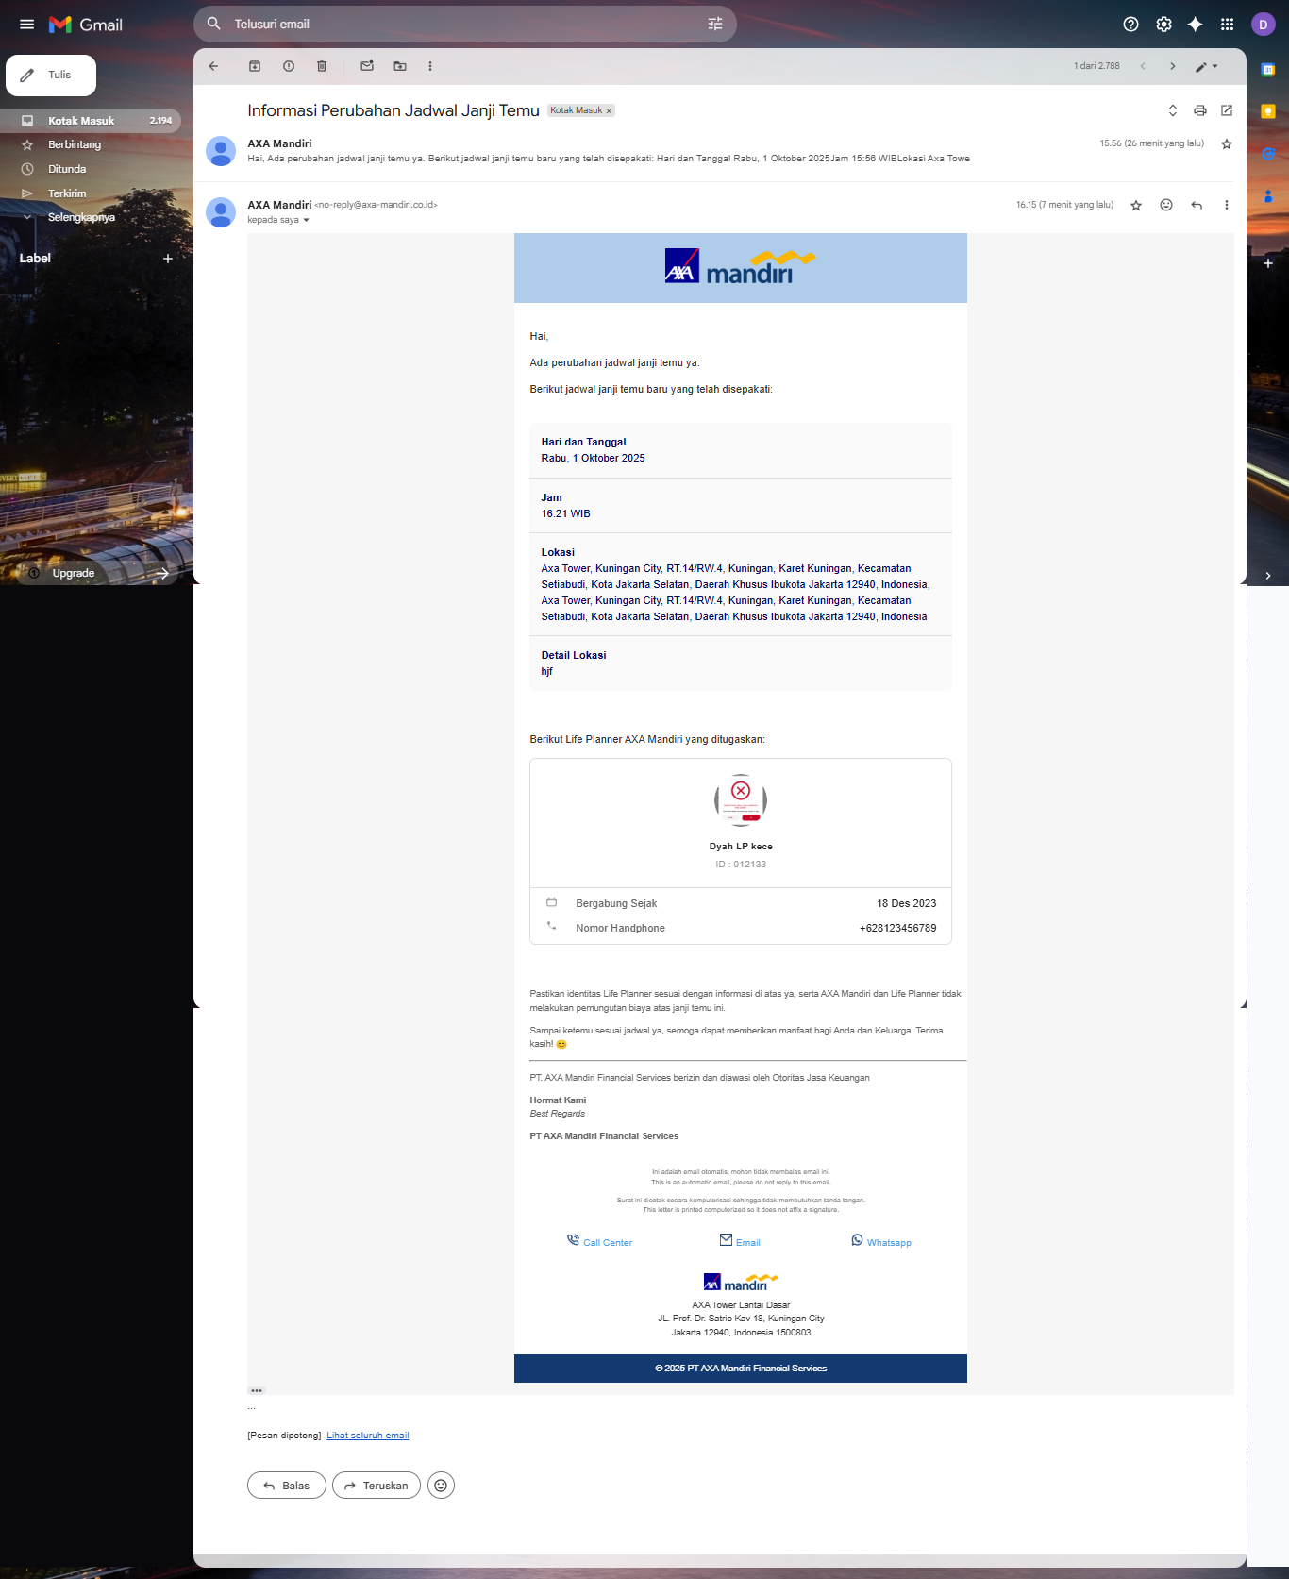

## Recording LP

[TC 7.11.1 - TC 7.11.6]

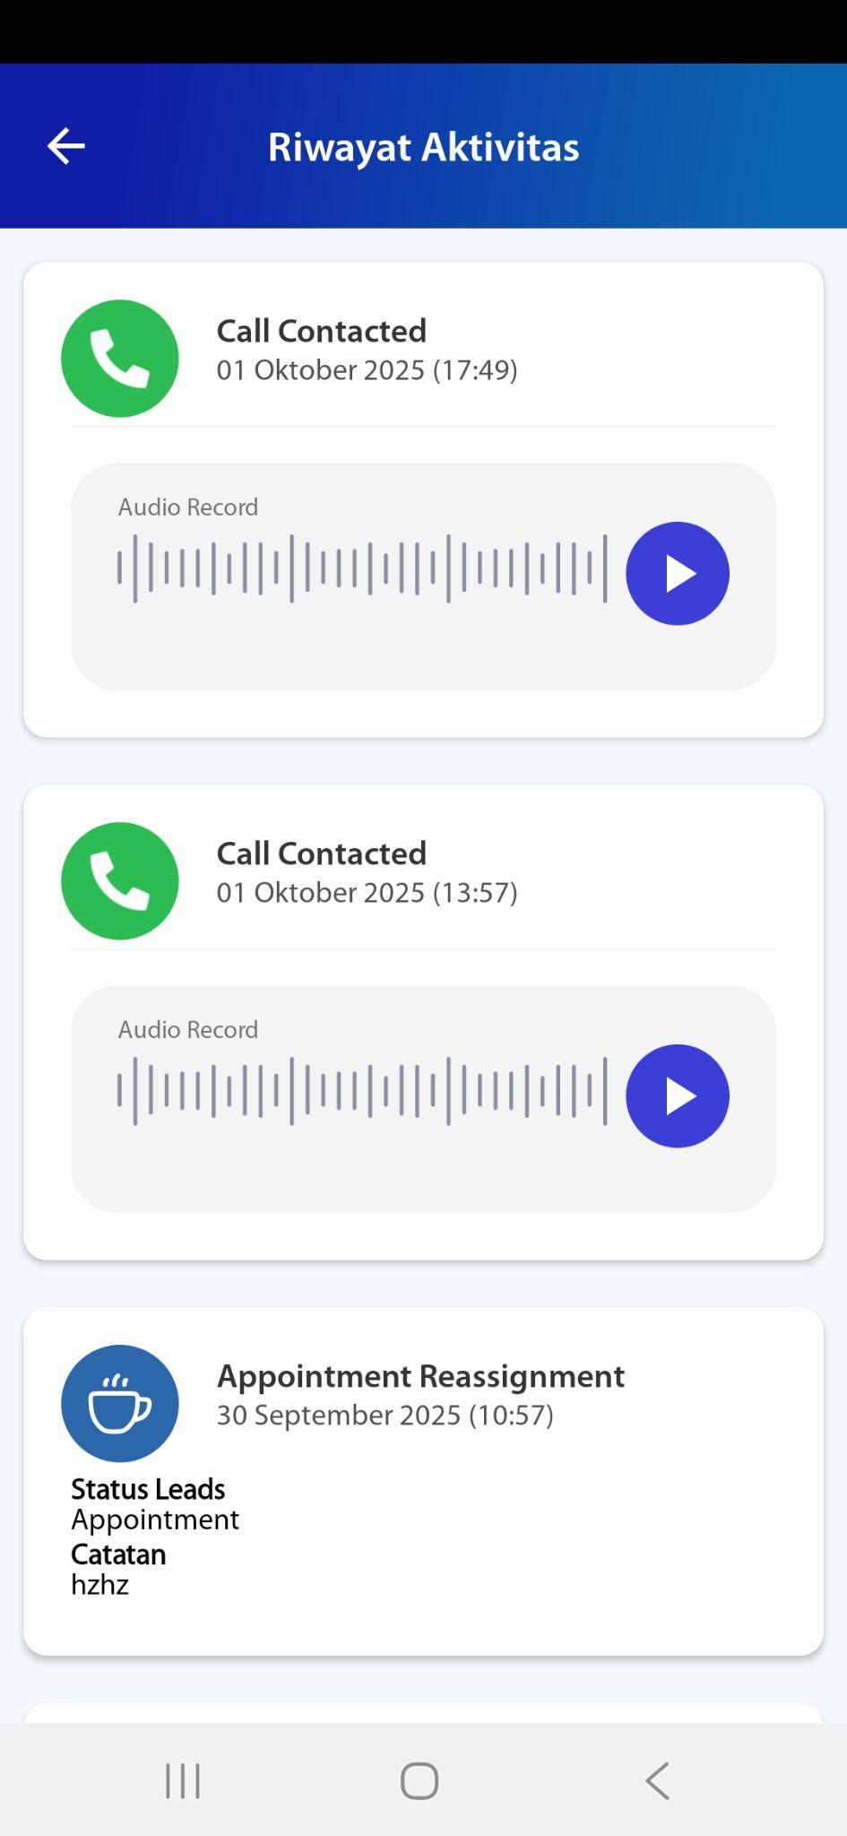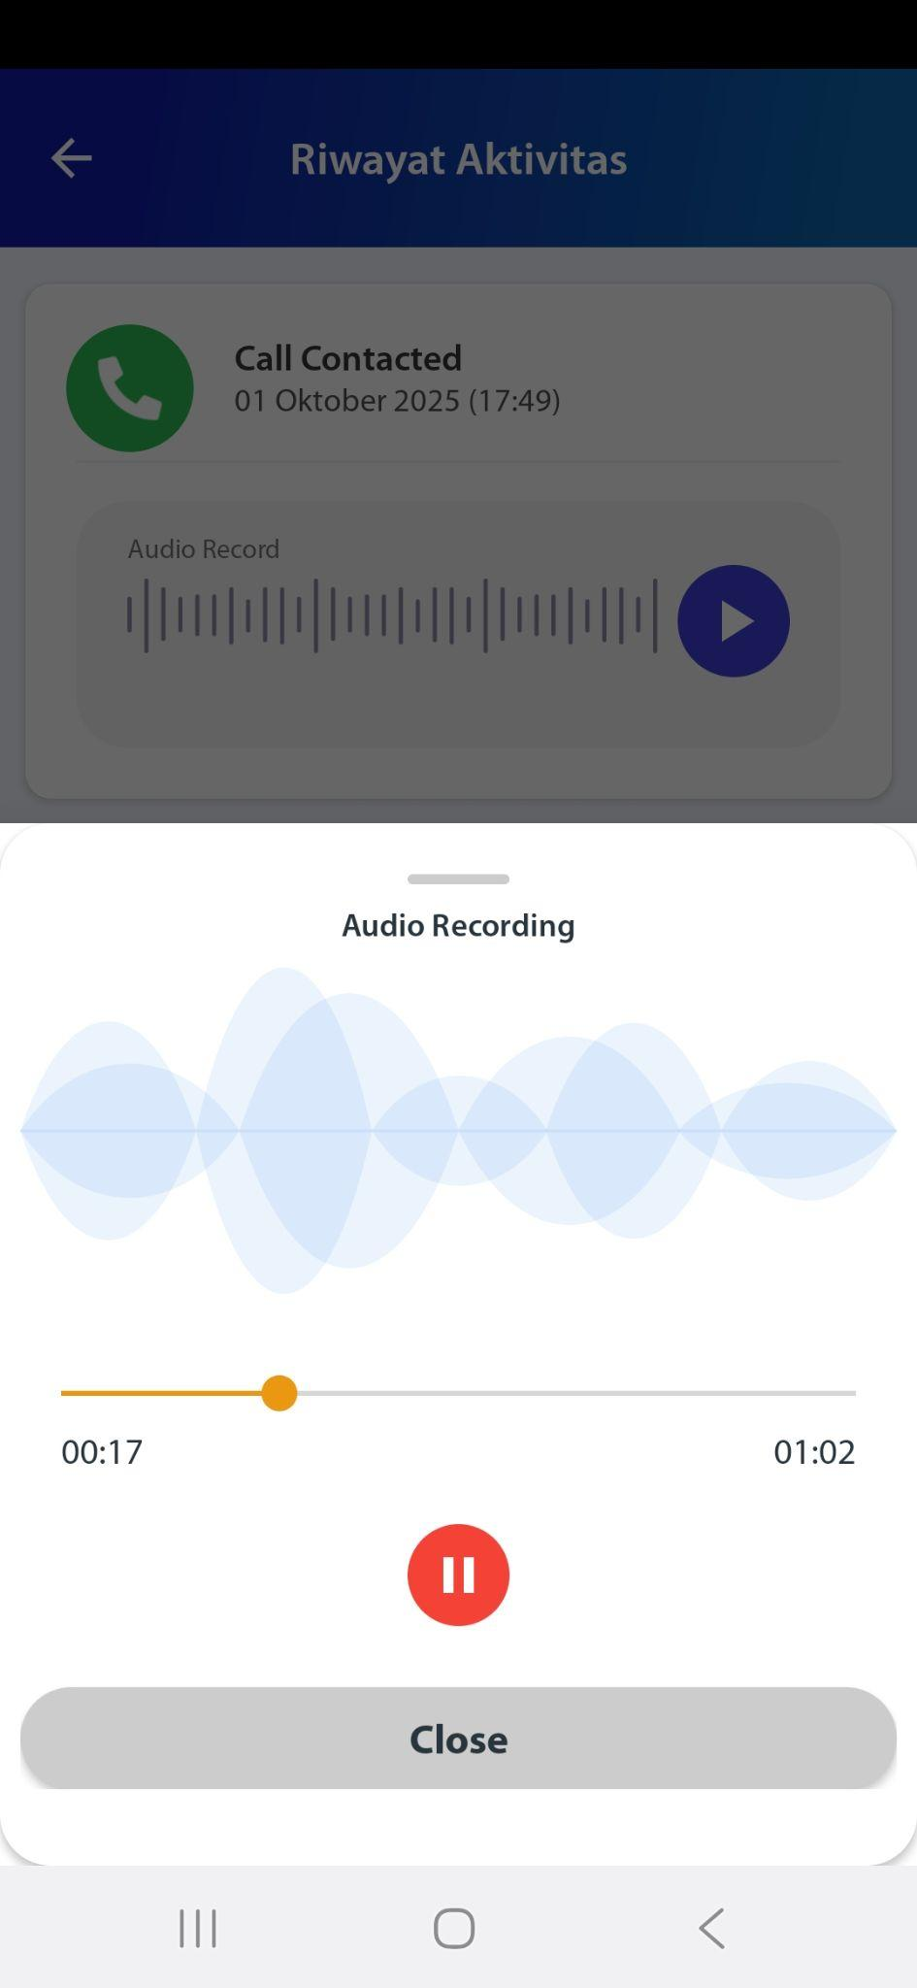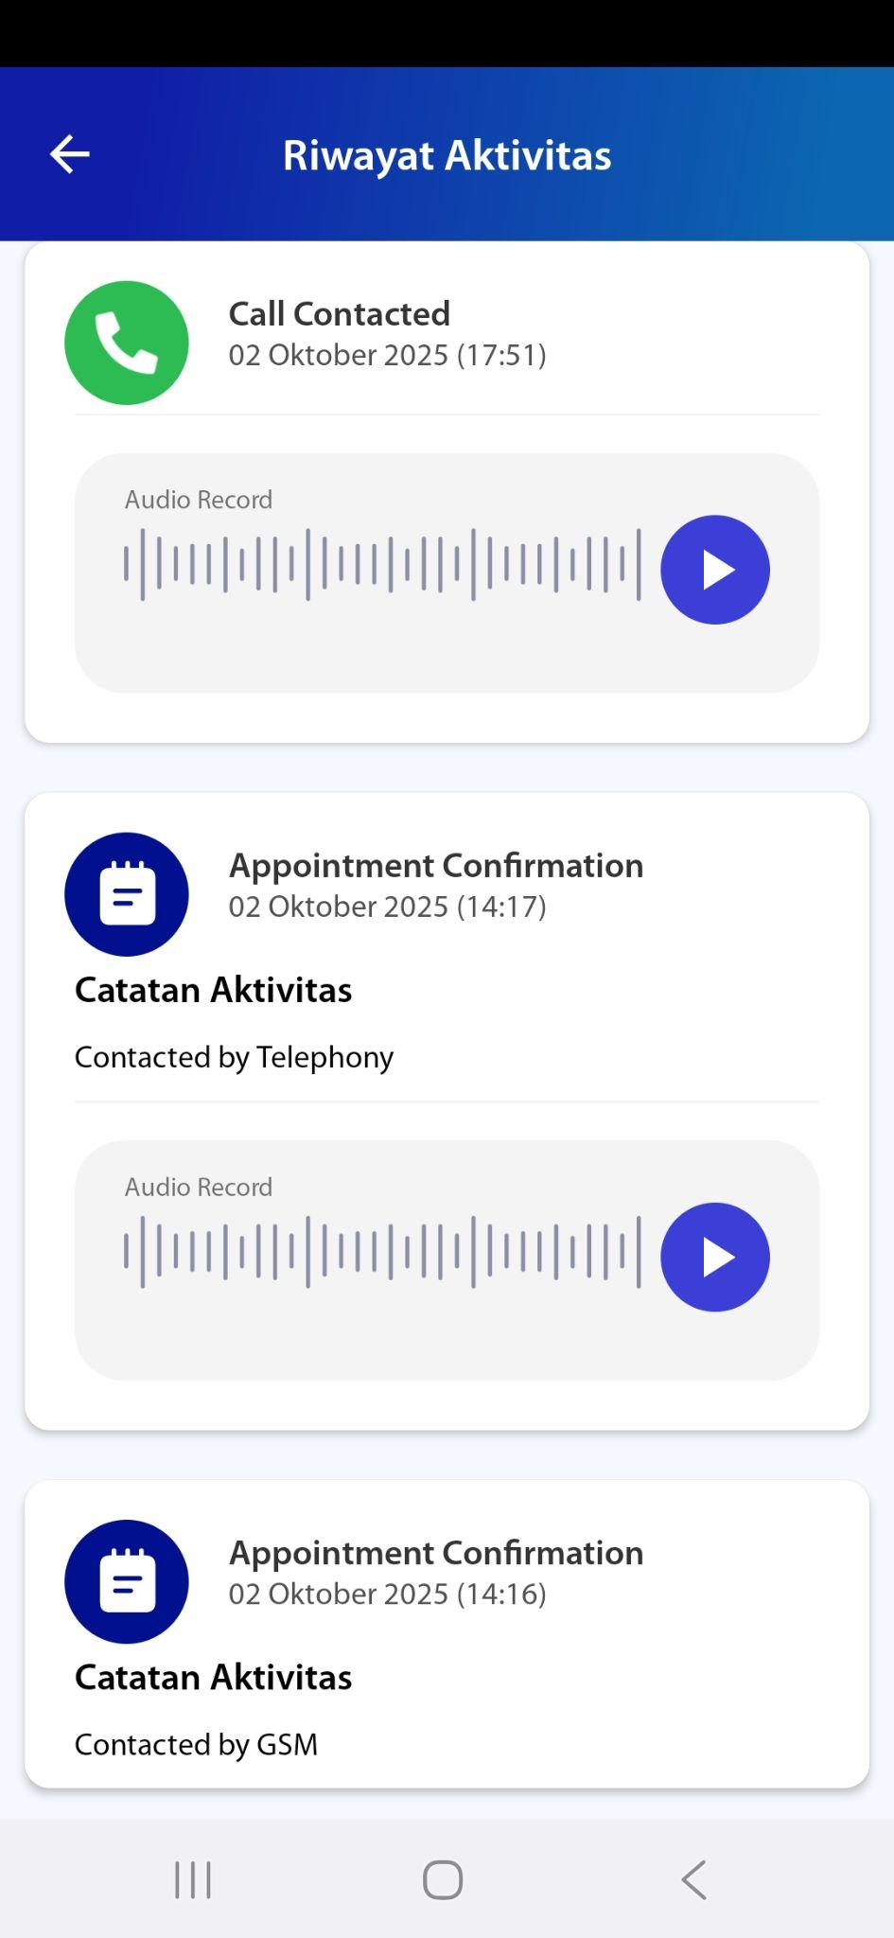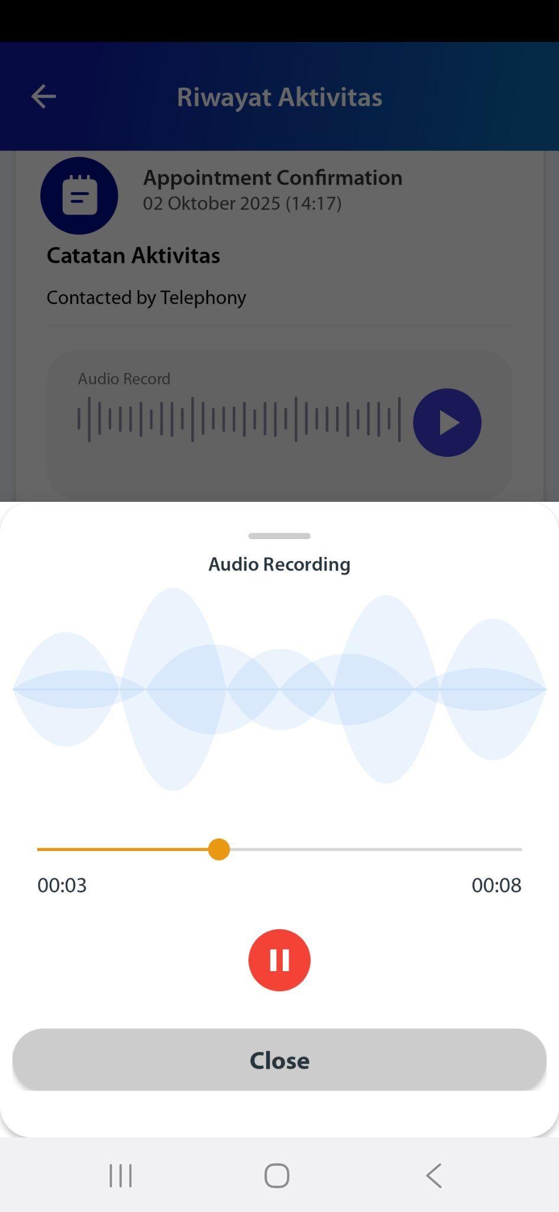

## API DB

[TC 2.8.1 - TC 2.8.3]

Curl

| curl --location 'https://wrdwebdlf02:80/gateway_service/clsj/ldm/api/v1/integration/leadsList' \  --header 'Access-Token: BD7IARwDpoygGECXHjN0jLmr0DeERW+k1efDjbhUufQ=' \  --header 'Content-Type: application/json' \  --data '{  "leadsId": null,  "leadsPhone": "6281400897730",  "leadsDOB" : "2000-10-10",  "leadsGender": "F",  "leadsProductCode": null,  "leadsStartDate" :null,  "leadsEndDate" :null,  "campaignName": ["emma referral","Self Generate"],  "limit": 100,  "page": 1  }' |
| --- |

Status Code

| 200 |
| --- |

Response

| {  "message": "Success",  "status": 1,  "page": 1,  "limit": 100,  "totalData": 2,  "data": [  {  "leadsId": "009664A3-C9A8-4AB4-B6C4-C254966C755D",  "leadsName": "ROXXXX SIT202506",  "leadsPhone": "6281400897730",  "leadsDOB": "2000-10-10",  "leadsGender": "F",  "leadsCreatedDate": "2025-06-25 16:41:06.787",  "leadsProductCode": null,  "leadsPolicyNumber": null,  "leadsReferralCode": null,  "campaignName": "EMMA Referral",  "statusHistory": [  {  "statusCode": null,  "statusDatetime": "2025-06-25 21:42:55.750",  "statusDescription": "Retry"  },  {  "statusCode": null,  "statusDatetime": "2025-06-25 21:43:46.013",  "statusDescription": "QC"  },  {  "statusCode": null,  "statusDatetime": "2025-06-25 21:43:46.013",  "statusDescription": "QC"  },  {  "statusCode": null,  "statusDatetime": "2025-06-26 13:30:23.050",  "statusDescription": "Appointment"  },  {  "statusCode": null,  "statusDatetime": "2025-06-26 13:30:23.047",  "statusDescription": "Approved"  }  ],  "agenCode": "700311",  "agenName": "sit.lp.2",  "agenReassignment": false,  "agenReassignmentName": "",  "agenReassignmentCode": 0  },  {  "leadsId": null,  "leadsName": "Roxxxx Sit202506",  "leadsPhone": "6281400897730",  "leadsDOB": "2000-10-10",  "leadsGender": "F",  "leadsCreatedDate": "2025-06-26 13:31:50.708",  "leadsProductCode": null,  "leadsPolicyNumber": null,  "leadsReferralCode": null,  "campaignName": "Self Generate",  "statusHistory": [  {  "statusCode": null,  "statusDatetime": "2025-06-26 13:31:50.707",  "statusDescription": "Appointment"  }  ],  "agenCode": "700311",  "agenName": "sit.lp.2",  "agenReassignment": false,  "agenReassignmentName": "",  "agenReassignmentCode": 0  }  ]  } |
| --- |

Screenshoot

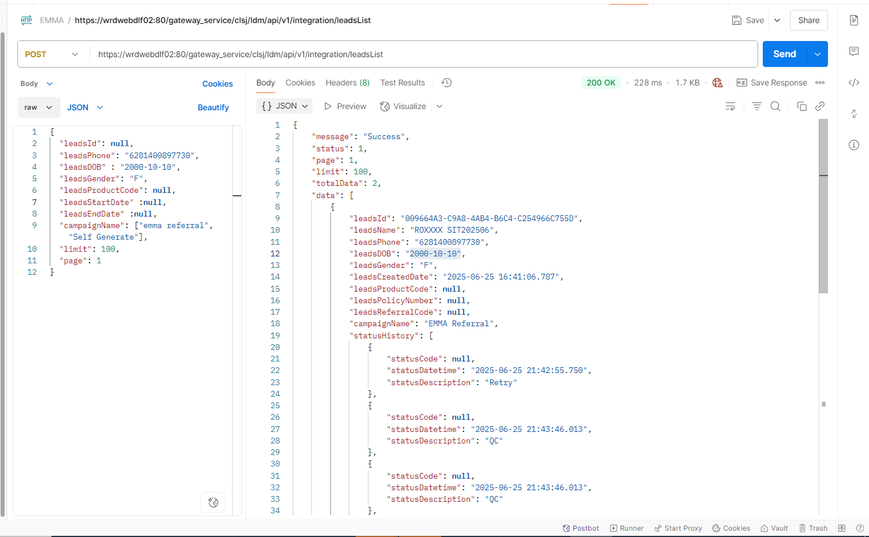

# ROLE : SALES LEADER

## Dashboard - Aktivitas - All Campaign

[TC 8.1.1 - TC 8.1.14]

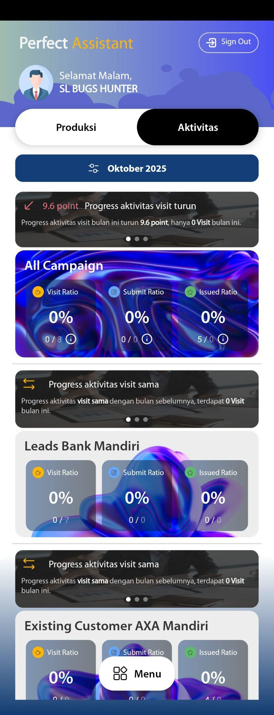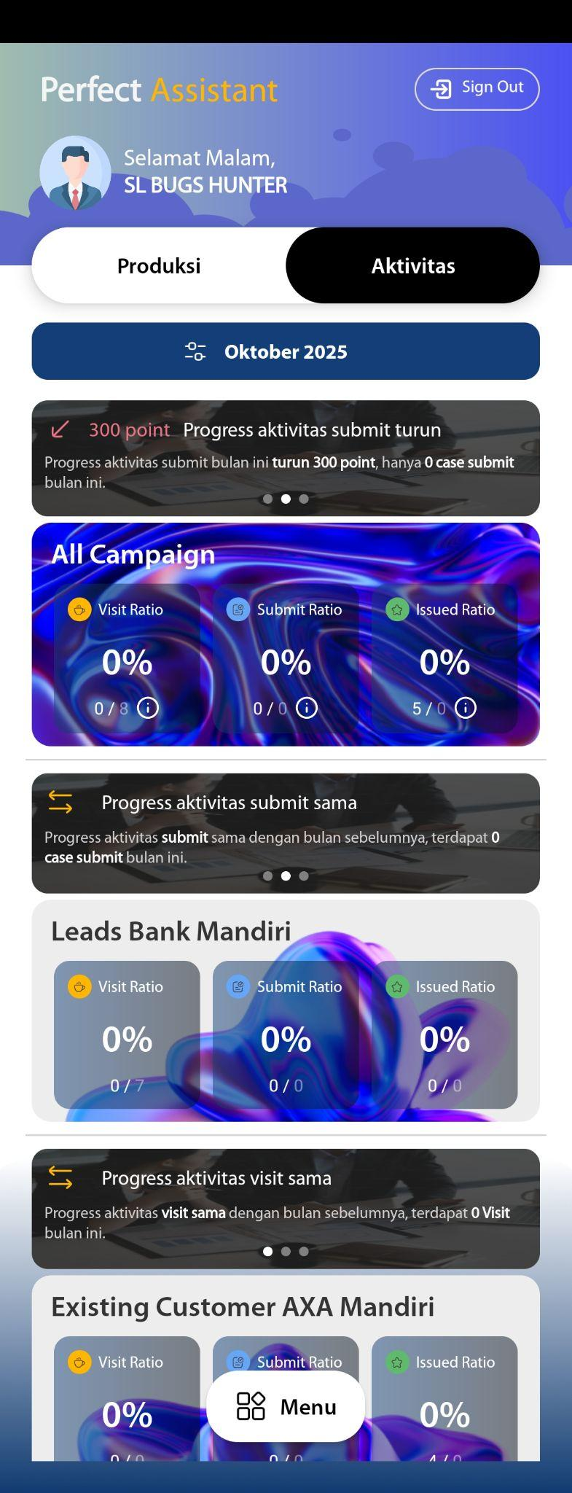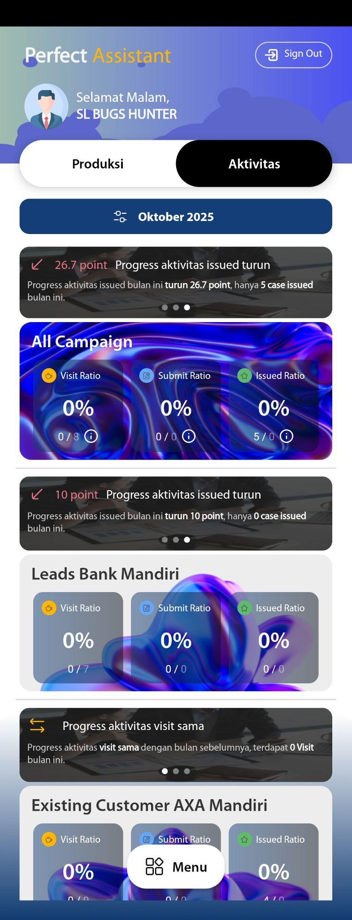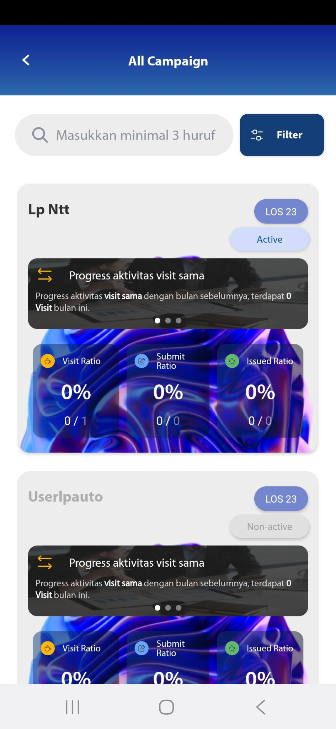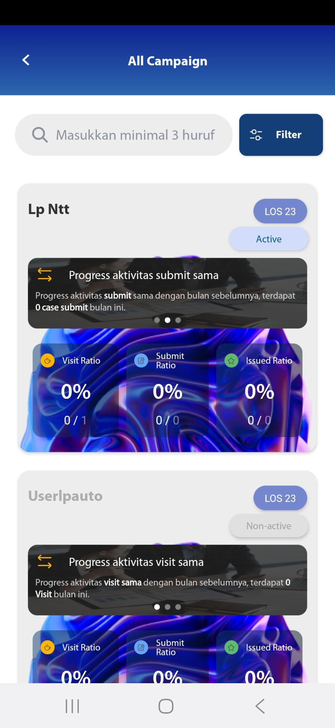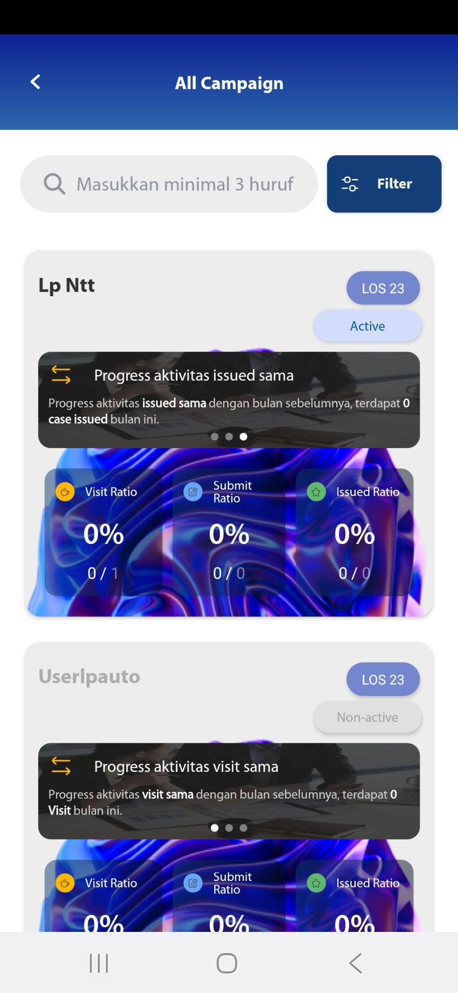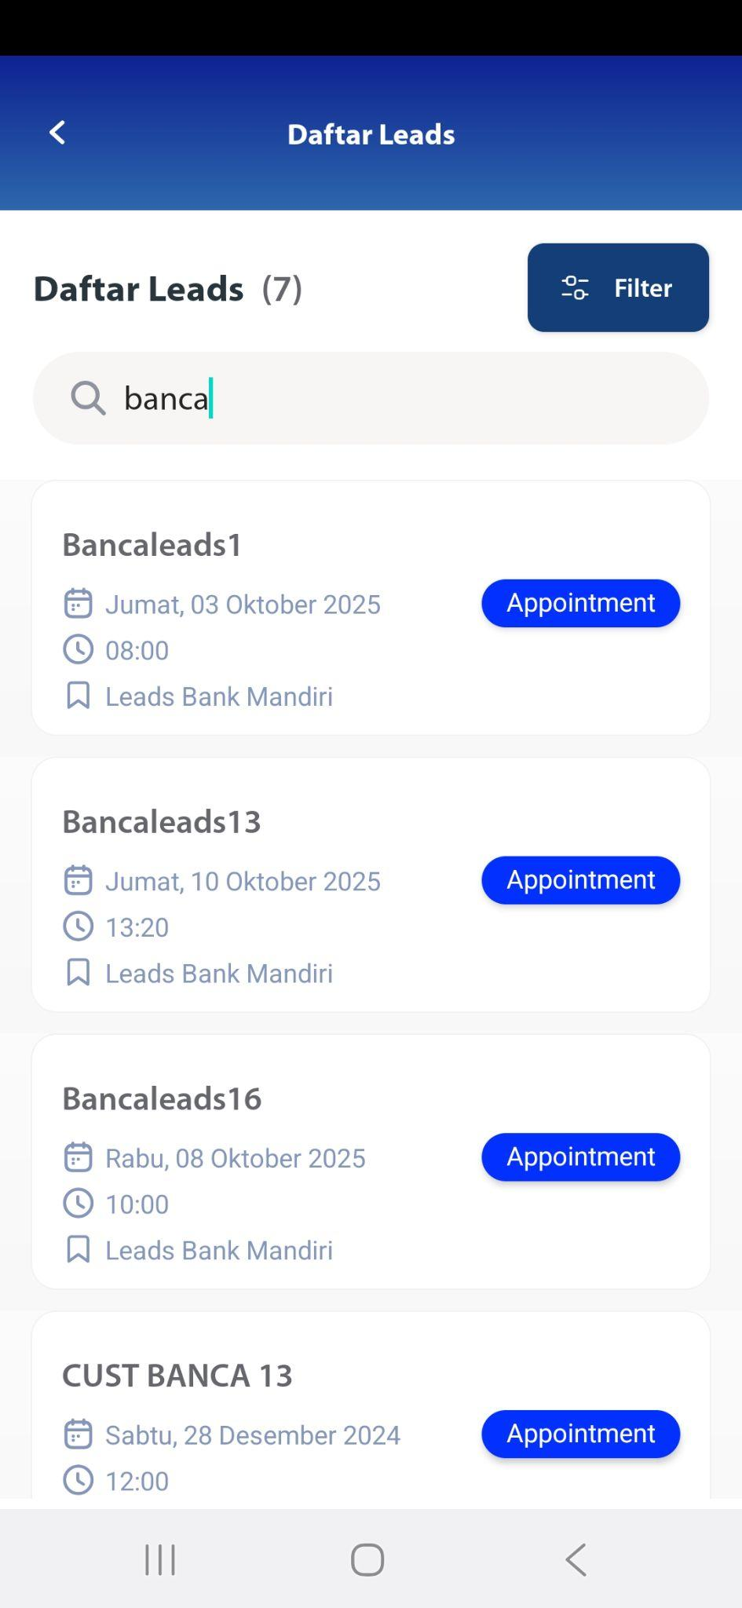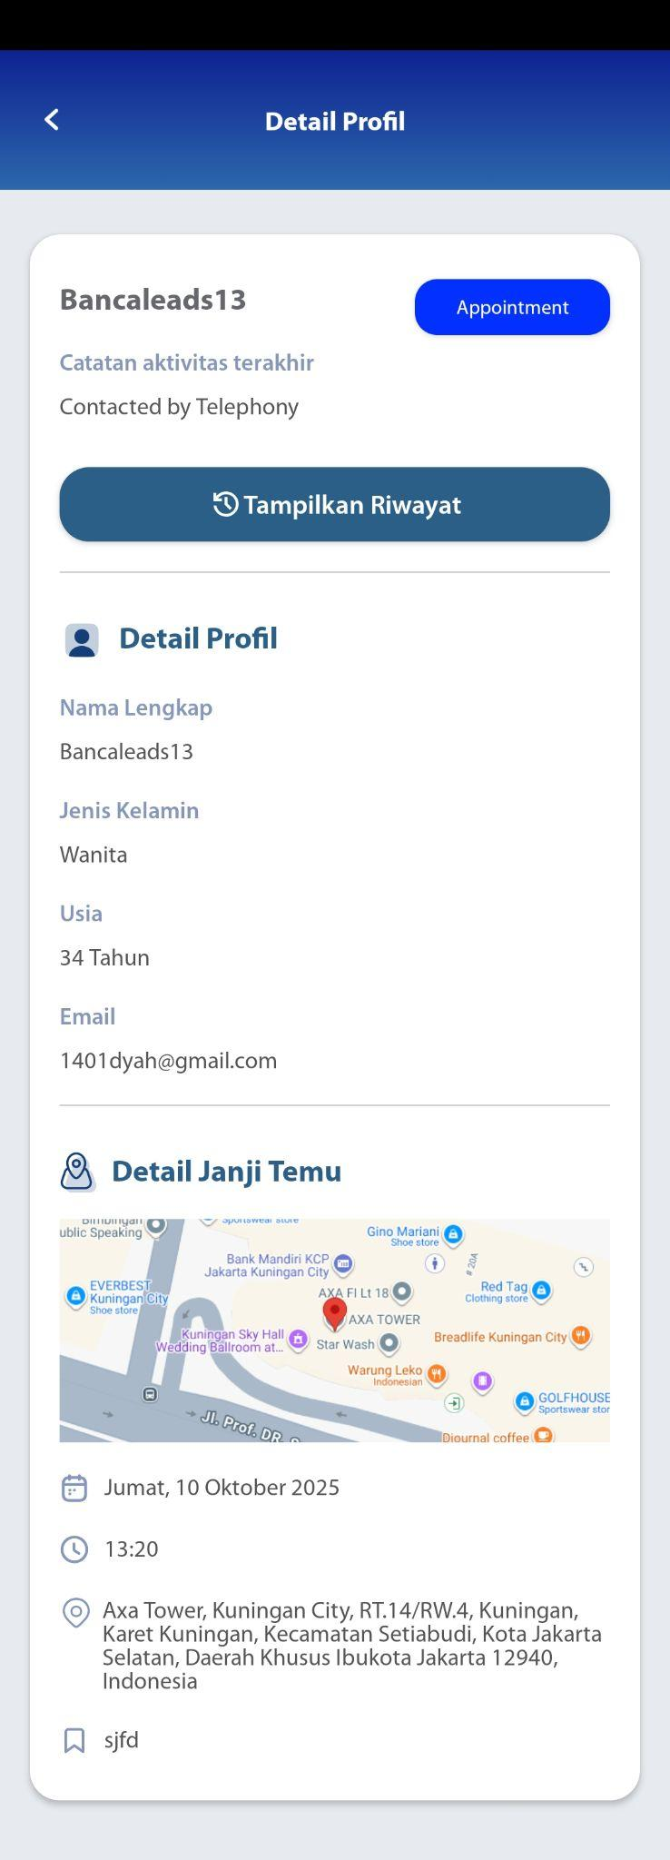

## Dashboard - Aktivitas – Campaign Leads Bank Mandiri

[TC 8.2.1 TC 8.2.14]



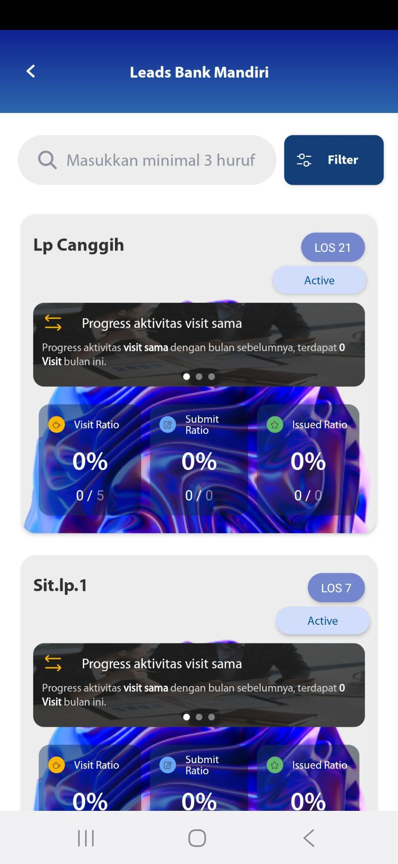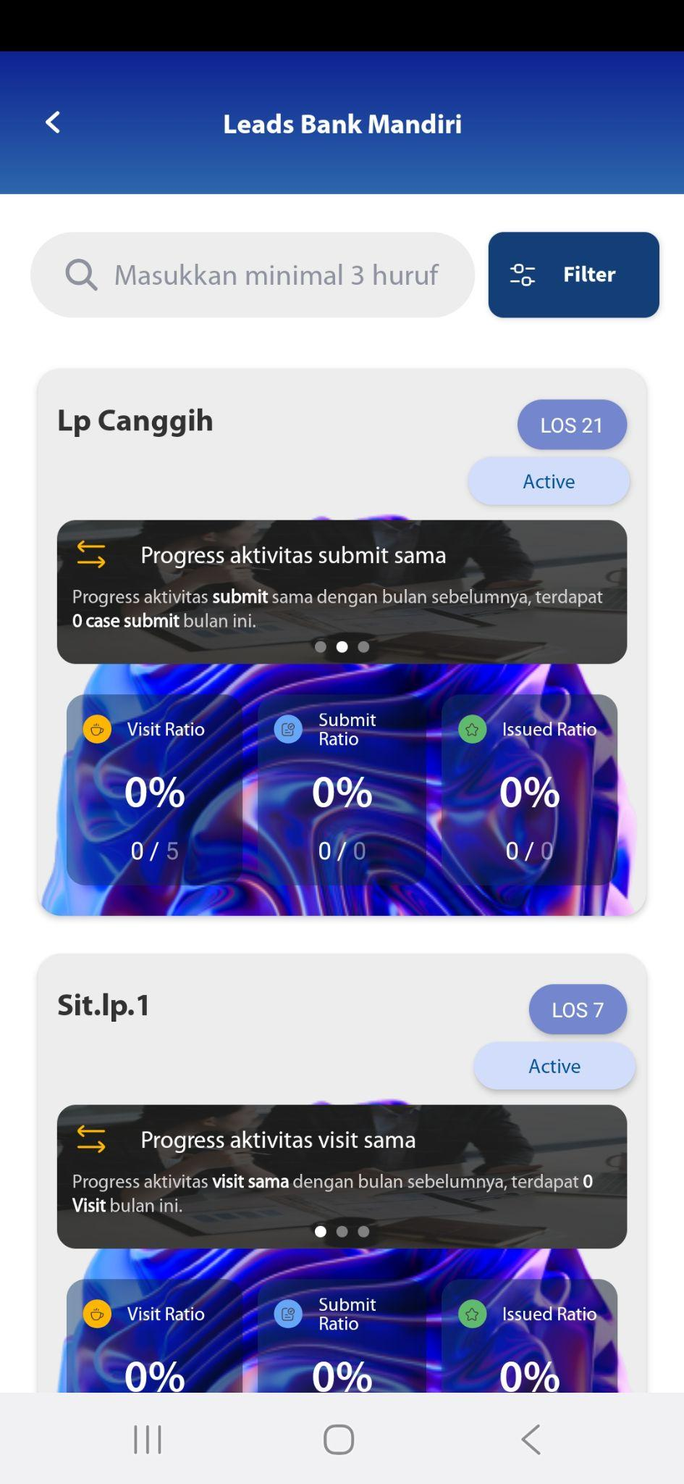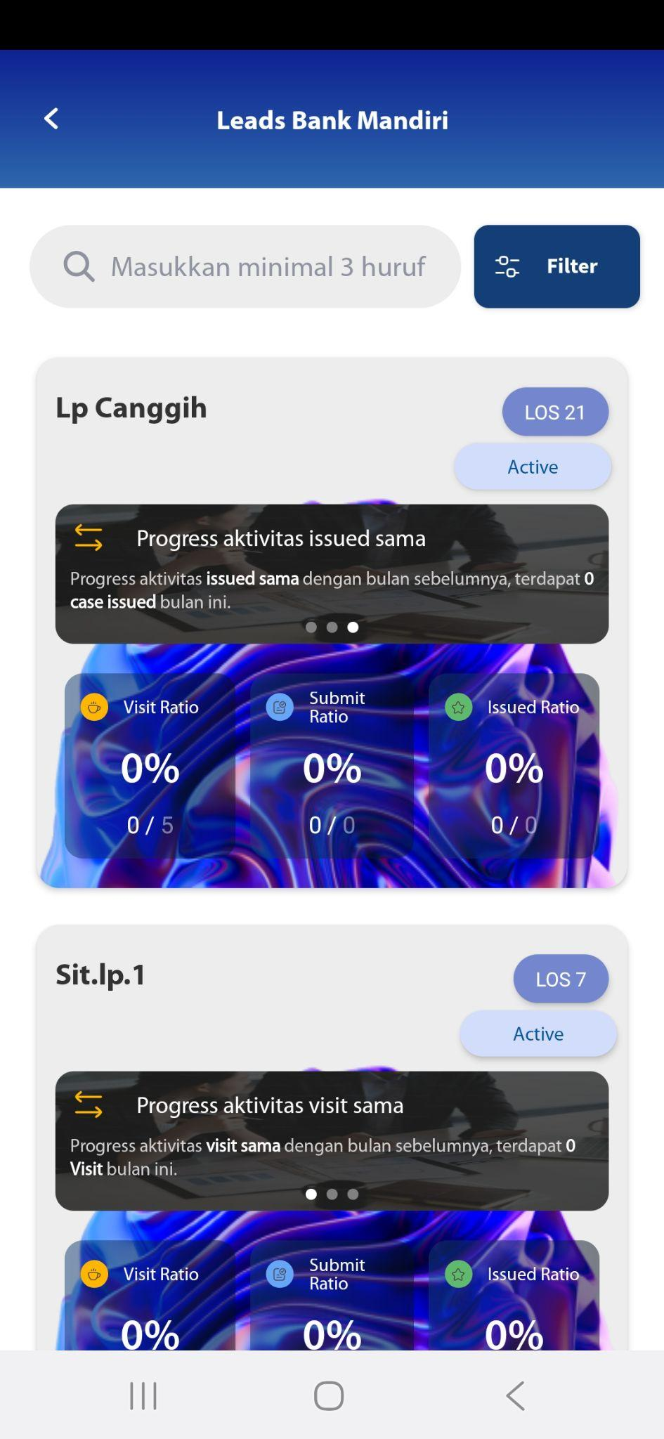



## Reassignment

[TC 8.3.1 - TC 8.3.8]

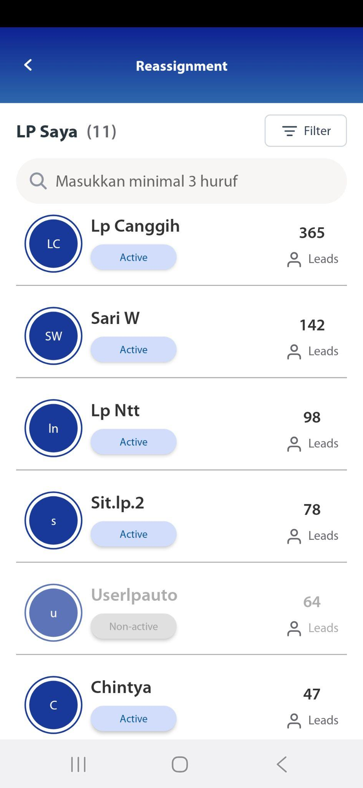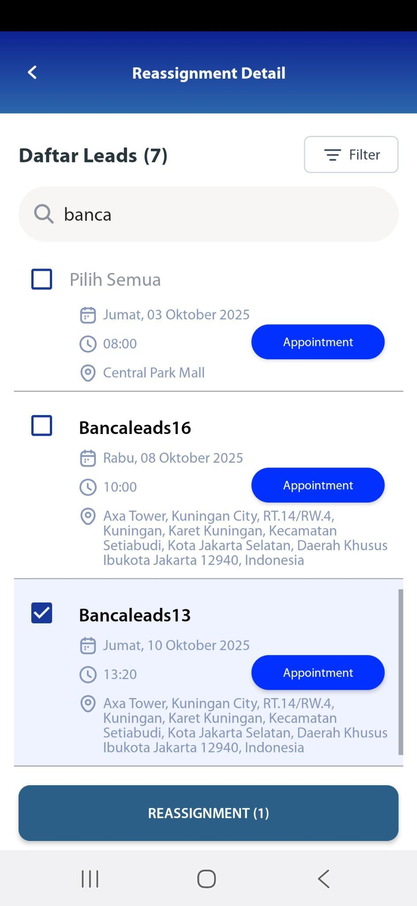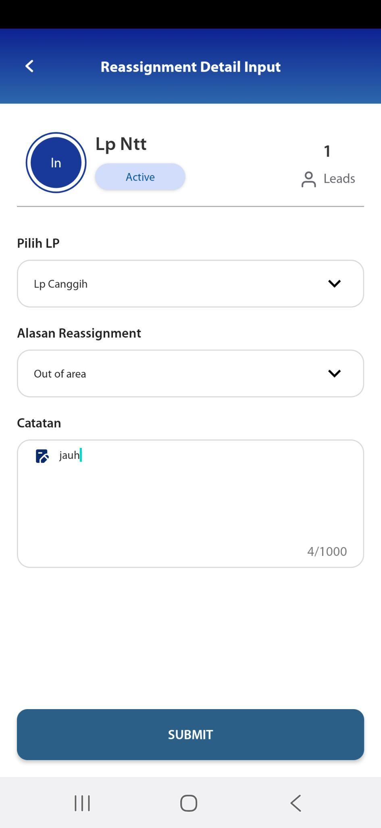

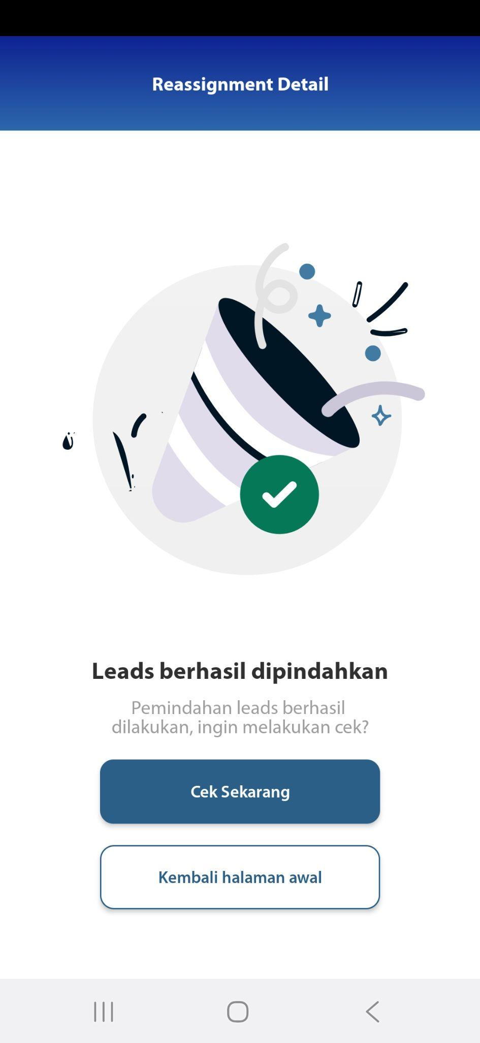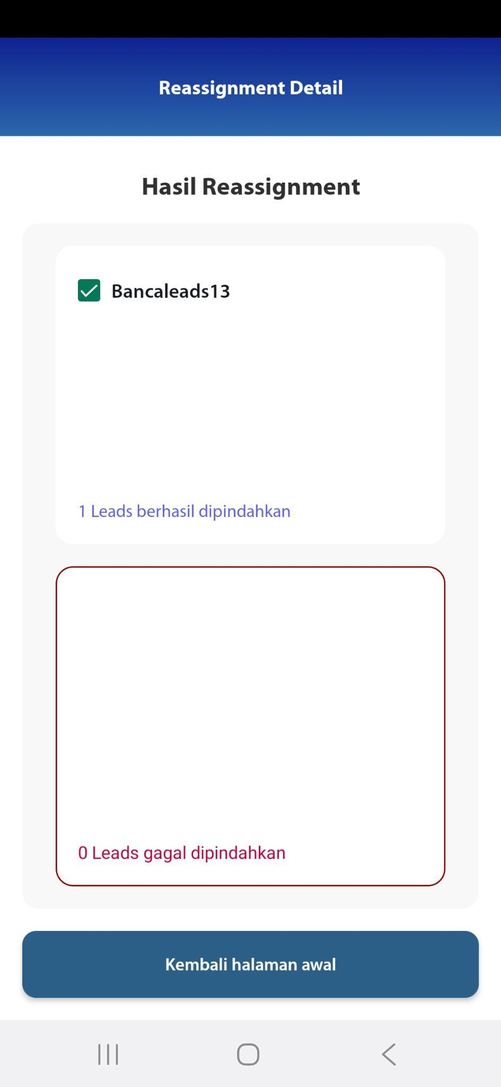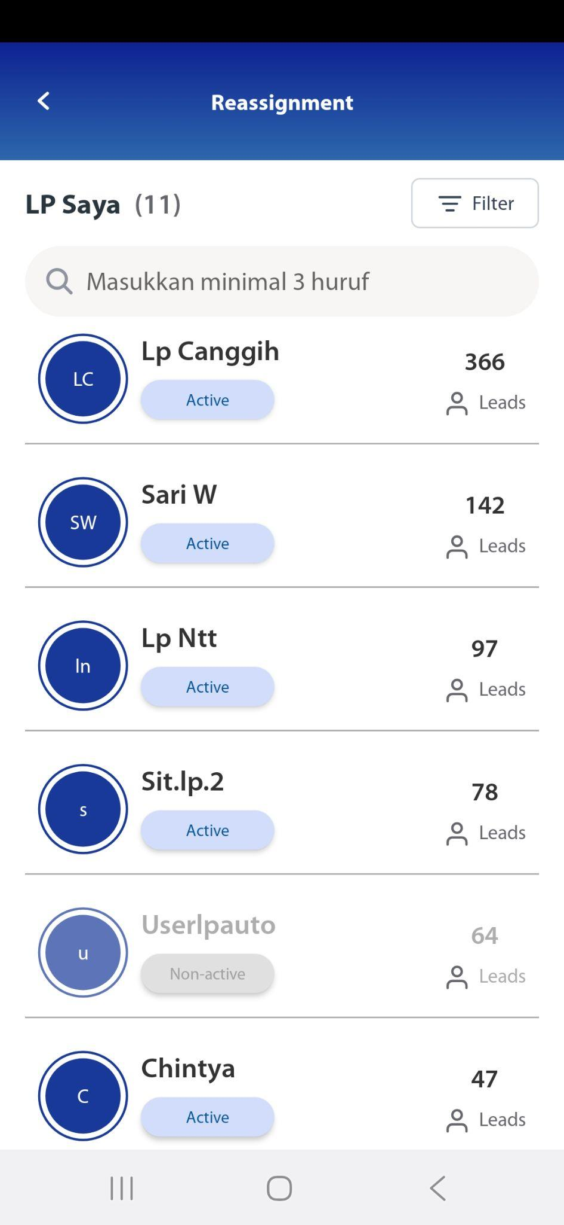

## Calender Activity

[TC 8.4.1 - TC 8.4.3]

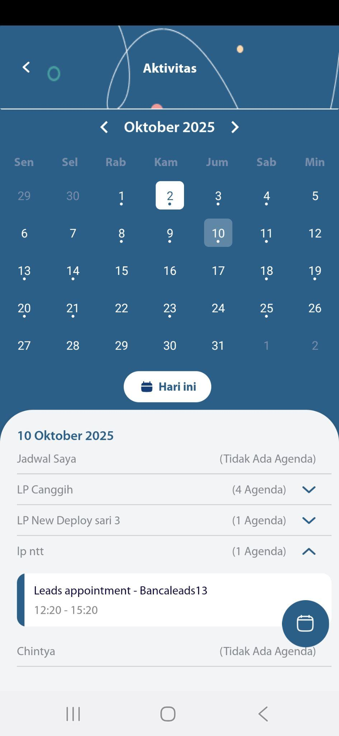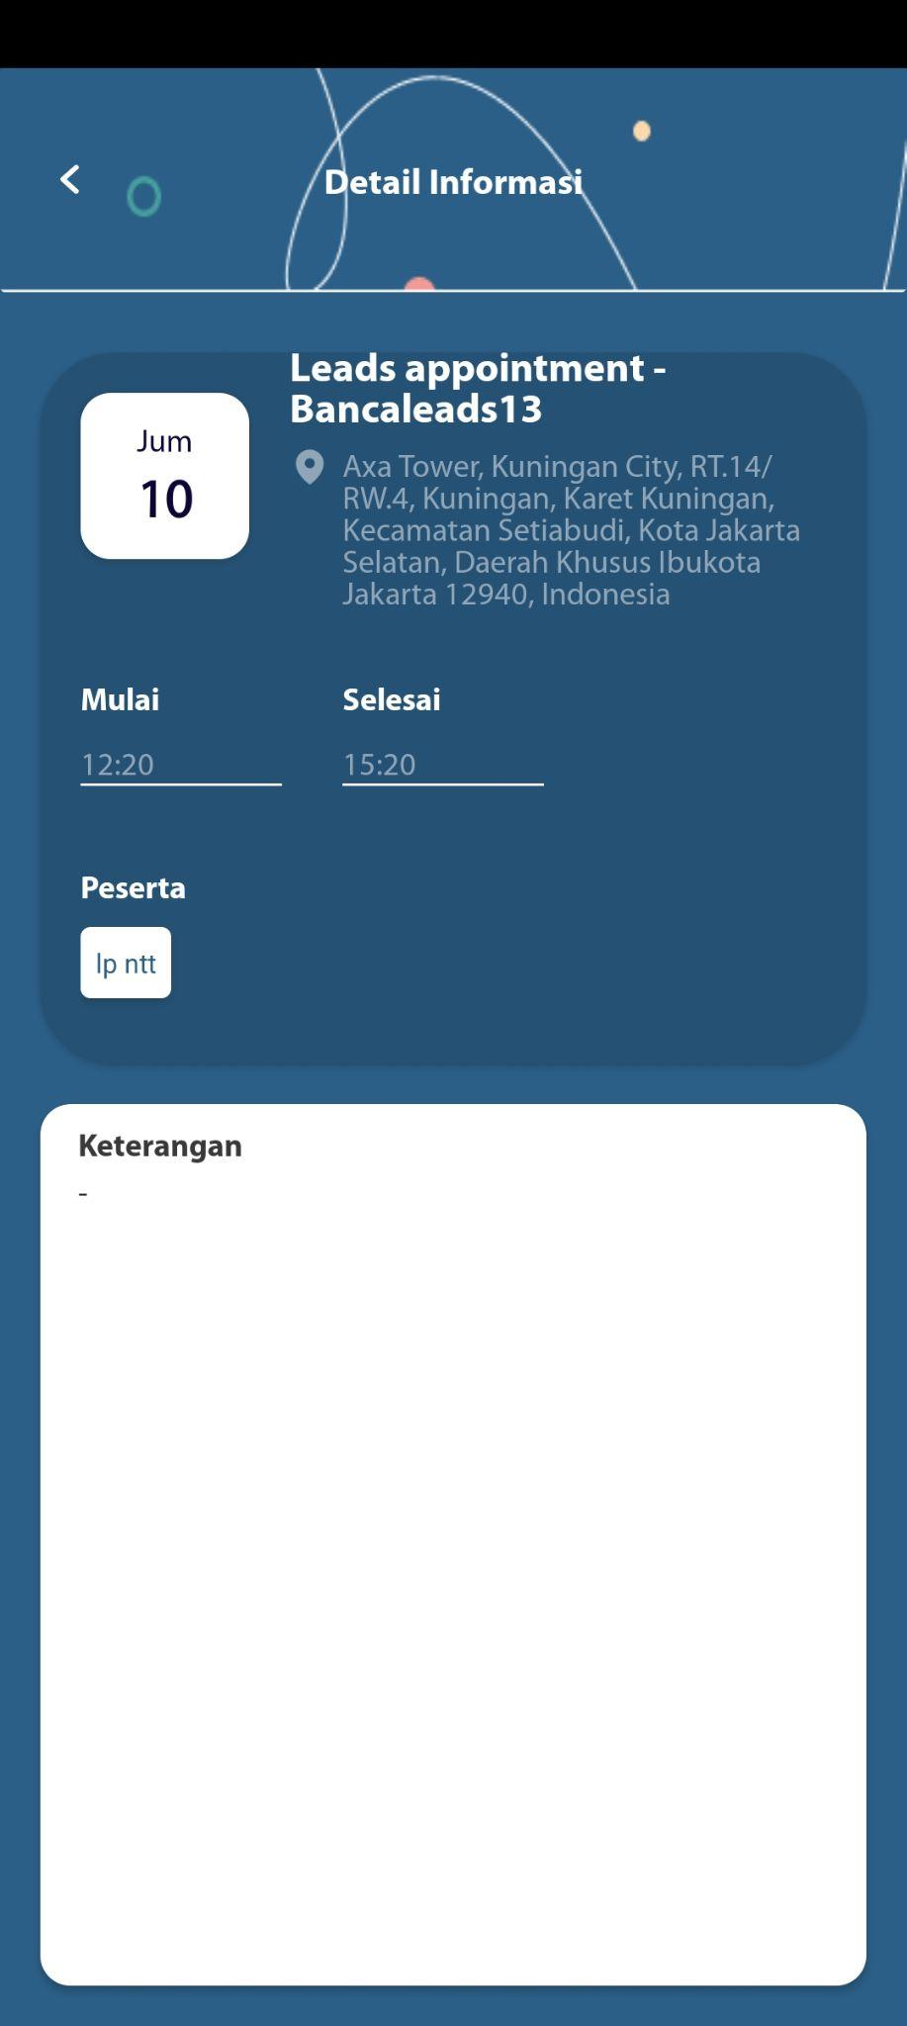

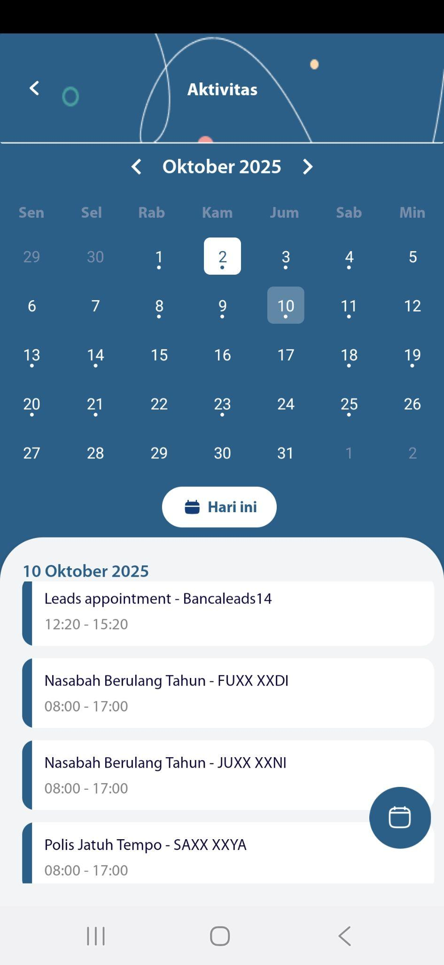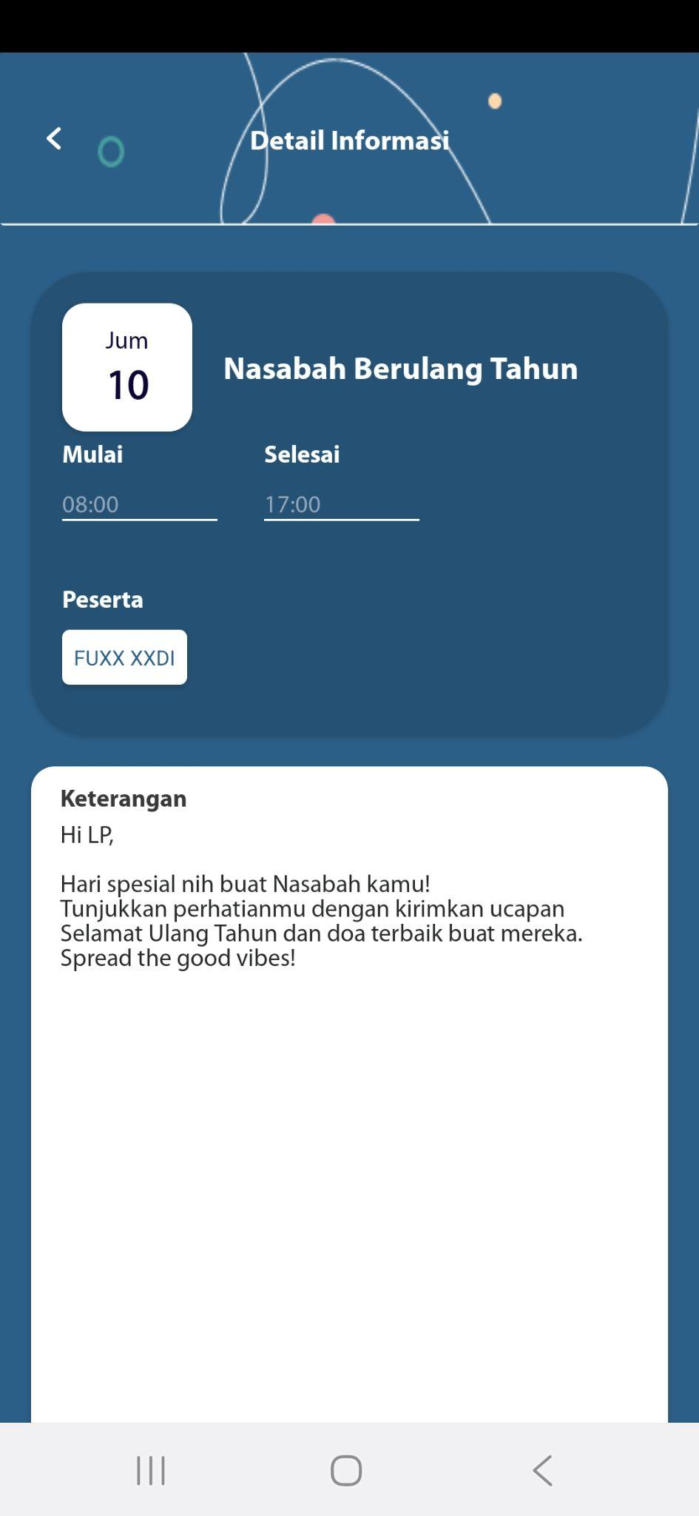

## Recording

[TC 8.5.1 - TC 8.5.5]

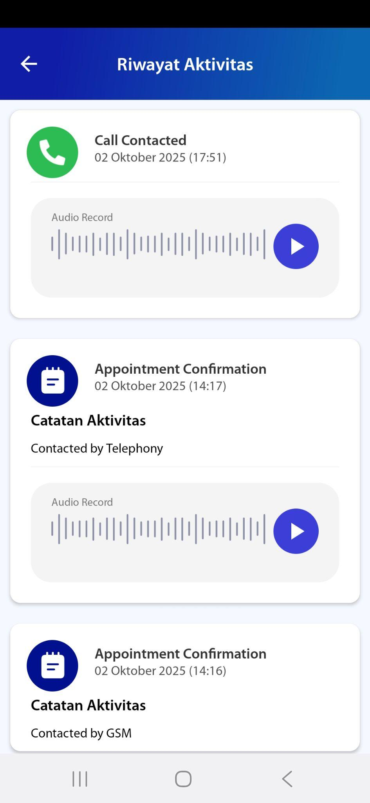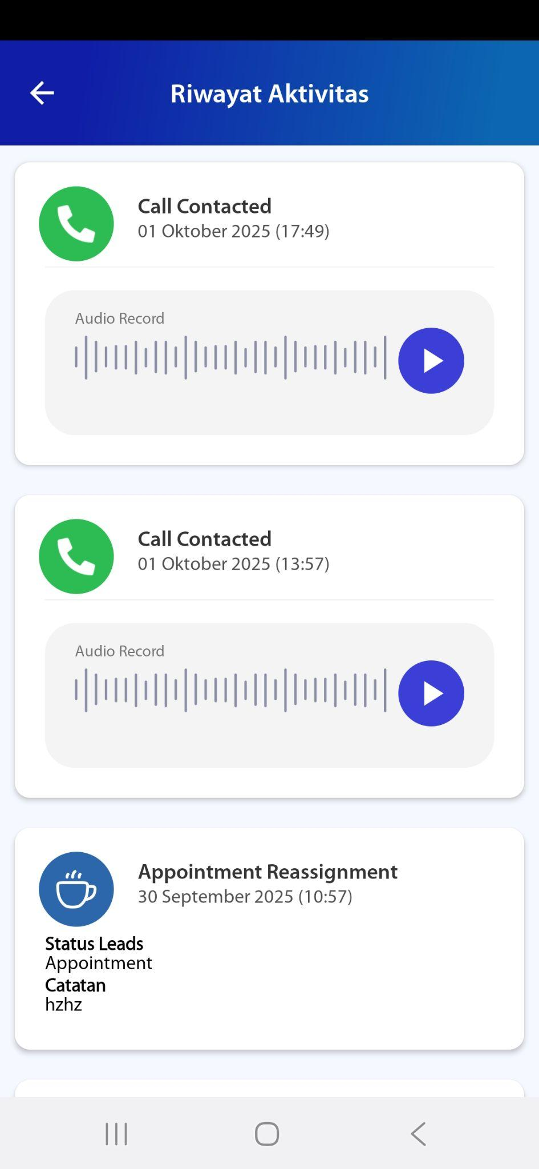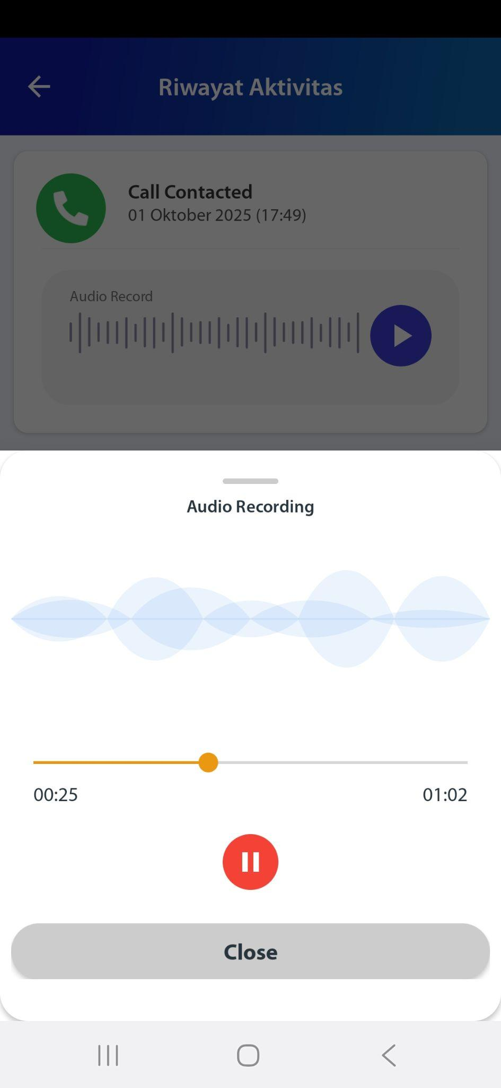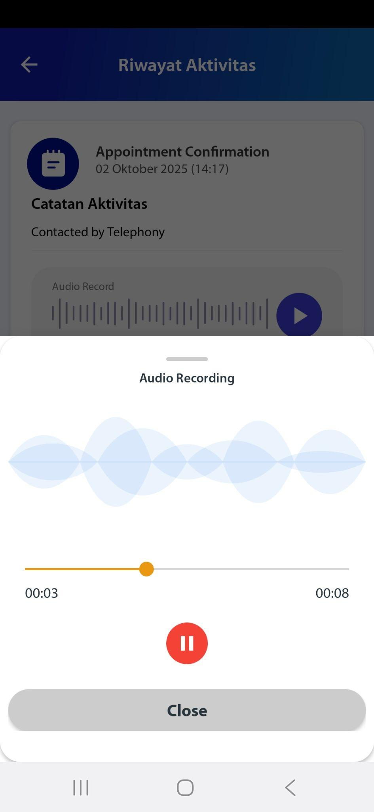

# ROLE : HEAD OF SALES

## Dashboard - Aktivitas - All Campaign

[TC 9.1.1 - TC 9.1.14]

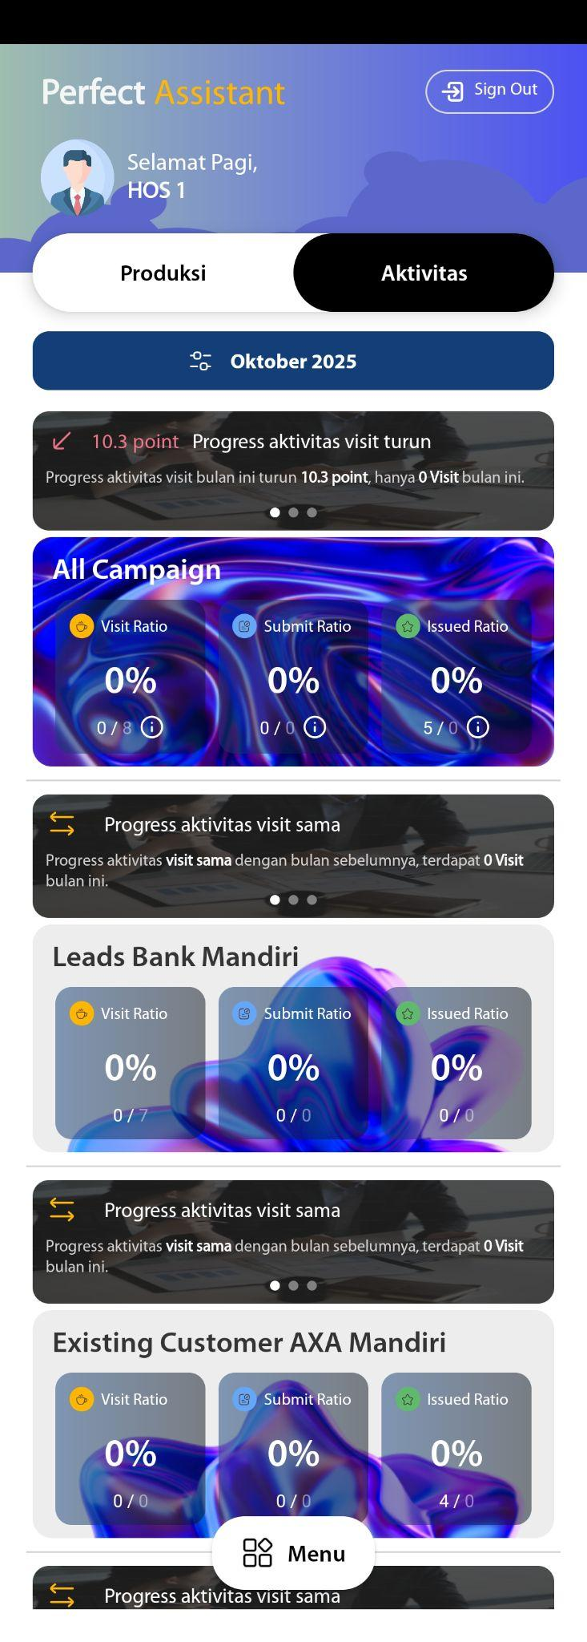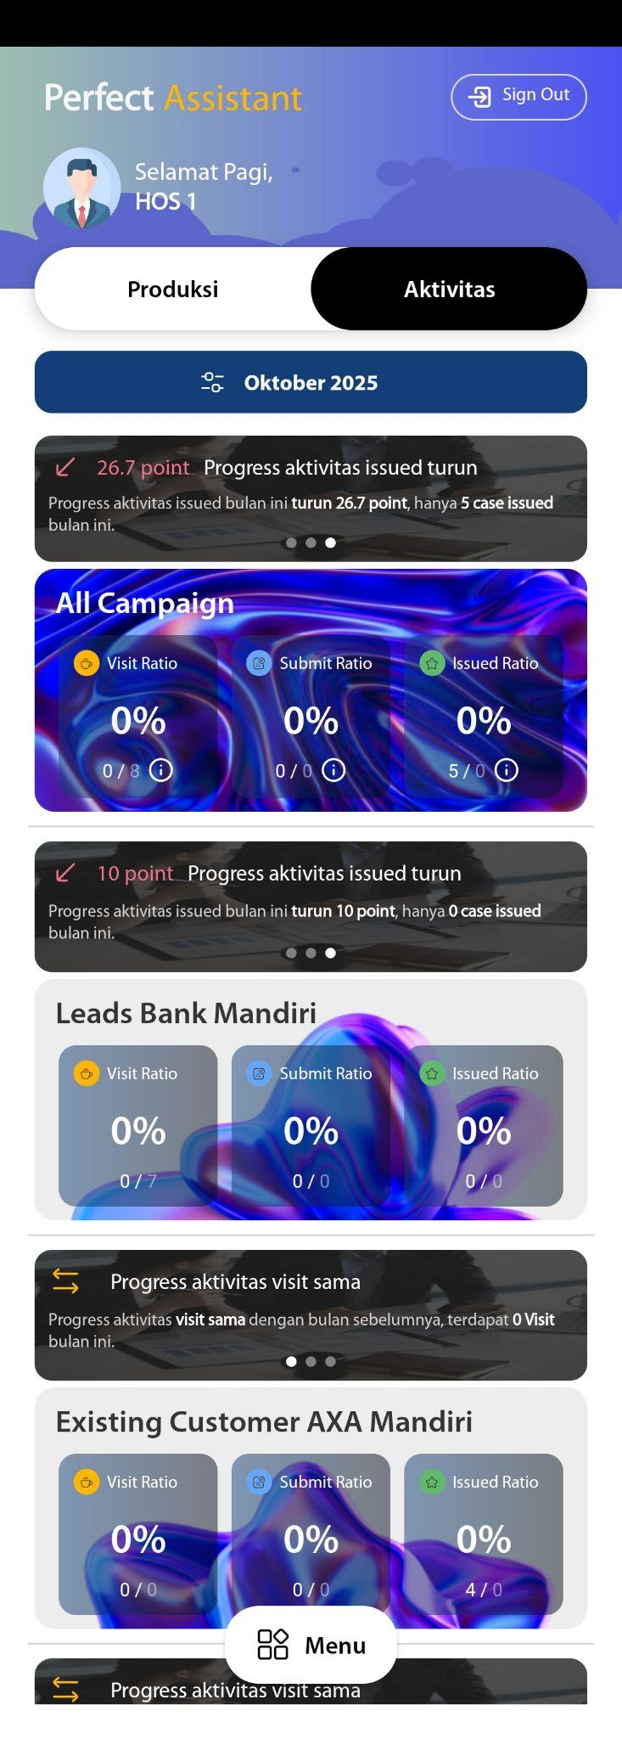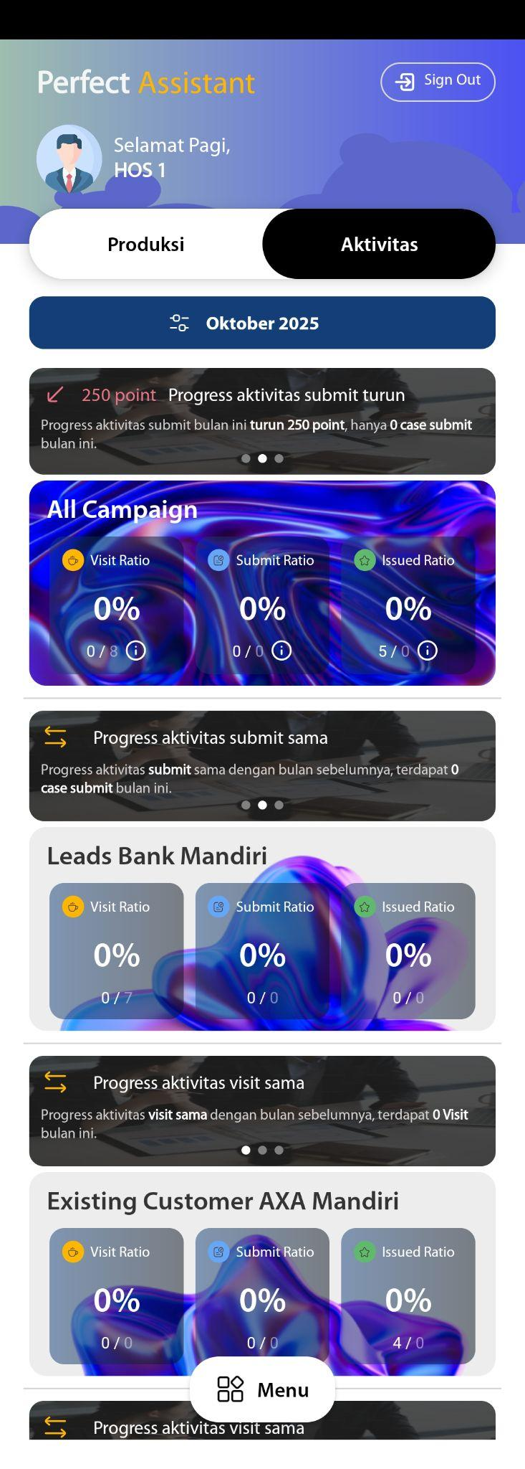

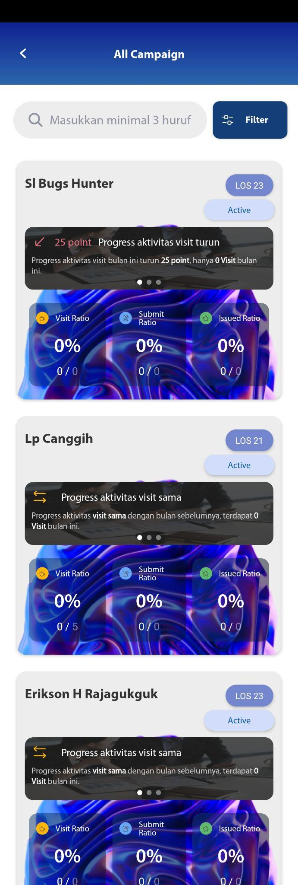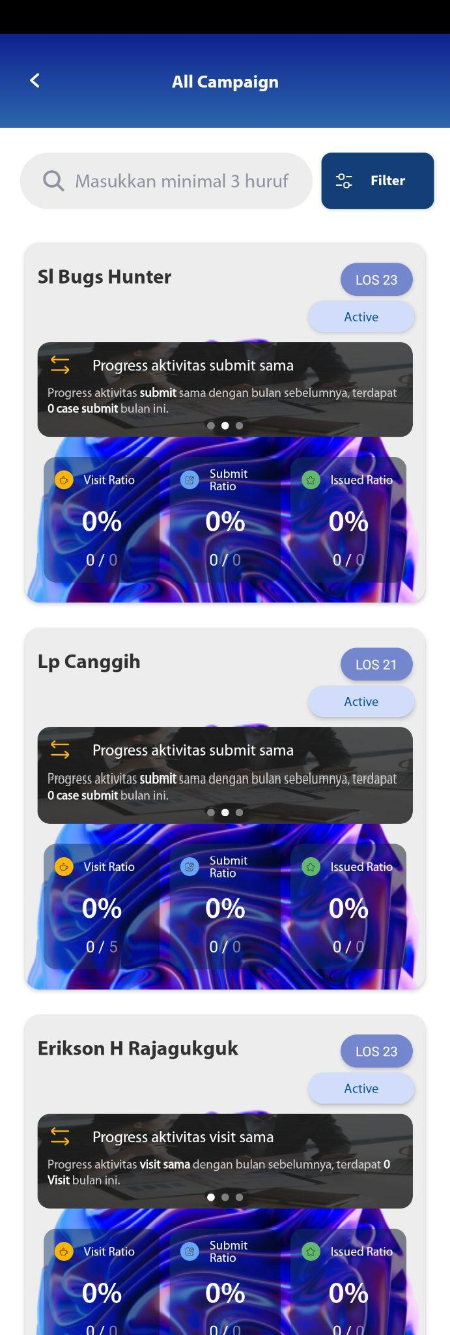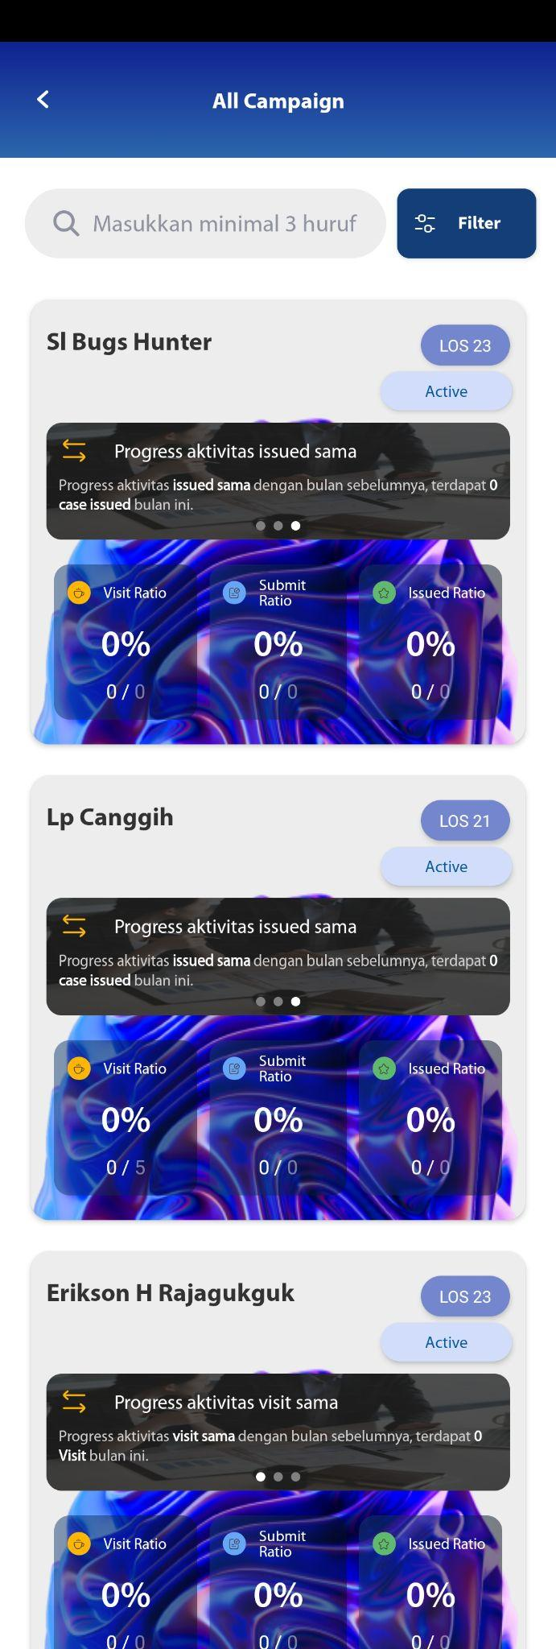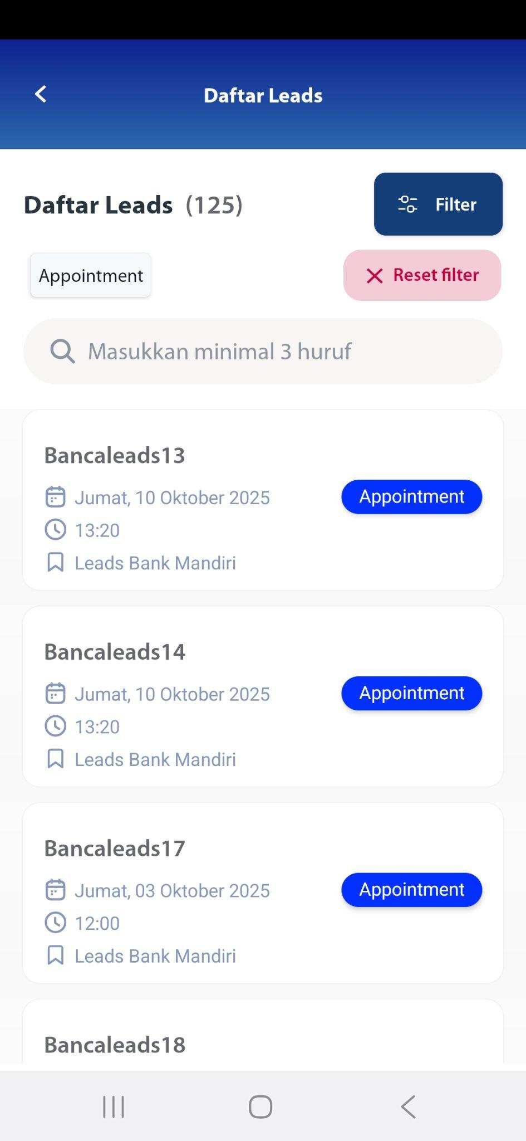

## Dashboard - Aktivitas - Campaign Leads Bank Mandiri

[TC 9.2.1 - TC 9.2.14]



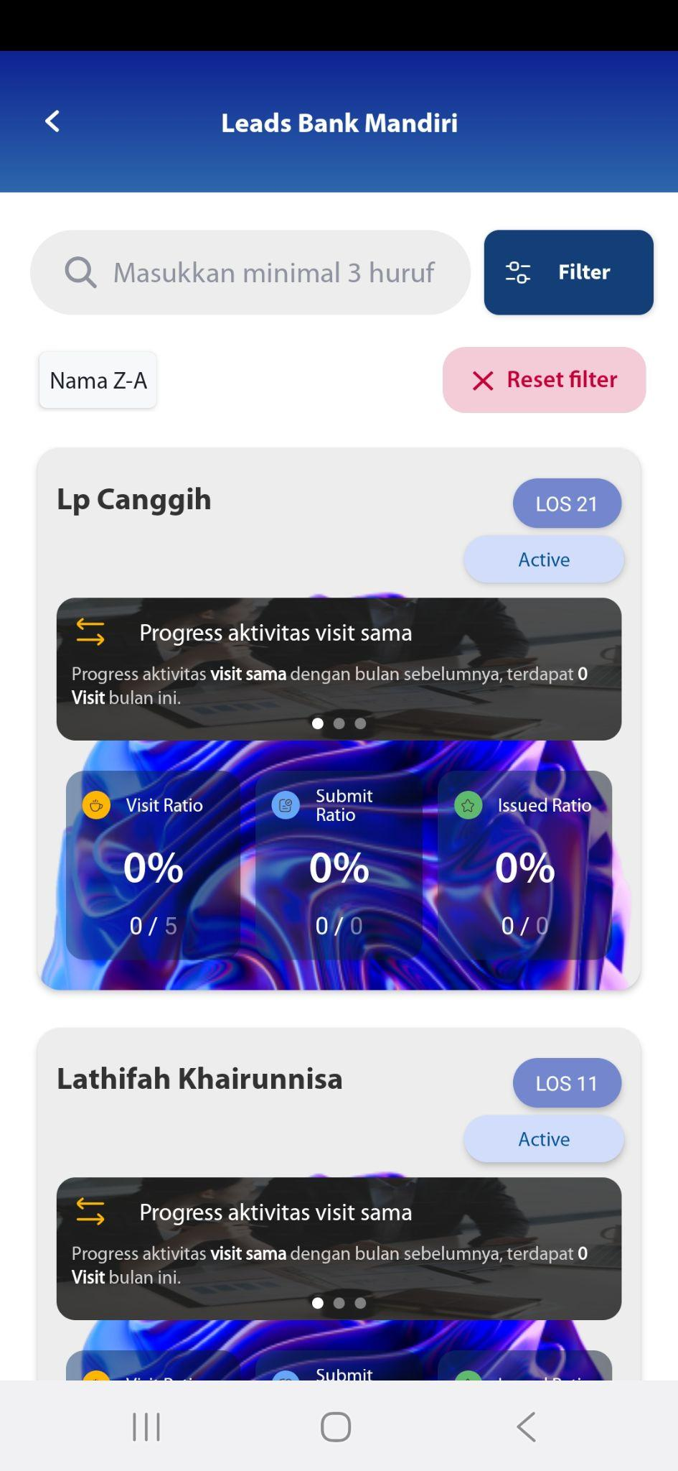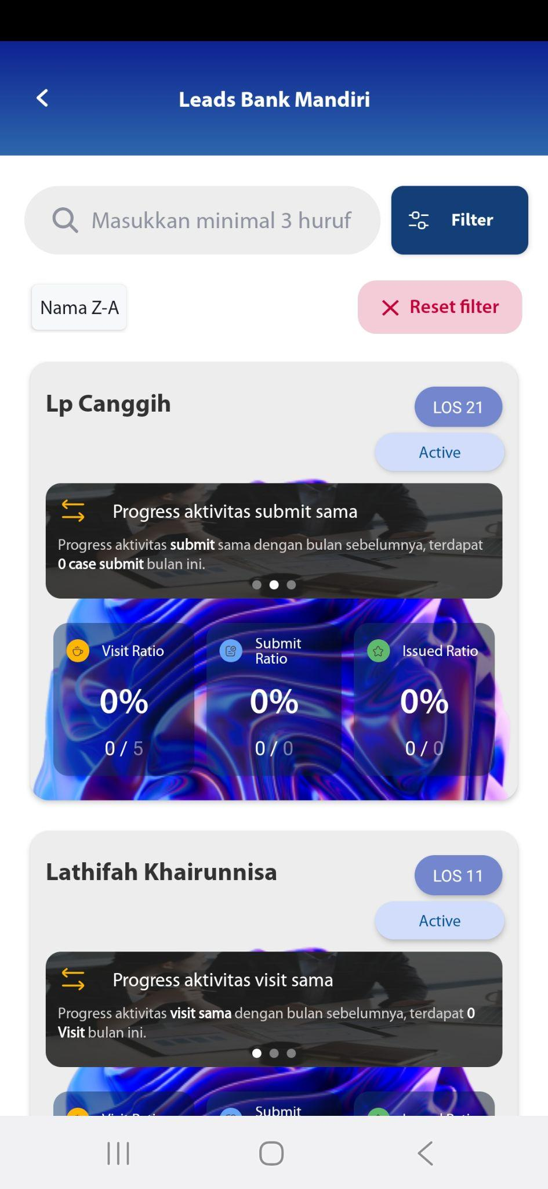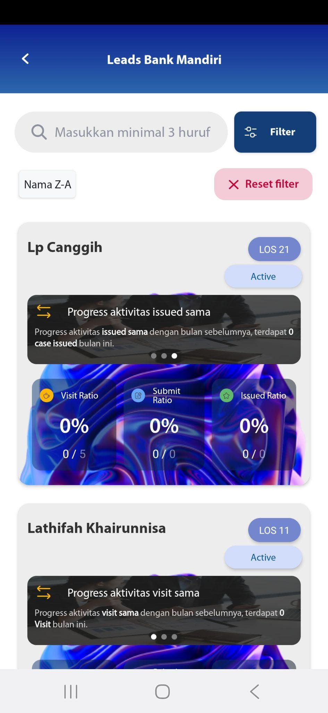



## Recording

[TC 9.3.1 - TC 9.3.5]

